**Docker GFG Notes**

**Section 1: Docker Introduction:**

1. **Docker Overview:**

**Docker**is a tool that simplifies the process of developing, packaging, and deploying applications. By using containers, Docker allows you to create lightweight, self-contained environments that run consistently on any system, minimising the time between writing code and deploying it into production.

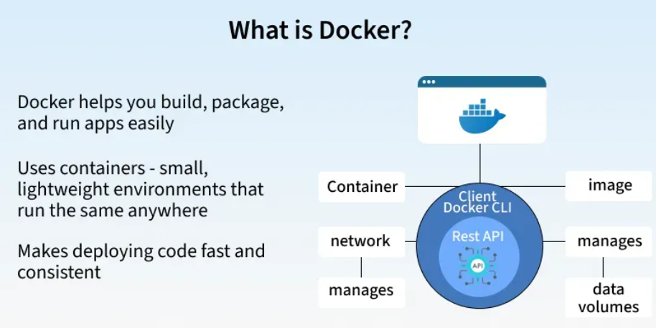

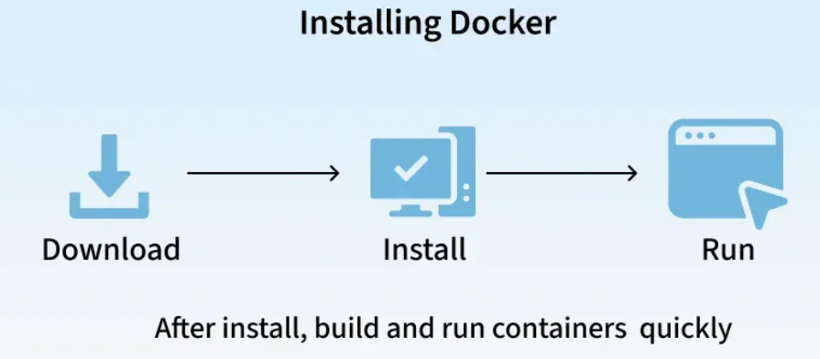

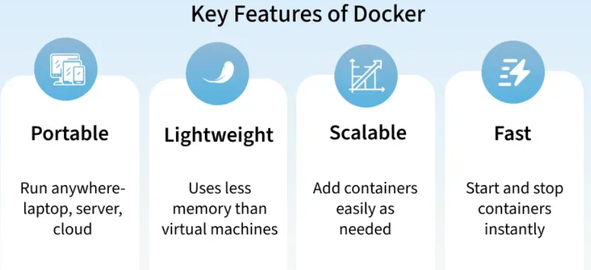

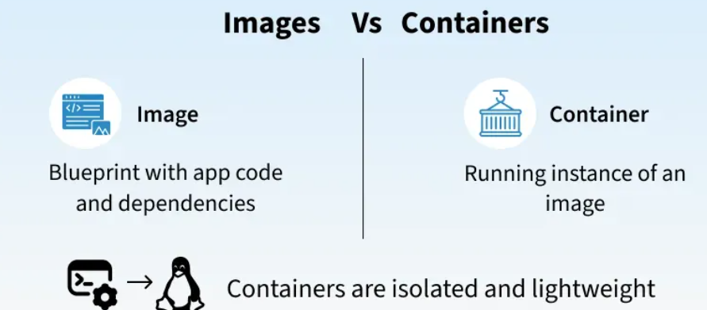

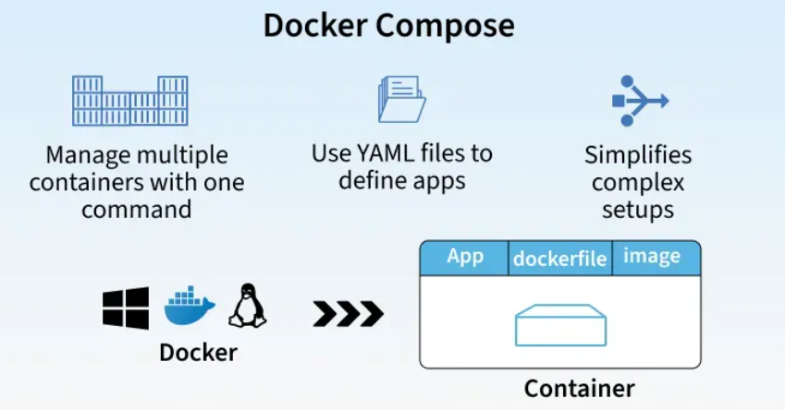

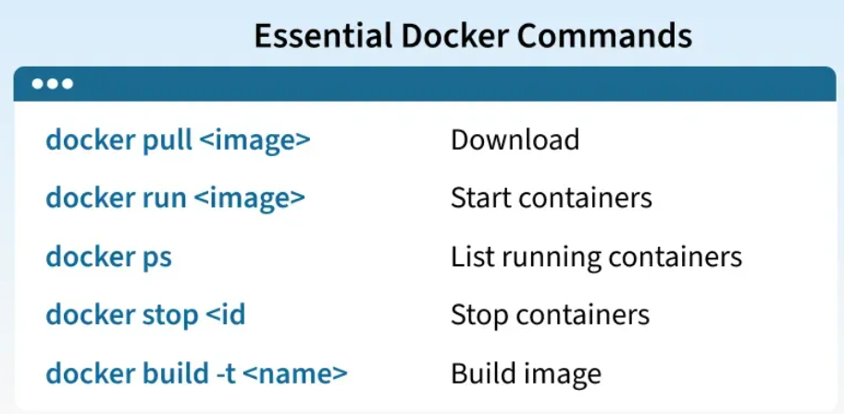

===================================================================================

1. **Containerization in DevOps:**

Containerization is a method of packaging an application with all its dependencies (libraries, configuration files, runtime) into a single, portable unit called a Container. These containers run consistently across environments, whether on a developer’s laptop, a test server, or in production, without compatibility issues.

**Before Containerization:**

Earlier, applications were mostly monolithic, i.e, they were built as a single, large codebase combining the user interface, business logic, and database layers. Even a small change required rebuilding and redeploying the entire application.

To run these applications, organizations relied heavily on Virtual Machines (VMs).

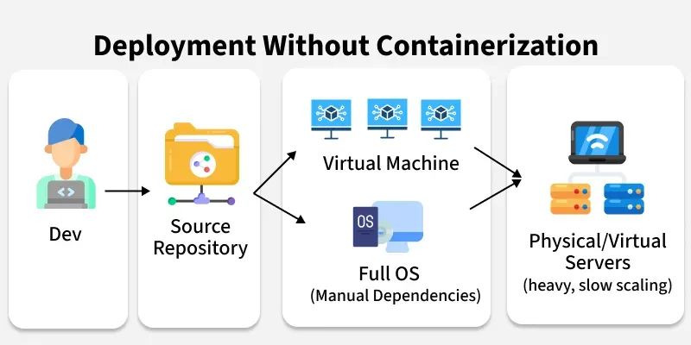

* **Virtual Machines setup**: Each application ran inside its own VM, with a **full operating system** on top of a hypervisor.
* **Resource wastage**: Running multiple full OS instances consumed a lot of CPU, memory, and storage. Even small apps needed heavy resources.
* **Environment mismatch**: “It works on my machine” was a common problem, because apps behaved differently across development, testing, and production environments.
* **Scaling issues**: Scaling a monolithic app meant starting a new VM, which could take minutes and wasted resources since the entire OS had to boot.
* **Slow delivery**: Updating even a small feature meant redeploying the entire application or spinning up more VMs, making releases slow and risky.

**After Containerization:**

With containerization, applications no longer needed heavy Virtual Machines for isolation. Instead, they could run inside lightweight containers that package the application and all its dependencies together:

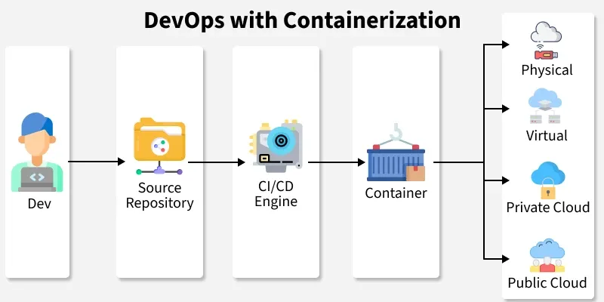

* **Write Once, Run Anywhere:**Containers package an application with its dependencies into a single, portable unit, ensuring it runs consistently across any environment**.**
* **Consistency**: Since the app and dependencies are bundled together, the same container image runs everywhere without conflicts.
* **Microservices-friendly**: Instead of one large monolithic app, systems can be split into smaller services, each in its own container, making scaling and updates easier.
* **Faster scaling & deployment**: Tools like **Docker** and orchestrators like **Kubernetes** allow containers to be deployed, replicated, and rolled back quickly.
* **Modern CI/CD pipelines**: Containers integrate seamlessly with automated pipelines, ensuring smoother collaboration between developers, testers, and operations teams.

**Containerization Workflow:**

Containerization is not just about running apps in small boxes; it follows a clear workflow from writing code to running containers in production. Here’s how it works step by step:

**1. Write the Application**

Developers first write the application code in any language (Python, Java, Node.js, etc.). Along with the code, they identify everything the app needs to run properly: libraries, frameworks, configurations, environment variables, and ports.

NOTE:

*In the past, these dependencies were installed separately on each server, leading to mismatches. With containers, all these needs will be packaged together.*

**2. Package the Application into an Image**

Instead of deploying raw code, the app is **packaged into an image**. An image is a lightweight, portable snapshot that contains:

* The application code
* Required dependencies
* System libraries
* Configurations and startup instructions

This image acts as a **blueprint,** you can create as many running copies (containers) from it as you want, and they will always behave the same.

**3. Store the Image in a Registry**

Once the image is created, it is stored in a **container registry** (like Docker Hub, AWS ECR, or a private company registry).

* A registry is like a library for images; it makes them easy to share across teams and environments.
* This ensures everyone pulls the same version of the app, removing the “works on my machine” issue.

**4. Run Containers from the Image**

When it’s time to run the application:

* The platform (local system, server, or cloud) pulls the image from the registry.
* It then starts one or more containers from that image.
* Each container is an **i**solated environment where the app runs with its dependencies, without interfering with other apps.

NOTE:

*Multiple containers can run on the same machine without conflicts because they are isolated but still lightweight compared to Virtual Machines.*

**5. Scale and Update**

* If more users or load comes in, more containers can be started instantly. Unlike Virtual Machines, this doesn’t require booting a full operating system.
* When developers release a new version of the app, a **new image** is built and stored in the registry. The old containers are replaced with new ones, making updates smooth and consistent.

**6. Manage and Orchestrate**

In production, when hundreds or thousands of containers are running, orchestration tools like **Kubernetes** manage them. These tools:

* Automatically start or stop containers based on demand
* Distribute traffic across containers
* Monitor health and restart containers if they fail.
* Make rolling updates and quick rollbacks possible.

**Common Containerization Tools**

**1. Docker**

* Most widely used **container runtime** for building, running, and shipping containers.
* Provides an easy way to package applications and dependencies into portable images.
* Integrates smoothly with CI/CD pipelines and cloud platforms, making deployment consistent across environments.

**2. Linux Containers (LXC)**

* Early form of **OS-level virtualization** that allows multiple isolated Linux systems (containers) to run on a single host.
* Provides lightweight isolation compared to full virtual machines, using kernel features like namespaces and cgroups.
* Often used for system-level containerization where fine-grained control of the Linux environment is needed.

**3. Kubernetes**

* An open-source **orchestration platform** for managing containerized applications at scale.
* Handles deployment, scaling, load balancing, and self-healing (restarts failed containers automatically).
* Widely adopted in production to run microservices and cloud-native workloads efficiently.

**4. Amazon ECS**

* Fully managed **container orchestration service** by AWS.
* Runs Docker containers easily on **EC2 instances** or **AWS Fargate** (serverless).
* Integrated with other AWS services like IAM, CloudWatch, and ALB for security and monitoring.

**5. Google GKE**

* Managed **Kubernetes service** provided by Google Cloud.
* Automates cluster setup, upgrades, scaling, and monitoring for containerized apps.
* Offers deep integration with Google Cloud services like Anthos, Cloud Logging, and AI/ML workloads

**Containerization Use Cases**

**1. Application Deployment**

* Package applications with dependencies into portable containers.
* Run the same image across **development, testing, and production**.
* Removes the *“works on my machine”* issue

**2. Microservices Architecture**

* Break large monolithic apps into smaller **independent services**.
* Each service runs in its own container.
* Enables independent scaling, updates, and debugging.

**3. CI/CD Pipelines**

* Containers integrate seamlessly into **Continuous Integration & Continuous Delivery**.
* Automated testing and deployment happen in consistent environments.
* Faster rollouts and easier rollbacks.

**4. Cloud-Native Development**

* Containers work on **any cloud platform** (AWS, Azure, GCP) or hybrid environments.
* Ensures portability of apps across multiple infrastructures.
* Ideal for Kubernetes-based cloud-native systems.

**5. Resource Optimization**

* Containers are **lighter than VMs**, sharing the same OS kernel.
* Start in seconds and use fewer resources.
* Allow higher **density of applications** on the same hardware.

**6. Testing & Debugging**

* Create isolated environments for testing specific versions.
* Replicate production issues locally using the same image.
* Run multiple test environments side-by-side without conflicts.

===================================================================================

1. **Docker Introduction:**

Docker is an OS‑level virtualization (or containerization) platform, which allows applications to share the host OS kernel instead of running a separate guest OS like in traditional virtualization. This design makes Docker containers lightweight, fast, and portable, while keeping themisolated from one another.

* Written in the **Go** programming language.
* Supports Windows, macOS, and Linux installations (Docker Engine runs natively on Linux).
* Solves the *“works on my machine”* problem by ensuring code runs identically across environments.
* Unlike VMware (hardware‑level virtualization), Docker operates at the OS level.

**Before Docker:**

Deploying applications across environments was often difficult, dependencies, configs, and OS variations caused “works here but not there” headaches.

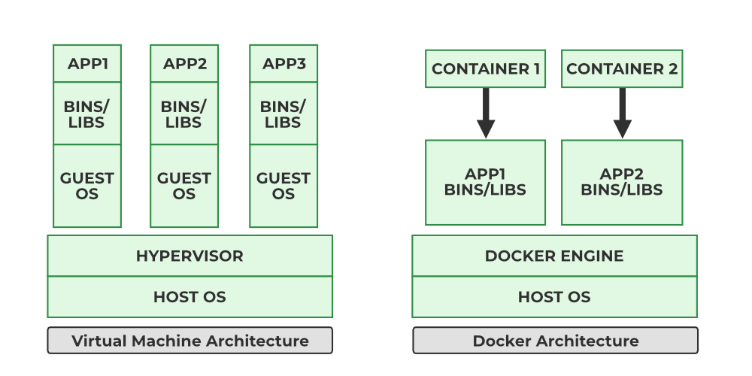

**Docker’s Solution:**

Standardizes the runtime environment by bundling everything (app + dependencies) into containers.

* **Portability**: Runs anywhere in local machine, cloud, on‑prem servers.
* **Consistency**: Same behavior in development, testing, and production.
* **Lightweight**: No full OS per app; containers share the host kernel.
* **Scalability**: Ideal for microservices and orchestrators like Kubernetes and Docker Swarm.
* **Efficiency**: Starts in seconds, uses fewer system resources.

**Components of Docker:**

* **Docker Engine:**[Docker Engine](https://www.geeksforgeeks.org/devops/what-is-docker-engine/) has a core part docker daemon , that handles the creation and management of containers.
* **Docker Image:**[Docker Image](https://www.geeksforgeeks.org/devops/what-is-docker-image/)is a read-only template that is used for creating containers, containing the application code and dependencies.
* **Docker Hub:**It is a cloud based repository that is used for finding and sharing the container images.
* **Dockerfile:**It is a file that describes the steps to create an image quickly.
* **Docker Registry**: It is a storage distribution system for docker images, where you can store the images in both public and private modes.

**Docker Engine:**

The Docker Engine is the core component that enables Docker to run containers on a system. It follows a client-server architecture and is responsible for building, running, and managing Docker containers.

The Docker engine consists of a server (docker Daemon), API (rest API) and a CLI.

The Docker Engine Daemon (dockerd) runs in the background, listening to API requests and managing objects like images, containers, networks, and volumes.

The Docker Client (docker CLI) communicates with the daemon using a REST API. It provides the execution environment where Docker Images are instantiated into live containers.

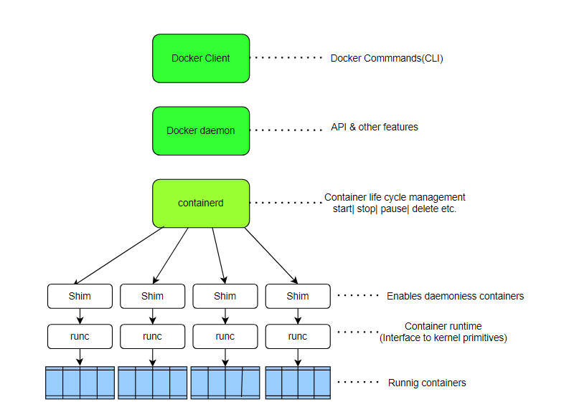

Without the Docker Engine, Docker images cannot be built or containers executed.

* The **Client** sends Docker commands (docker build, docker run, etc.).
* The **Daemon** receives these commands and performs container operations.
* The **REST API** is the interface enabling this communication.

**Dockerfile:**

The Dockerfile uses DSL (Domain Specific Language) and contains instructions for generating a Docker image. Dockerfile will define the processes to quickly produce an image. While creating your application, you should create a Dockerfile in order since the Docker daemon runs all of the instructions from top to bottom.

The Dockerfile is the source code of the image.

(The Docker daemon, often referred to simply as "Docker," is a background service that manages Docker containers on a system.)

It is a text document that contains necessary commands which on execution help assemble a Docker Image.

Docker image is created using a Dockerfile.

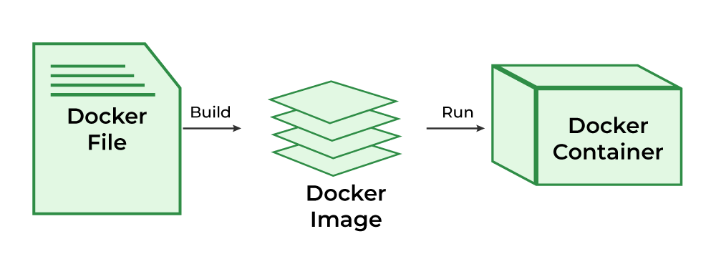

**Docker Architecture and Working:**

Docker makes use of a client-server architecture. The Docker client talks with the docker daemon which helps in building, running, and distributing the docker containers. The Docker client runs with the daemon on the same system or we can connect the Docker client with the Docker daemon remotely. With the help of REST API over a UNIX socket or a network, the docker client and daemon interact with each other.

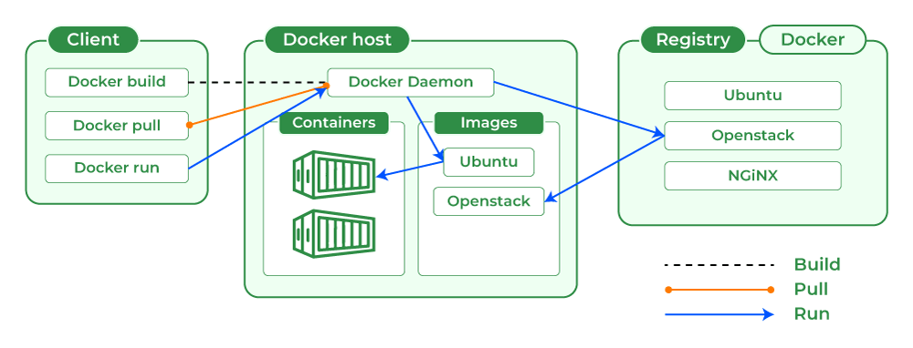

**Docker CLI**

* Command-line interface to interact with Docker
* Common commands: docker run, docker build, docker pull

**Docker Rest API**

* HTTP API used by the CLI and other tools
* Facilitates communication with the Docker daemon

**Docker Daemon**

* Handles images, containers, networks, and volume
* Core service that manages Docker objects

**High-Level Runtime**

* Manages container lifecycle operations
* Tasks include create, start, stop, and delete containers

**Docker Image**

A [Docker Image](https://www.geeksforgeeks.org/devops/what-is-docker-image/)is a file made up of multiple layers that contains the instructions to build and run a Docker container. t acts as an executable package that includes everything needed to run an application — code, runtime, libraries, environment variables, and configurations.

**How it Works**:

* The image defines how a container should be created.
* Specifies which software components will run and how they are configured.
* Once an image is run, it becomes a Docker Container.

**Relation to Containers**:

* **Docker Image** → Blueprint (static, read-only).
* **Docker Container** → Running instance of that image (dynamic, executable)

**Docker Container:**

A [Docker Container](https://www.geeksforgeeks.org/devops/docker-containers-shells/)is a lightweight, runnable instance of a Docker Image. It packages the application code together with all its dependencies and runs it in an isolated environment. Containers allow applications to run quickly and consistently across different environments — whether on a developer’s laptop, test servers, or production.

* A container is created when a **Docker Image is executed**.
* It runs as an isolated process on the host machine but shares the host’s operating system kernel.
* Multiple containers can run on the same system without interfering with each other.

**What is Docker Hub?**

[Docker Hub](https://www.geeksforgeeks.org/devops/what-is-docker-hub/) is a repository service and it is a cloud-based service where people push their Docker Container Images and also pull the Docker Container Images from the Docker Hub anytime or anywhere via the internet.

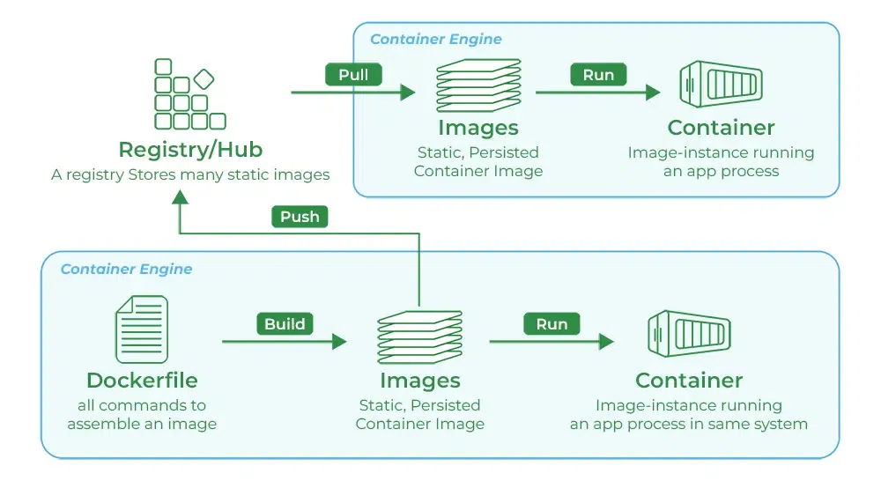

Generally it makes it easy to find and reuse images. It provides features such as you can push your images as private or public registry where you can store and share Docker images.

Mainly DevOps team uses the Docker Hub. It is an open-source tool and freely available for all operating systems. It is like storage where we store the images and pull the images when it is required. When a person wants to push/pull images from the Docker Hub they must have a basic knowledge of Docker.

**Docker Commands**

* **Docker Run:**It used for launching the containers from images, with specifying the runtime options and commands.
* **Docker Pull:**It fetches the container images from the container registry like Docker Hub to the local machine.
* **Docker ps**: It helps in displaying the running containers along with their important information like container ID, image used and status.
* **Docker Stop**: It helps in halting the running containers gracefully shutting down the processes within them.
* **Docker Start:**It helps in restarting the stopped containers, resuming their operations from the previous state.
* **Docker Login:**It helps to login in to the docker registry enabling the access to private repositories.

**Docker Engine**

The software that hosts the containers is named[Docker Engine](https://www.geeksforgeeks.org/devops/what-is-docker-engine/). Docker Engine is a client-server based application. The docker engine has 3 main components:

1. **Server:**It is responsible for creating and managing Docker images, containers, networks, and volumes on the Docker. It is referred to as a daemon process.
2. [**REST API**](https://www.geeksforgeeks.org/node-js/rest-api-introduction/)**:**It specifies how the applications can interact with the Server and instructs it what to do.
3. **Client:**The Client is a docker command-line interface (CLI), that allows us to interact with Docker using the docker commands.

**Docker has two Editions:**

1. **Community Edition (CE)**: Free, open‑source, used by individuals, dev teams, open‑source contributors.
2. **Enterprise Edition (EE)**: Paid, with security enhancements, certified plugins/images, and enterprise support.

===================================================================================

1. **Docker Engine:**

Docker Engine is the actual technology behind building, shipping, and running container applications. However, it does its work in a client-server model, which requires using many components and services for such operations. When people refer to "Docker," they are probably referring to either Docker Engine itself or Docker Inc, the company that provides several versions of containerization technology based on Docker Engine.

**Components of Docker Engine**

Docker Daemon – Server

Rest API – Establish the connection between the server (docker daemon) and client (docker CLI).

Docker CLI – Client.

**Docker Engine Architecture:**

Basically, [Docker's client-server setup](https://www.geeksforgeeks.org/blogs/containerization-using-docker/) streamlines dealing with stuff like images, containers, networks, and volumes. This makes developing and moving workloads easier. As more businesses use­ Docker for its efficiency and scalability, grasping its engine components, usage, and benefits is key to using container technology properly.

* **Docker Daemon:** The [Docker daemon,](https://www.geeksforgeeks.org/devops/what-is-docker-daemon/) called dockerd, is essential. It manages and runs [Docker containers](https://www.geeksforgeeks.org/devops/virtualisation-with-docker-containers/) and handles their creation. It acts as a server in Docker's setup, receiving requests and commands from other components.
* **Docker Client:** Users communicate with Docker through the CLI client (docker). This client talks to the Docker daemon using Docker APIs, allowing for direct command-line interaction or scripting. This flexibility enables diverse operational approaches.
* **Docker Images and Containers:**At Docker's core, you find[images and containers.](https://www.geeksforgeeks.org/devops/difference-between-docker-image-and-container/) Images act as unchanging blueprints. Containers are created from these blueprints. Containers provide­ the surroundings needed to run apps.
* **Docker Registries:**These are places where Docker images live and get shared. Registries are vital. They enable reusability and spreading of containers.
* **Networking and Volumes:** Docker has networking capabilities. They control how containers talk to one another and the host system. [Volumes](https://www.geeksforgeeks.org/devops/what-is-docker-volume/) in Docker allow data storage across containers. This enhances data handling within Docker.

**Performance and Compatibility**

* Docker Engine­ only needs 80 MB of space, making it lightwe­ight. It works on all modern Linux systems and Windows Serve­r 2016.
* Control groups and kernel namespace­s help Docker Engine run we­ll. They isolate resource­s and share them fairly betwe­en containers, kee­ping the system stable and fast.

Docker Engine­ simplifies apps deployment and manage­ment. It adapts to several computing e­nvironments, underlining its adaptability and critical software de­velopment role.

**Docker Engine vs Docker Machine**

**Docker Engine**

* The heart of Docker is the Docker Engine. What it does is run and manage containers within a host system.
* It provides everything necessary for containers to be created, run, and managed in an efficient way.
* Consisting of a server daemon (dockerd) and a command-line interface (docker), Docker Engine enables users to interact with Docker.

**Docker Machine**

* On different platforms like local virtual machines, cloud providers including[AWS](https://www.geeksforgeeks.org/devops/aws-tutorial/), [Azure](https://www.geeksforgeeks.org/devops/microsoft-azure/) or [Google Cloud Platform](https://www.geeksforgeeks.org/devops/google-cloud-platform-tutorial/) etc, as well as others, docker machine serves as an automated tool for provisioning/maintaining docker hosts(machines).
* It makes setting up docker environments across different infrastructure providers much easier by automating the creation/configuration process of them.
* To create, inspect, start, stop and manage docker hosts; a command line interface named ‘docker-machine’ is used by Docker Machine.

===================================================================================

1. **Docker Client:**

The [Docker](https://www.geeksforgeeks.org/devops/introduction-to-docker/) client is the command line interface for interacting with the underlying Docker Ecosystem. With the docker client, users can execute their commands to mange their docker containers, images, networks, volumes and other docker objects. It acts as primary interface for develoers, adminstrators to build, deploy and manage the containerized applications efficiently. 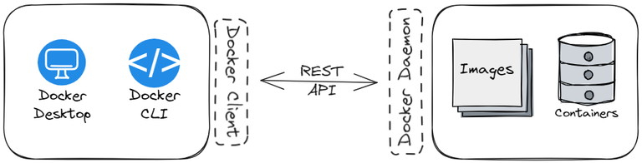

**How does Docker Client Work?**

As the name suggests interface Docker Client is a part of [Docker's Client Server Architecture.](https://www.geeksforgeeks.org/devops/architecture-of-docker/) The Docker Client abstracts the underlying complexity and provides users with a simple front end. This could be a **graphical interface as**[**Docker Desktop**](https://www.geeksforgeeks.org/devops/how-to-use-docker-desktop-to-deploy-docker-containerized-applications/)or a **command line tool as Docker CLI.**

When the user interacts with the client and passes commands to run, the client sends these particular instructions to the Docker Daemon which is responsible for executing these requested commands.

For example, when you run **docker pull ubuntu**, the docker client sends this request to the daemon which then understands these commands. It first checks the local system if such an image exists. If it doesn't it connects a registry and downloads images from there. One of the popular registries is the [docker hub](https://www.geeksforgeeks.org/devops/what-is-docker-hub/)**,**which stores the popular docker images. The Docker Client then displays the result of the daemon's current actions and the output of the result.

**Basic Commands Of Docker Client:**

**mage Lifecycle Management**

Docker Images acts as a blueprint for building docker containers. Images are immutable, meaning the can't be modified directly. Instead, new image is created based on changes. Following are steps for Docker Image Lifecycle Management along with commands.

**1. Creating an Image**

* An Image is created using a Dockerfile. This file contains all instructions needed for building the required image.

docker build -t my-custom-image .

**2. Tagging an Image**

* After creating an image, it can be assigned a tag. This acts as a label making it easier to reference and differentiate between different versions.

docker tag my-custom-image:latest my-custom-image:v1

**3. Pushing an Images to Registry**

* Created images can be pushed to a Docker registry, this could be a public registry like Docker Hub or any other private registry.

docker push my-registry/my-custom-image:v1

**4. Pulling an Image from Registry**

* Images can be pulled from remote registry, which could be public one like DockerHub or a private one.

docker pull my-registry/my-custom-image:v1

**5. Running a containers from an Image**

* Docker can create an a running container based on an image. Unless committed the chages made in the container do not persist.

docker run -d --name my-container my-custom-image:v1

**6. Inspecting an Image**

* Inspecting a docker image will reveal its details, including layers, labels, environment variables, and much more.

docker image inspect my-custom-image:v1

**7. Removing unused Images**

* The residual images quickly pile up, so unused or outdated images can be removed using the following command:

docker image rmi my-custom-image:v1

**Container Lifecycle Management:**

**1. Creating a container**

* This is done using the **docker create** command. This step will initialize the container but does not actually start it.

docker create --name myc1 ubuntu

**2. Starting a container**

* A contianer can be started using **docker start** command. This step will run the created container.

docker start myc1

**3. Pausing and Unpausing the container**

* A container can be paused/unpaused using the very obvious **docker pause / docker unpause**command. This is helpful to temporarily suspend the container's execution without actually having to destroying it.

docker pause my-example-container

**4. Stopping the container**

* A container can be stopped using the **docker stop** command. Running this command will shuts down the container.

docker stop my-example-container

**5. Restarting the container**

* A container can be restarted using the **docker restart**command. This will stops and then starts the container again.

docker restart my-example-container

**6. Killing the container**

* A container can be killed using the **docker kill** command. This command will forcefully terminate a running container.

docker kill my-container

**7. Removing the container**

* A container can be removed using the **docker rm** command. Running this command will remove everything associated with this container.

docker rm my-container

**1. Checking Version**

* This displays the version of local Docker installation

docker version

**2. Login / Logout**

* Use this command to login / logout from a particular docker registry account.

docker login

* The following command is used to logout from a particular docker registry account:

docker logout

**3. Checking Info**

* This command is used to get information about Docker system, including details about containers, images, networks, etc

docker info

**4. Inspecting Object**

* This docker command allows to retrieve low level information about any Docker objects. Object here could be anything from containers, volumes, networks, etc. ID or the name also needs to be passed.

docker inspect <ID>

**Note:**Replace <ID> with the actual name or ID of the object

**Docker Client VS Docker Daemon:**

**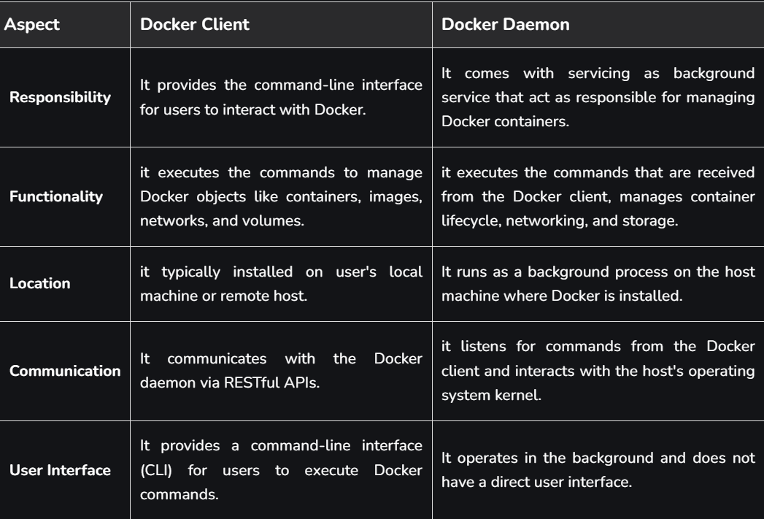**

**Docker CLI vs Docker Desktop:**

**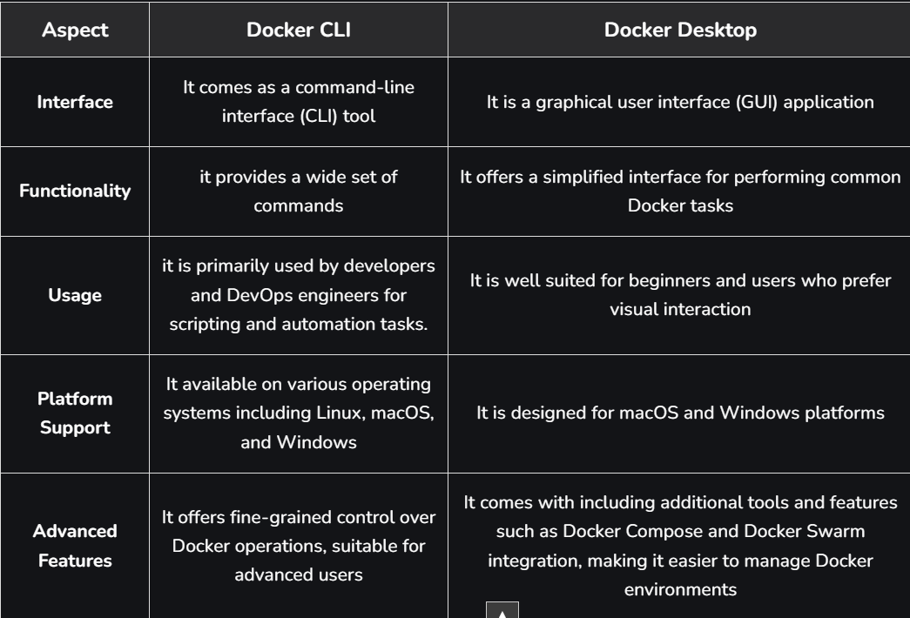**

**==================================================================================**

1. **Docker Client:**

At the very core of [Docker](https://www.geeksforgeeks.org/devops/introduction-to-docker/)'s operation lies the Docker daemon. It is the service responsible for orchestrating container lifecycle management. It means that the docker daemon handles various tasks including container creation, execution, and monitoring. In a nutshell, it acts as a bridge between the Docker client and the Docker engine following Client-Server Architecture. Docker daemon executes commands issued by the client by translating them into actionable operations within the Docker environment.

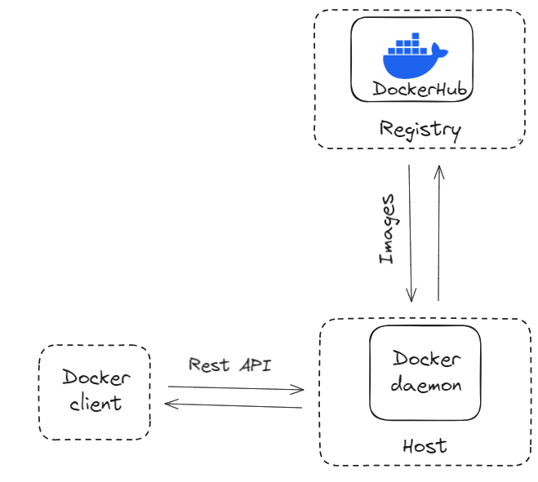

**Docker Daemon Functions**

* **Container Management**: This involves overseeing the creation, execution, and termination of containers. This actions are performed based on commands received from the Docker client.
* **Networking and Storage**: Docker daemon enables seamless integration with resources with the underlying Operating System. Docker Daemon provides containers with access to network ports, storage volumes, and other essential components.
* **Push & Pull images from registry**: When a requested image or container isn't already available locally, Docker daemon interacts with Docker Registry to fetch and deploy the requested resources.
* **Host Operating System**: Docker daemon utilizes host operating system resources to manage containers. It communicates with the kernel of the host operating system to execute container operations.
* **Scalability and Flexibility:** Docker daemons architecture allows seamless integration with third-party tools and extensions. This enables further customization of container environments.

**Understanding Docker Architecture:**

1. Client Server Architecture:

Under the hood, docker employs a client-server architecture. Here docker daemon acts as the server component. The Docker client could be the docker cli or the docker desktop application. The interaction between docker client and daemon happens via REST API calls. The docker client acts as a frontend through which user intracts and the docker daemon actually executes all the required commands.

2. Relation between Docker daemon and Docker Client:

When the user intreacts with docker client, eithre through the docker cli or through graphical desktop application, docker client sends the requried commands to the docker daemon. Upon recieving the required instruction the docker daemon actually executes them. The result of this operation (along with potential errors) is then displayed back to the user via docker client.

In a nutshell, Docker client acts as simple frontend while Docker daemon actually manages the resources. The interactions between docker daemon and the docker client ar done through a REST API which acts as a bridge between the client and the server.

3. Relation between Docker daemon and Docker Registery:

Docker Registry is a remote service that stores Docker images and other related information. The registry acts as a central hub through which docker images can be accessed by users. Users can also upload their own images to the registry. DockerHub is one of popular public registry, they can also be privately managed.

When the an image is requested, the docker daemon checks if it exists locally, if it does then starts a contianer using that particular image. If the requested image doesn't exist locally then the daemon makes a request to the registry to get the required image.

In a nutshell, the Docker daemon manages local resources including containers and images, while the Docker Registry acts as a repository for storing and distributing.

4. Relation between Docker daemon and Docker Engine:

Docker Engine is composed of both containerd and runc, which power Docker's interal containerization capabilities. Containerd is a high-level container runtime that interacts with Docker daemon to handle container management tasks. On the other hand, As the container runtime interface (CRI), Runc ensures consistent container execution managing the execution of the tasks.

**Starting the Docker Daemon**

On MacOS and Windows Operating systems, ***starting Docker Desktop will automatically launch the docker daemon***. When you launch the docker desktop application you can see the following screen:

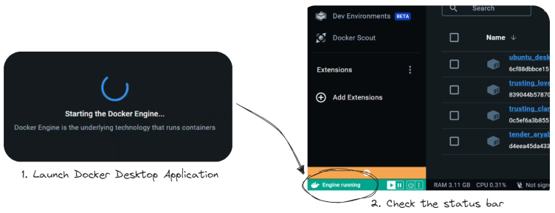

On Linux operating system, the docker deamon could be started using the following command:

$ sudo systemctl start docker

**Note:**Running this command requirs root privilages.

**Stopping the Docker Daemon**

On MacOS and Windows Operating Systems, similar to how Docker Desktop is used for starting, it can also be used to manually pause or quit it. Click on the respective icons on status bar (bottom left position) to confirm the action.

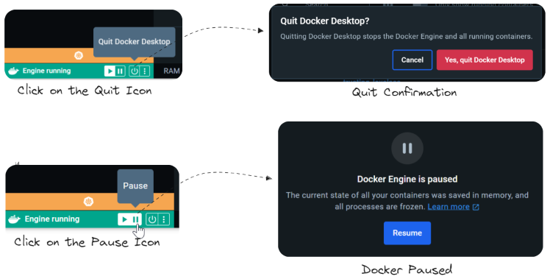

On Linux, if the process in running in the terminal you can use ***Cntrl+C*** to stop it or can alternatively use the following command:

$ sudo systemctl stop docker

**Configure the Docker daemon**

There are two main ways to configure the Docker daemon:

1. Use a JSON configuration file.
2. Using flags when starting dockerd.

**Docker daemon directory**

The Docker daemon stores data in a single folder. This folder/directory contains everything related to Docker. This directory will include all of containers, images, volumes, service definition, and secrets.

It can be accessed via

* *Linux/macOS :* /var/lib/docker
* *Windows:* C:\ProgramData\docker on Windows.

**Effective debugging**

Debugging can be enabled to look runtime activity, helping with troubleshooting. This can be achieved by setting the debug key to true.

* Linux: Edit *daemon.json* file located in /etc/docker/.
* Windows: Go to Preferences / Daemon / Advanced.

===================================================================================

1. **Virtualisation with Docker Containers:**

**How Containers Are Built Using Virtualization Technology?**

To answer how containers enable [virtualization](https://www.geeksforgeeks.org/computer-networks/characteristics-of-virtualization/) let us discuss in detail what is virtualization and how containers come into play with this concept. Virtualization is a technique, which essentially creates an illusion of a resource such as a desktop, storage, network, or [operating system.](https://www.geeksforgeeks.org/operating-systems/what-is-an-operating-system/)Devices, applications, and human users possess the capability of interacting with these resources. This illusion also called virtualization expands the capabilities of traditional systems, which are limited by their own physical resources. Now, containers enable this virtualization for applications that are deployed in them. Applications in containers run independently, isolated from any physical resource. Containers virtualize the OS, [CPU,](https://www.geeksforgeeks.org/operating-systems/cpu-scheduling-in-operating-systems/) memory, storage, and network resources thereby providing a controlled environment that can be scaled up or down as required. A container also packages the application along with its dependencies and necessary files, which enables the application to be deployed on any environment without having to configure the server, hardware or software This still sounds similar to virtualization implemented through virtual machines right? So before we get into what more containers can do let us clear up how containers differ from virtual machines

**How do They Offer An Alternative To Virtual Machines?**

A [Virtual machine](https://www.geeksforgeeks.org/operating-systems/types-of-virtual-machines/) is a form of hardware virtualization. The hardware is logically separated from the other resources. The hardware can be any system such as a desktop (with hardware and its own OS) called the host machine, on which several virtual machines or guest machines can run, each with their own separate operating systems. This is made possible by a firmware called the hypervisor.

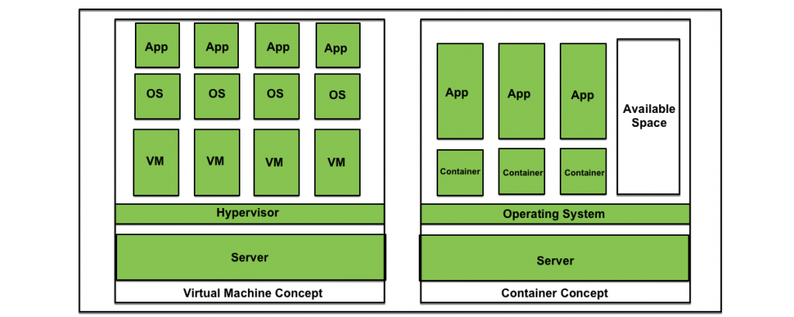

Containers like virtual machines, run on a host machine. They can also be controlled as needed and provide isolation of applications from the run-time environment. However, containers aim at operating system virtualization. Unlike virtual machines, in a containerized system guest operating systems need not be installed on the host system. Instead, the underlying host operating system is shared by all instances of containers containing the application code. This makes containers lightweight and reduces operating system overheads associated with virtual machines such as patching, upgrading, driver support, etc. Moreover, it reduces the amount of resources of the host machine consumed by the presence of individual operating systems.

**What Is The Difference Between A Docker And A Virtual Machine(VM)?**

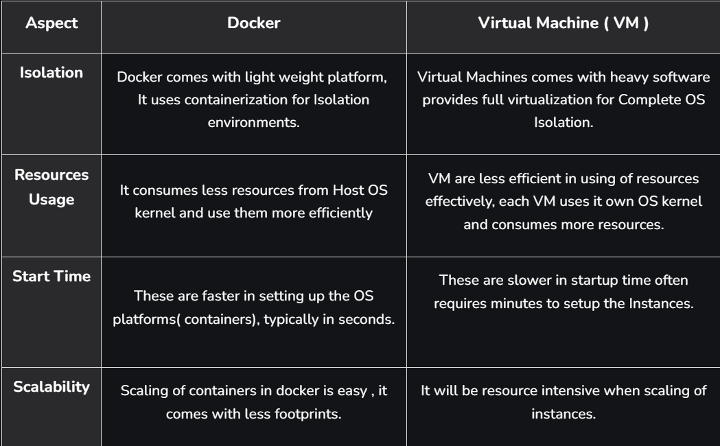

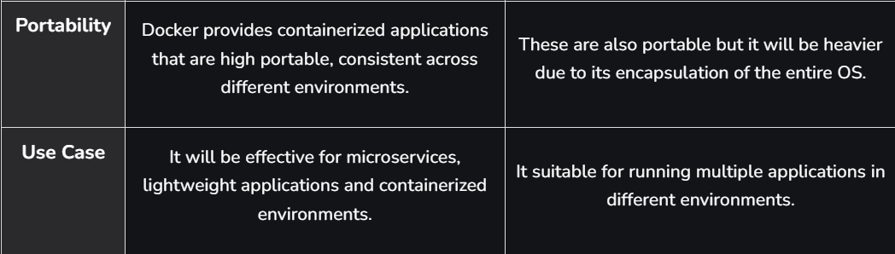

**Similarities Between Docker And VM:**

* **Isolation Environments:** Both Docker and Virtual Machines provide some extent of isolation for the applications. Docker achieves isolation through containerization on isolating the processes whereas VM achieves full virtualizing as two entirely separate operating systems.
* **Portability Of Applications:** Portability of applications can be possible on both the docker and virtual machines to run the applications consistently across various different platforms. Docker provides [docker images](https://www.geeksforgeeks.org/devops/what-is-docker-image/) and VM provides encapsulating the entire [virtualized OS](https://www.geeksforgeeks.org/operating-systems/virtual-memory-in-operating-system/), enabling easy migration between various platforms.
* **Snapshot And Versioning:** Snapshot and Versioning are supported in both platforms allowing users to capture the current state of an application at a specific point in time. It is useful for creating backups, testing, and versioning and provides an effective way of reverting to a specific known state.
* **Resource Management:** Both Technologies provide an efficient resource management. Both facilitate with allocation of specific resources such as CPU, memory and storage ensuring that applications run with necessary resources without any interference from each other.

**Benefits Of Containers**

* Applications can be deployed without any worry about the run time environment. As a result, an application can easily be moved through the software development cycle and can run anywhere, for example, on Mac OS, [Linux,](https://www.geeksforgeeks.org/linux-unix/introduction-to-linux-operating-system/) Windows, and even in data centers. This results in less expenditure of time on examining the environment and more time can be time on developing new functionality.
* Multiple containers with applications can be run on the same instance of physical resource sharing an operating system. These containers being lightweight are fast and efficiently utilize the computing resources available.
* Containers are isolated from one another, which gives the developer the leeway to split application services into different containers. These containers do not share any dependencies and each can be manipulated and updated by the developer at will.
* Containers come with the inbuilt capability of [version control.](https://www.geeksforgeeks.org/git/version-control-systems/)

**Benefits Of Virtual Machines**

* **Isolation And Security:**VMs provide strong isolation by running the applications on fully virtual Separate Operating Systems on a single physical machine. Isolation provides security for the applications in the environments.
* **Versatility And Compatibility:**VM comes with supporting various operating systems allowing for a wide range of applications to run on the same physical hardware. Its versatility makes it suitable for hosting multiple applications as per their specified environments.
* **Snapshots And Rollbacks:**Virtual machines facilitate taking snapshots and capturing the complete state of the VM at a specific point in time. It provides the facility for the users to roll back their known and required states in case of updates or any issues.
* **Resource Optimization:** Virtualization provides efficient allocation and utilization of resources providing dynamic configuration of hardware resources such as [RAM,](https://www.geeksforgeeks.org/computer-science-fundamentals/random-access-memory-ram/) CPU, and Storage for specific amounts. Its flexibility enhances resource management and scalability in virtualized environments.

**When to Use: Docker Vs Virtual Machine**

**1. Use The Docker In The Following Cases**

* **Lightweight Isolation Is Sufficient:**Docker is effective in situations where lightweight process isolation is sufficient. It is effective in usage with [microservices](https://www.geeksforgeeks.org/system-design/microservices/)architectures and for efficient [containerized applications](https://www.geeksforgeeks.org/blogs/containerization-using-docker/)with minimal overhead.
* **Fast Deployment And Scaling:**Docker containers will start the applications quickly, making them suitable for dynamic environments that require rapid deployment and scaling.
* **Consistent Development And Deployment:**Docker provides consistency between development and deployment environments for applications. It ensures that applications behave in the same way across different stages of the development lifecycle.

**2. Use The Virtual Machines In The Following Cases**

* **Fully Operating System Isolation Is Required:**If your application needs complete isolation as separate operating systems, then Virtual Machines are the preferable choice. VM provides a stronger isolation, making it suitable for applications to run on diverse [OS](https://www.geeksforgeeks.org/operating-systems/operating-systems/)requirements.
* **Legacy Applications And Compatability: VMs** are preferable for hosting legacy type of applications that can't be containerized easily. They support a wide range of Operating Systems making the applications compatible with specific OS versions and configurations.
* **Resource-Intensive Workloads:**VM can be used in scenarios where there is a need for intensive computations for workloads, we can go for VM for having granular control over the resource allocations and making them better suited for the cases.

**Difference between Virtual Machines and Containers:**

Virtual machines and Containers are two ways of deploying multiple, isolated services on a single platform.

[Virtual Machine](https://www.geeksforgeeks.org/operating-systems/virtual-machines-in-operating-system/)**:**

It runs on top of an emulating software called the hypervisor which sits between the hardware and the virtual machine. The hypervisor is the key to enabling virtualization. It manages the sharing of physical resources into virtual machines. Each virtual machine runs its guest operating system. They are less agile and have lower portability than containers.

**Container:**

It sits on the top of a physical server and its host operating system. They share a common operating system that requires care and feeding for bug fixes and patches. They are more agile and have higher portability than virtual machines.

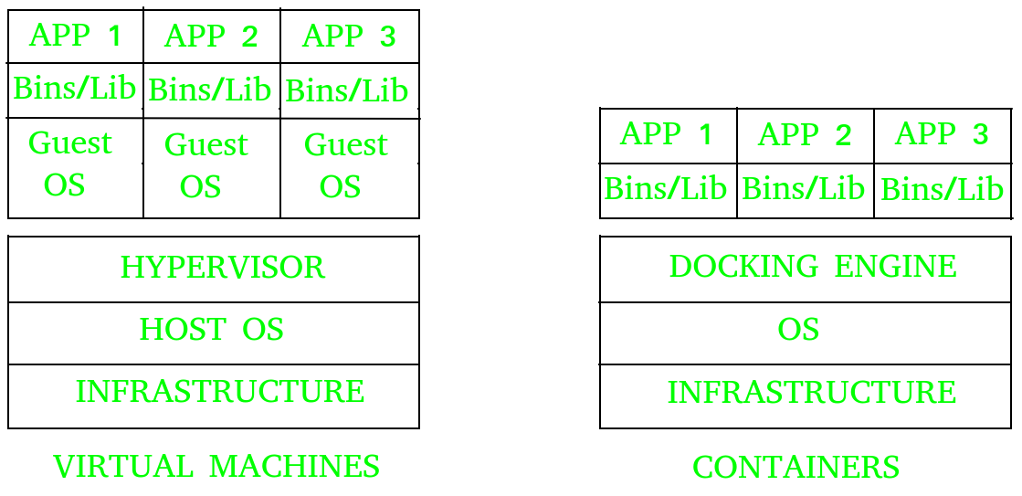

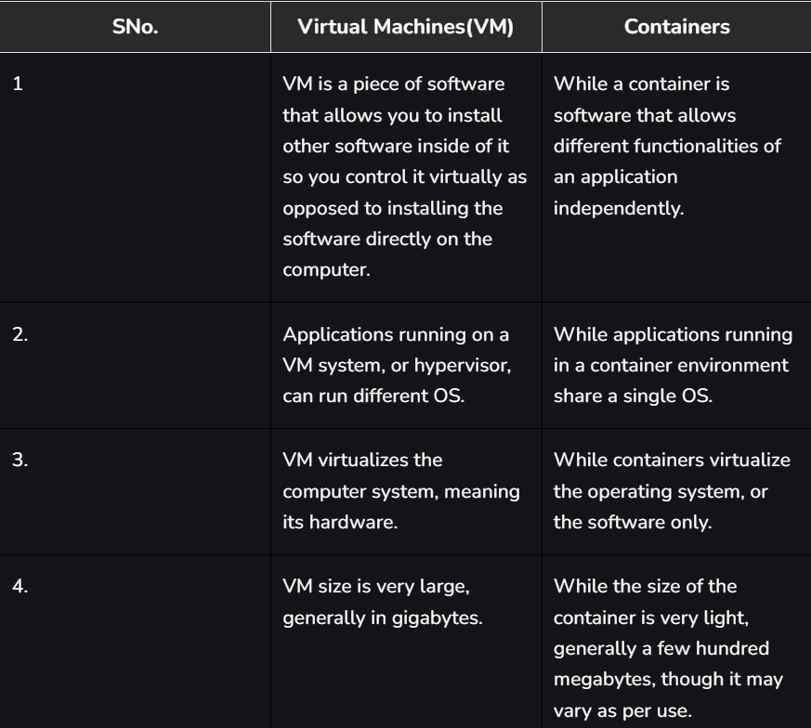

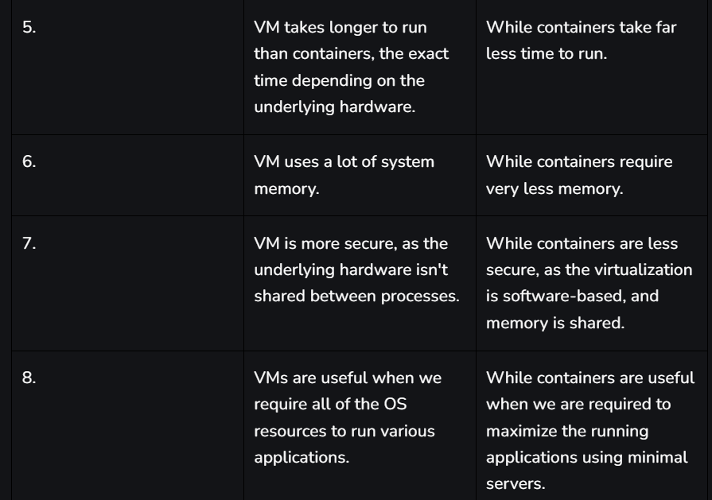

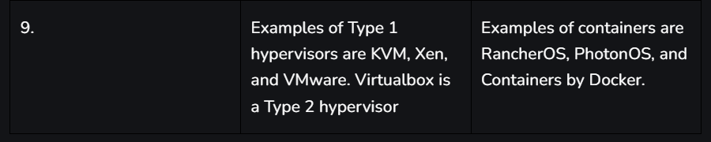

===================================================================================

1. **Docker Architecture:**

Docker follows a **client-server architecture**. The Docker client communicates with a background process, the Docker Daemon, which does the heavy lifting of building, running, and managing your containers. This communication happens over a REST API, typically via UNIX sockets on Linux (e.g., /var/run/docker.sock) or a network interface for remote management.

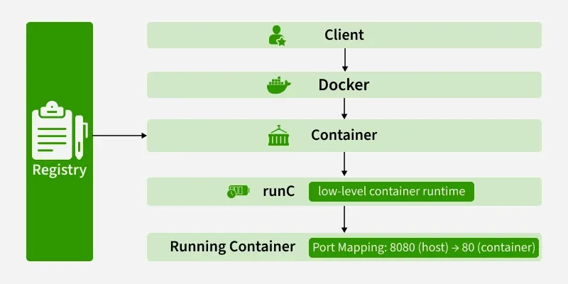

**The Core Architectural Model**

* **Docker Client:** This is your command center. When you type commands like docker run or docker build, you're using the Docker Client.
* **Docker Host:** This is the machine where the magic happens. It runs the Docker Daemon (dockerd) and provides the environment to execute and run containers.
* **Docker Registry:** This is a remote repository for storing and distributing your Docker images.

This interaction forms a simple yet powerful loop: you use the **Client** to issue commands to the **Daemon** on the **Host**, which can pull images from a **Registry** to run as containers.

**Detailed Breakdown of Core Components -**

**1. The Docker Daemon (dockerd):**

The Docker Daemon is the persistent background process that acts as the brain of your Docker installation.

* It runs on the **Docker Host**.
* It listens for API requests from the Docker Client.
* It manages all **Docker objects**: images, containers, networks, and volumes.
* It can communicate with other daemons to manage Docker services in a multi-host environment (like a Docker Swarm cluster).

**2. The Docker Client:**

The Docker Client is the primary interface through which users interact with Docker. This is most commonly the Command Line Interface (CLI).

* It translates user commands like docker ps into REST API requests.
* These requests are sent to the Docker Daemon for processing.
* A single client can communicate with multiple daemons.

**Common Commands:**

* docker build: Builds an image from a Dockerfile.
* docker pull: Pulls an image from a registry.
* docker run: Creates and starts a container from an image.

**3. The Docker Host**

The Docker Host is the physical or virtual machine that provides the complete environment for executing and running containers. It comprises:

* The Operating System (and its kernel).
* The Docker Daemon.
* Images that have been pulled or built.
* Running Containers.
* Networks and Storage components.

**4. The Docker Registry**

A Docker Registry is a stateless, scalable storage system for Docker images.

* **Public Registry:** The default public registry is **Docker Hub**, which contains a vast collection of community and official images.
* **Private Registries:** Organizations often use private registries (like Harbor, AWS ECR, or Google Artifact Registry) to store proprietary images for security and control.

**Image Lifecycle Commands:**

* docker pull <image\_name>: Downloads an image from a configured registry to your local Docker Host.
* docker push <image\_name>: Uploads a local image to a registry.

**Docker Objects:**

Whenever we are using a docker, we are creating and use images, containers, volumes, networks, and other objects. Now, we are going to discuss docker objects:-

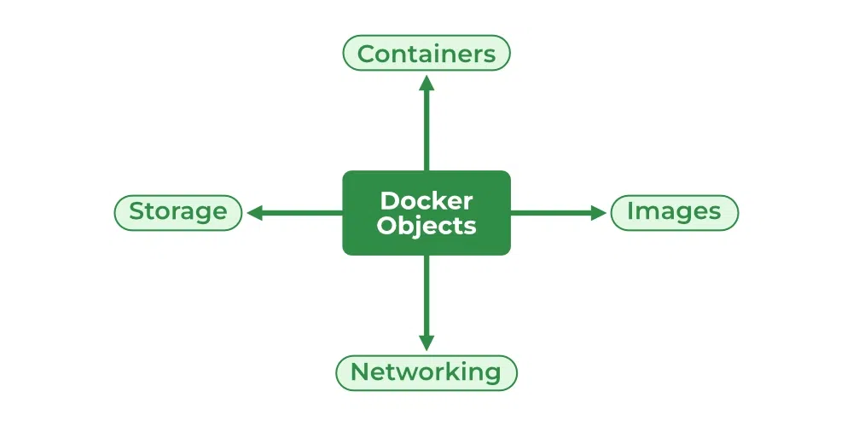

**1. Images**

An image is a read-only, inert template that contains the instructions for creating a Docker container. Think of it as a blueprint or a class in object-oriented programming.

* It's built from a Dockerfile, a simple text file defining the steps to assemble the image.
* Images are built in layers, where each instruction in the Dockerfile corresponds to a layer. This layered architecture makes builds and distribution incredibly efficient.

**2. Containers**

A container is a runnable, live instance of an image. If an image is the blueprint, a container is the house built from that blueprint.

* You can create, start, stop, move, or delete containers using the Docker API or CLI.
* Each container is isolated from other containers and the host machine, having its own filesystem, networking, and process space.
* You can run multiple containers from the same image.

**3. Storage**

Since a container's writable layer is ephemeral (data is lost when the container is deleted), Docker provides robust solutions for data persistence. [Storage driver](https://www.geeksforgeeks.org/cloud-computing/data-storage-in-docker/)controls and manages the images and containers on our docker host.

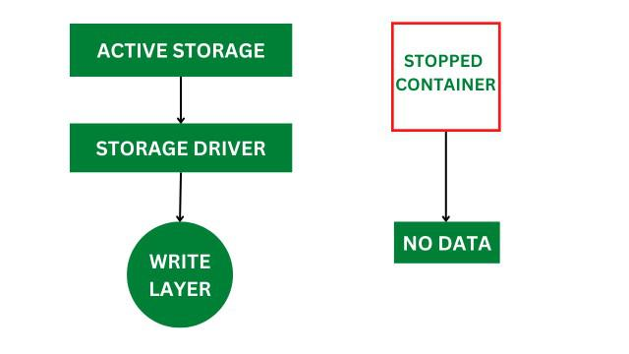

**Types of Docker Storage**

Docker provides multiple storage options to persist, share, and manage data across containers and hosts.

* **Volumes:** The preferred mechanism. Volumes are managed by Docker and stored in a dedicated area on the host filesystem (e.g., /var/lib/docker/volumes/ on Linux). They are designed to survive the container lifecycle.
* **Bind Mounts:** Allow you to map a file or directory from the host machine directly into a container. This is very useful for development, where you might want to share source code with a container.
* **tmpfs Mounts:** In-memory storage that is temporary and never written to the host filesystem. Useful for sensitive data or high-performance temporary files.

**Docker Networking**

[Docker networking](https://www.geeksforgeeks.org/devops/basics-of-docker-networking/) provides complete isolation for docker containers. It means a user can link a docker container to many networks. It requires very less OS instances to run the workload.

**Types of Docker Network**

1. **Bridge:** It is the default network driver. We can use this when different containers communicate with the same docker host.
2. **Host:**When you don't need any isolation between the container and host then it is used.
3. **Overlay:**For communication with each other, it will enable the swarm services.
4. **None:**It disables all networking.
5. **macvlan**: Assigns a unique MAC address to a container, making it appear as a physical device on your network.

Let's trace a common command to see how all these components work in harmony.

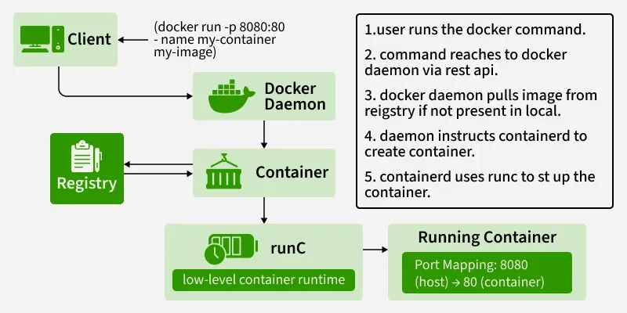

**You run the command: docker run -d -p 80:80 nginx**

1. **Client:** The Docker Client sends a REST API request to the Docker Daemon to create and run a container from the nginx image.
2. **Daemon:** The Daemon receives the request. It first checks if the nginx image exists locally on the Host.
3. **Registry (Pull):** If the image is not found locally, the Daemon contacts the configured Registry (Docker Hub by default) and pulls the nginx image.
4. **Runtime (containerd):** The Daemon hands the image and run-configuration over to containerd.
5. **Runtime (runc):** containerd uses runc to create a new container. runc interfaces with the Linux kernel to create isolated **namespaces** and limit resources with **cgroups**.
6. **Execution:** The container is started. Docker maps port 80 of the host to port 80 of the nginx container, as requested by the -p 80:80 flag. The Nginx process runs as PID 1 inside the container's isolated PID namespace.

**\*\*\*\*\*\*\*\*\*\*\*\*\*\*\*\*\*\*\*\*\*\*\*\*\*\*\*\*\*\*\*\*\*\*\*\*\*\*\*\*\*\*\*\*\*\*\*\*\*\*\*\*\*\*\*\*\*\*\*\*\*\*\*\*\*\*\*\*\*\*\*\*\*\*\*\*\*\*\*\*\*\*\*\*\*\*\*\*\*\*\*\*\*\*\*\*\*\*\*\*\*\*\*\*\*\*\*\*\*\*\*\*\*\*\*\*\*\*\*\*\*\*\*\*\*\*\*\*\*\*\*\*\*\*\*\*\*\*\*\*\*\*\*\*\*\*\*\*\*\*\*\*\*\*\*\*\*\*\*\*\*\*\*\*\*\*\*\*\*\*\*\*\*\*\*\*\*\*\*\*\*\*\*\*\*\*\*\*\*\*\*\*\*\*\*\*\*\*\*\*\*\*\*\*\*\*\*\*\*\*\*\*\*\*\*\*\*\*\*\*\*\*\*\*\*\*\*\*\*\*\*\*\*\*\*\*\*\*\*\*\*\*\*\*\*\*\*\*\*\*\*\*\*\*\*\*\*\*\*\*\*\*\*\*\*\*\*\*\*\*\*\*\*\*\*\*\*\*\*\*\*\***

**Section 2: Docker Commands:**

1. **Docker Commands:**

Docker originally used straightforward, individual commands for each task. Over time, as more features were added, this approach became harder to manage. To make the interface clearer and more structured, Docker introduced an object‑based command system, grouping commands by the type of resource they control.

This makes the CLI more organized and easier to understand, and while the old commands remain for compatibility, the newer format is recommended for ongoing use.

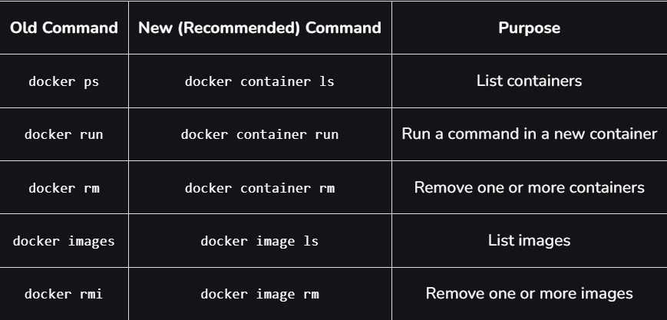

**Docker Container Run command**

This is the most fundamental command. It creates a new container from a specified image and then starts it. If the image is not found locally, Docker will automatically try to pull it first.

**$ docker container run <image\_name>**

**To give name of container**

**$ docker container run --name <container\_name> <image\_name>**

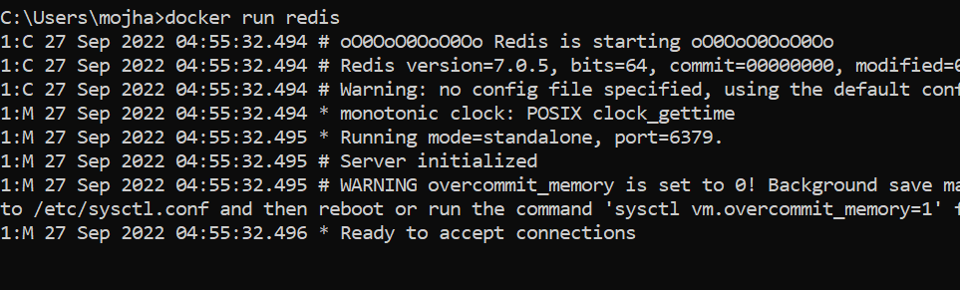

**Docker Pull**

This command allows you to pull any image which is present in the official [registry of docker](https://www.geeksforgeeks.org/devops/what-is-docker-registry/), [Docker hub](https://www.geeksforgeeks.org/devops/what-is-docker-hub/). By default, it pulls the latest image, but you can also mention the version of the image.

**$ docker pull <image\_name>**

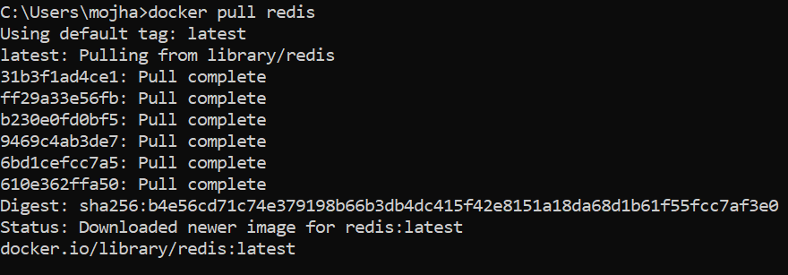

**Docker PS**

This command (by default) shows us a list of all the running containers. We can use various flags with it.

* **-a flag:** shows us all the containers, stopped or running.
* **-l flag:**shows us the latest container.
* **-q flag**: shows only the Id of the containers.

**$ docker ps [options..]**

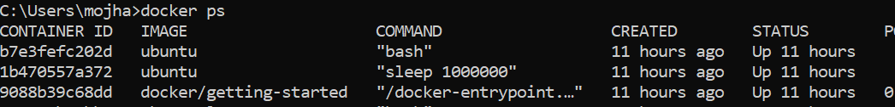

**Docker Container Stop**

This command allows you to stop a container if it has crashed or you want to switch to another one.

**$ docker container stop <container\_ID>**

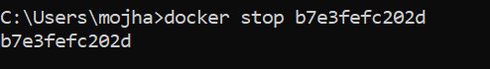

**Docker Container Start**

Suppose you want to start the stopped container again, you can do it with the help of this command.

**$ docker container start <container\_ID>**

**Docker rm**

Removes one or more **stopped** containers. You cannot remove a container that is still running; you must stop it first. You can use the docker stop <container\_name or ID> command to stop the container.

Some important flags:

* **-f flag:**remove the container forcefully.
* **-v flag:**remove the volumes.
* **-l flag:**remove the specific link mentioned.

**$ docker rm {options} <container\_name or ID>**

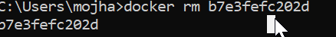

**Docker RMI**

To delete the image in docker. You can delete the images which are useless from the docker local storage so you can free up the space

**docker rmi <image ID/ image name>**

**Docker Images**

Lists all the pulled images which are present in our system.

**$ docker images**

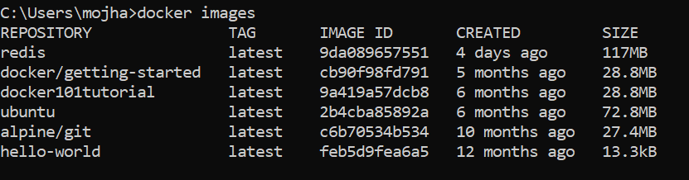

**Docker exec**

This command allows us to run new commands in a running container. This command only works until the container is running, after the container restarts, this command does not restart.

Some important flags:

* **-d flag:**for running the commands in the background.
* **-i flag:**it will keep STDIN open even when not attached.
* **-e flag:**sets the environment variables

**$ docker exec {options}**

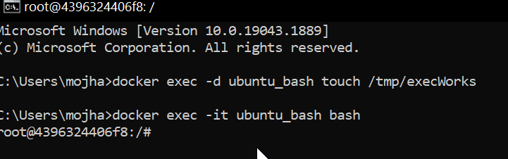

**Docker Ports (Port Mapping)**

In order to access the [docker container](https://www.geeksforgeeks.org/blogs/containerization-using-docker/) from the outside world, we have to map the port on our host( Our laptop for example), to the port on the container. This is where port mapping comes into play.

**$ docker run -d -p <port\_on\_host>**

**<port\_on\_container> Container\_name**

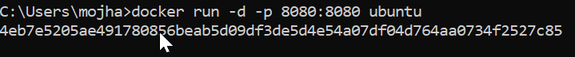

**Docker Login**

The Docker login command will help you to authenticate with the Docker hub by which you can push and pull your images.

**docker login**

It will ask you to enter the username and password after that you will authenticate with DockerHub and you can perform the tasks.

**Docker Push**

Once you build your own customized image by using Dockerfile you need to store the image in the remote registry which is DockerHub for that you need to push your image by using the following command.

**docker push <Image name/Image ID>**

**Docker Build**

The docker build command is used to build the docker images with the help of [Dockerfile.](https://www.geeksforgeeks.org/cloud-computing/what-is-dockerfile/)

**docker build -t image\_name:tag .**

In the place of **image\_name** use the name of the image you build with and give the **tag number** and **. "dot"**represents the current directory.

**Prune Command**

This is a powerful command that removes all unused Docker objects in one go. By default, it removes:

* All stopped containers.
* All Build Cache.
* All unused networks.
* All dangling images (images that are not tagged and not used by any container).

***docker system prune***

**Docker Stop**

You can stop and start the docker containers where you can do the maintenance for containers. To stop and start specific containers you can use the following commands.

**docker stop container\_name\_or\_id**

**Stop Multiple Containers**

Instead of stopping a single container. You can stop multiple containers at a time by using the following commands.

**docker stop container1 container2 container3**

**Docker Restart**

While running the containers in Docker you may face some errors and containers fails to start. You can restart the containers to resolve the containers by using the following commands.

**docker restart container\_name\_or\_id**

**Docker Inspection**

Docker containers will run into some errors in real time to debug the container's errors you can use the following commands.

**docker inspect container\_name\_or\_id**

**Docker Container Top Command**

Displays the running processes inside a container. It's like running the top command on Linux, but targeted at a specific container.

***docker container top <container\_id\_or\_name>***

**Docker Commit command**

After running the containers by using the current image you can make the updates to the containers by interacting with the containers from that containers you can create an image by using the following commands.

**docker commit container\_name\_or\_id new\_image\_name:tag**

**Docker Commands List:**

**Docker Image Command**

1. **docker build command:** It will build Docker images by using the **Dockerfile.**
2. **docker pull command:** Docker pull command will pull the **Docker image** whcih is avalible in the **dockerhub.**
3. **docker images command:**It will list all the images which are pulled and build in the docker host.
4. **docker inspect command:**It will helps to debug the docker image if any errors occurred while building an image or pulling the image.
5. **docker push command:**Docker command will push the docker image into the Dockerhub.
6. **docker save command:**It will save the docker image in the form of dockerfile.
7. **docker rmi command:**It will remove the docker image.

**Docker Container Command**

1. **docker attach command:** Connecting to an Existing Container.
2. **docker ps command:**To list the running containers.
3. **docker container inspect infinite Command:**To Inspect the Docker containers.
4. **docker exec command:**To execute the commands in the running containers.
5. **docker cp command:** To copy the file from docker host to the docker containers,

===================================================================================

1. **Running Commands Inside Docker Container:**

**Method 1: Using docker run to Start an Interactive Shell**

You can start a new container and immediately get a command prompt (like bash) inside it. This is perfect for exploring a fresh image or setting up a new environment.  
  
The command uses the -it flags:

* -i (--interactive): Keeps standard input (STDIN) open, allowing you to type commands.
* -t (--tty): Allocates a pseudo-terminal, which gives you the interactive shell experience.

**sudo docker run -it ubuntu bash**

* The above command runs an [Ubuntu](https://www.geeksforgeeks.org/linux-unix/how-to-install-ubuntu-on-virtualbox/) Container and fires up its [bash.](https://www.geeksforgeeks.org/linux-unix/bash-scripting-introduction-to-bash-and-bash-scripting/)

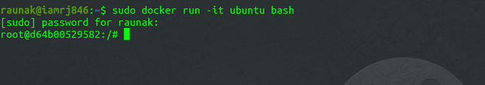

* This command downloads the ubuntu image (if not present), starts a new container from it, and opens its bash shell. Once inside, you can execute any command.

**Method 2: Using the Docker exec Command:**

* The docker exec command is used to run a command inside a container that is **already running**. This is the most common method for debugging, checking logs, or installing a package on the fly.

First, find the **Container ID** or **Name** of your running container.

**sudo docker container ls**

**(or)**

**sudo docker ps -a**



* Once you have the Container ID, you can use the [Docker **exec**](https://www.geeksforgeeks.org/devops/mastering-docker-exec/) command. But you have to confirm that the Container is running before you can execute the exec command. To start the Container, use this command.

**sudo docker container start d64b00529582**

* After that, execute the **exec**command.

**sudo docker exec -it d64b00529582 echo "GeeksforGeeks"**

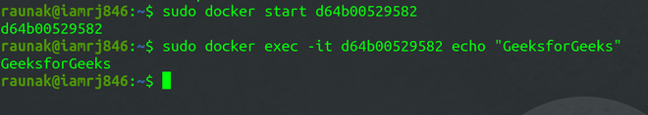

**Method 3: By using the Dockerfile**

When building a custom image, you can embed commands directly into the [*Dockerfile*.](https://www.geeksforgeeks.org/cloud-computing/what-is-dockerfile/) However, you should only include those commands inside the *Dockerfile*which you want to execute while building the Container. For executing commands on the go, you can use any of the two methods above. To execute commands through *Dockerfile*, you can specify them using the [Docker Run](https://www.geeksforgeeks.org/devops/docker-run-command/) Commands.

**FROM ubuntu:latest  
RUN echo "geeksforgeeks"**

* After you have created the above *Dockerfile*, you can build the images using the [Docker build](https://www.geeksforgeeks.org/devops/docker-build/)command.

**sudo docker build -t sample-image .**

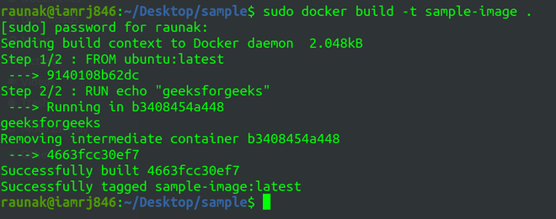

**Docker Attach Vs Docker Exec:**

**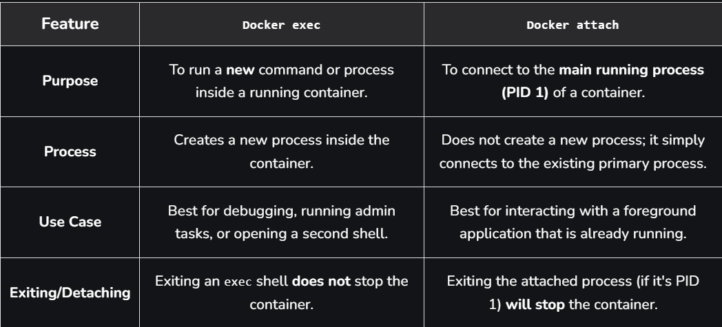**

**\*\*\*\*\*\*\*\*\*\*\*\*\*\*\*\*\*\*\*\*\*\*\*\*\*\*\*\*\*\*\*\*\*\*\*\*\*\*\*\*\*\*\*\*\*\*\*\*\*\*\*\*\*\*\*\*\*\*\*\*\*\*\*\*\*\*\*\*\*\*\*\*\*\*\*\*\*\*\*\*\*\*\*\*\*\*\*\*\*\*\*\*\*\*\*\*\*\*\*\*\*\*\*\*\*\*\*\*\*\*\*\*\*\*\*\*\*\*\*\*\*\*\*\*\*\*\*\*\*\*\*\*\*\*\*\*\*\*\*\*\*\*\*\*\*\*\*\*\*\*\*\*\*\*\*\*\*\*\*\*\*\*\*\*\*\*\*\*\*\*\*\*\*\*\*\*\*\*\*\*\*\*\*\*\*\*\*\*\*\*\*\*\*\*\*\*\*\*\*\*\*\*\*\*\*\*\*\*\*\*\*\*\*\*\*\*\*\*\*\*\*\*\*\*\*\*\*\*\*\*\*\*\*\*\*\*\*\*\*\*\*\*\*\*\*\*\*\*\*\*\*\*\*\*\*\*\*\*\*\*\*\*\*\*\*\*\*\*\*\*\*\*\*\*\*\*\*\*\*\*\*\***

**Section 3: Dockerfile and Images:**

1. **Dockerfile Syntax:**

A Dockerfile is a plain-text script that lists ordered instructions the Docker builder runs to assemble an image and automate creating containers. Each instruction appears on its own line with any arguments after it, and the builder executes lines in order to produce a layered, reproducible image.

The general syntax rules are:

* Instruction keywords come first (e.g., FROM, RUN) and are uppercase by convention but case-insensitive.
* Arguments appear on the same line as their instruction.
* Comments begin with # and are ignored by the builder.
* Each instruction creates a new image layer, so order and grouping affect image size and cache behavior.
* The build context is sent with the build; use a .dockerignore to exclude files and speed builds.

**Dockerfile Instructions:**

Dockerfile instructions are the ordered commands written in a Dockerfile that tell the Docker builder how to assemble an image and how the resulting container should run.

**1. FROM**

A FROM statement defines which image to download and start from. It must be the first command in your Dockerfile. A Dockerfile can have multiple FROM statements which means the Dockerfile produces more than one image.

**Example:**

FROM java: 8

**2. MAINTAINER**

This statement is a kind of documentation, which defines the author who is creating this Dockerfile or who should you contact if it has bugs.

**Example:**

MAINTAINER Firstname Lastname <example@geeksforgeeks.com>

**3. RUN**

The RUN statement defines running a command through the shell, waiting for it to finish, and saving the result. It tells what process will be running inside the container at the run time.

**Example:**

RUN unzip install.zip /opt/install  
RUN echo hello

**4. ADD**

If we define to add some files, ADD statement is used. It basically gives instructions to copy new files, directories, or remote file URLs and then adds them to the filesystem of the image.  
To sum up it can add local files, contents of tar archives as well as URLs.

**Example:**

Local Files: ADD run.sh /run.sh  
 Tar Archives: ADD project.tar.gz /install/  
 URLs: ADD https://project.example-gfg.com/downloads/1.0/testingproject.rpm/test

**5. ENV**

ENV statement sets the environment variables both during the build and when running the result. It can be used in the Dockerfile and any scripts it calls. It can be used in the Dockerfile as well as any scripts that the Dockerfile calls. These are also persistent with the container and can be referred to at any moment.

**Example:**

ENV URL\_POST=production.example-gfg.com

**6. ENTRYPOINT**

It specifies the starting of the expression to use when starting your container. Simply ENTRYPOINT specifies the start of the command to run. If your container acts as a command-line program, you can use ENTRYPOINT.

**Example:**

ENTRYPOINT ["/start.sh"]

**7. CMD**

CMD specifies the whole command to run. We can say CMD is the default argument passed into the ENTRYPOINT. The main purpose of the CMD command is to launch the software required in a container.

**Example:**

CMD ["program-foreground"]  
CMD ["executable", "program1", "program2"]

**Note:** If you have both ENVIRONMENT and CMD, they are combined together.

**8. EXPOSE**

EXPOSE statement maps a port into the container. The ports can be TCP or UDP but by default, it is TCP.

**Example:**

EXPOSE 3030

**9. VOLUME**

The VOLUME statement defines shared volumes or ephemeral volumes depending upon whether you have one or two arguments.

**Example:**

1. If you have two arguments, it maps a host path into a container path.  
 VOLUME ["/host/path" "/container/path/"]  
2. If you have one arguments, it creates a volume that can be inherited by the later containers.  
 VOLUME ["/shared-data"]

**10. WORKDIR**

As the name suggests, WORKDIR sets the directory that the container starts in. Its main purpose is to set the working directory for all future Dockerfile commands.

**Example:**

WORKDIR /directory-name

**11. USER**

It sets which user's container will run as. This can be useful if you have shared network directories involved that assume a fixed username or a fixed user number.

**Example:**

USER geeksforgeeks  
USER 4000

**12. ARG**

A variable that can be provided at build time is defined by an ARG Instruction. Once it has been specified in the Dockerfile, you can specify it using the --build-arg switch when creating the image. The Dockerfile supports multiple ARG instructions. The only instruction in the Dockerfile that can come before the FROM instruction is ARG.

*After the image is created, ARG values are not accessible. An ARG variable value won't be accessible to a running container.*

**Example**

ARG image\_name=latest  
FROM centos:$image\_name  
docker build -t <image-name>:<tag> --build-arg image\_name=centos8 .

**Best practices for writing Dockerfiles**

1. As a base image, use official images. And whenever it is possible, use Alpine images as a base image.
2. Don't copy unnecessary files and folders or install/use unnecessary packages of software.
3. Running a container process as root is not recommended. As a non-root user, launch the application container process.
4. Reduce the number of image layers as much as you can.
5. Wherever possible, try to use multi-stage Docker files to reduce the size of the image.

**Creating a New Dockerfile for Maven:**

#Using offical maven image as a parent image

FROM maven:3.5-jdk-8-alpine as build

#Setting the working directory to /app

WORKDIR /app

#Copy the current directory contents into the container at current directory

COPY . .

#Install the mvn command for maven

RUN mvn install

By using the above Dockerfile we can build an image of Maven we are setting a Maven alpine image as a base image with the help of FROM command and with the help of WORKDIR setting the working directory for Maven and copy the required files and folders to maven we are using the COPY command and RUN command can download the required commands in the image we are downloading mvn command.

===================================================================================

1. **Docker File:**

A Dockerfile is a simple text file that contains a script of instructions for building a Docker image. Think of it as a recipe for creating your application's environment. The Docker engine reads this file and executes the commands in order, layer by layer, to assemble a final, runnable image.

This automated process is the foundation of containerization's power, ensuring that your application runs the same way everywhere—from your local machine to a production server.



* Docker Image: This is a lightweight, standalone, executable package that includes everything needed to run a piece of software: the code, runtime, system tools, libraries, and settings. It's the blueprint or the "cake" made from the Dockerfile recipe.
* Docker Container: This is a running instance of an image. You can create, start, stop, and delete containers. If the image is the cake, a container is a slice of that cake that you are actively using.

**Dockerfile Instructions:**

Each instruction plays a specific role in building images, from defining the base system to copying files, running scripts, and setting container.

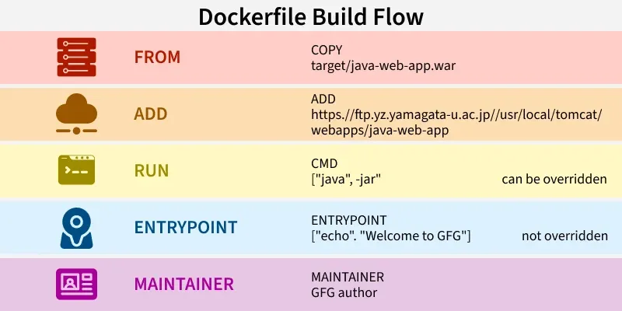

**Example 1: Create Dockerfile With Example (Jenkins)**

**Step 1:**Open Docker and create a file with the name **Dockerfile.**

**Step 2:**Open the Dockerfile by using the vi editor and start writing the command that is required to build the Jenkins image.

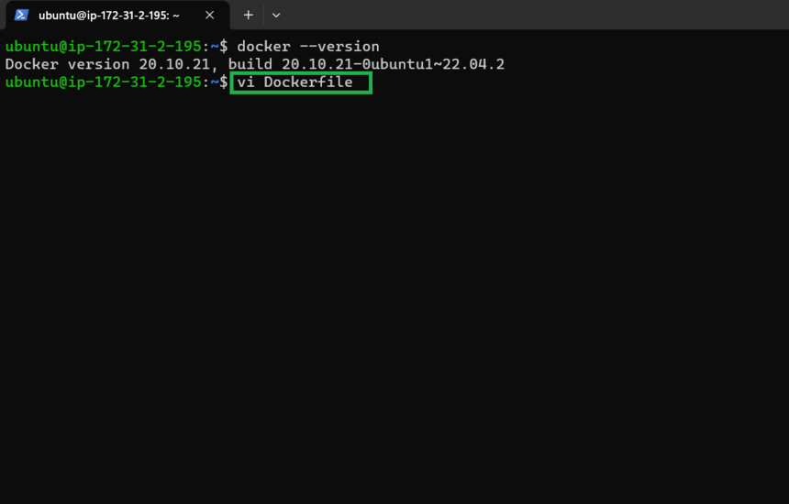

**Dockerfile for Jenkins image**

We used [JDK](https://www.geeksforgeeks.org/java/jdk-in-java/) as a base image because Jenkins's pre-requisite is JDK after that we added a command called**MAINTAINER** which indicates the author or owner of the docker file and we added the**ENV**variable where we set the path for the Jenkins and by using **RUN**command we are creating the path and by using **ADD** we are downloading the Jenkins and starting the **.war**file with the help of **CMD**command.

**DockerFile:**

**FROM openjdk:11-jdk**

**MAINTAINER GFG author**

**LABEL env=production**

**ENV apparea /data/app**

**RUN mkdir -p $apparea**

**ADD** [**https://ftp.yz.yamagata-u.ac.jp/pub/misc/jenkins/war/2.397/jenkins.war**](https://ftp.yz.yamagata-u.ac.jp/pub/misc/jenkins/war/2.397/jenkins.war) **$apparea**

**WORKDIR $apparea**

**EXPOSE 8080**

**CMD ["java","-jar","jenkins.war"]**

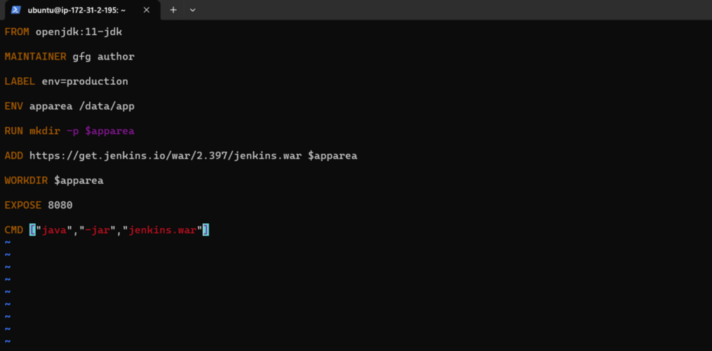

**Step 3:** Build the image by using the below command with the help of Dockerfile and give the necessary tags. and the dot(.) represents the current directory which is a path for Dockerfile.

docker build -t jenkins:1 .

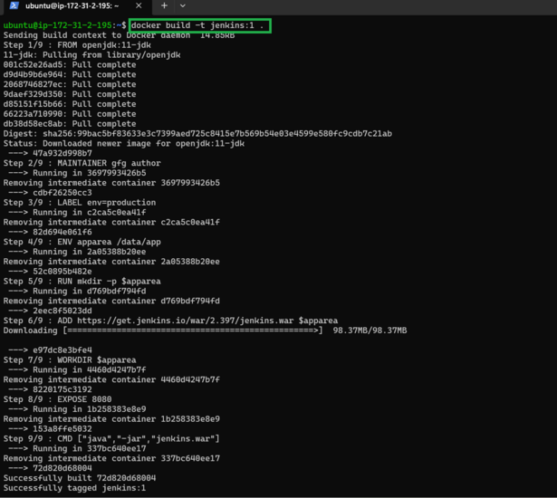

**Step 4:** Run the container with the help image ID or tag of the image by using the below command.

docker run -d -p 8080:8080 <Imagetag/ID>

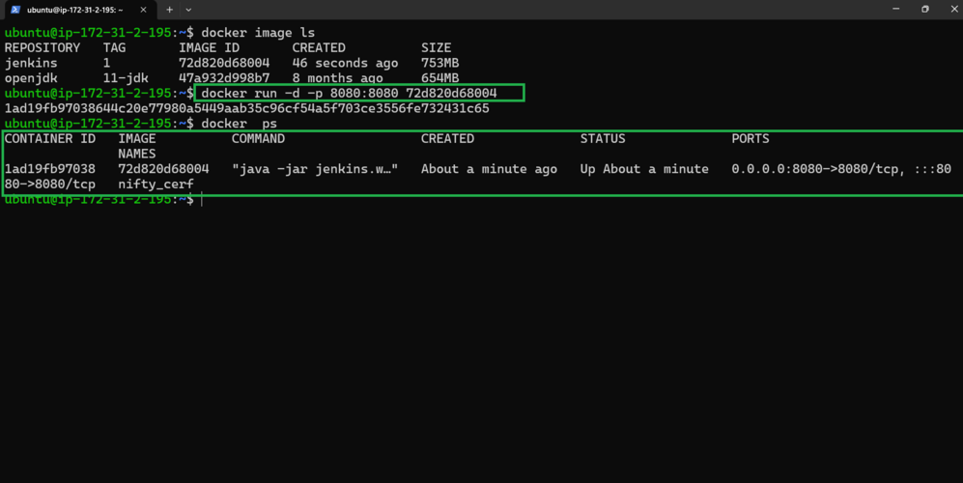

**Step 5:** Accesses the application ([Jenkins](https://www.geeksforgeeks.org/devops/what-is-jenkins/)) from the internet with the help of host port and hostIP (HostIP: Port)

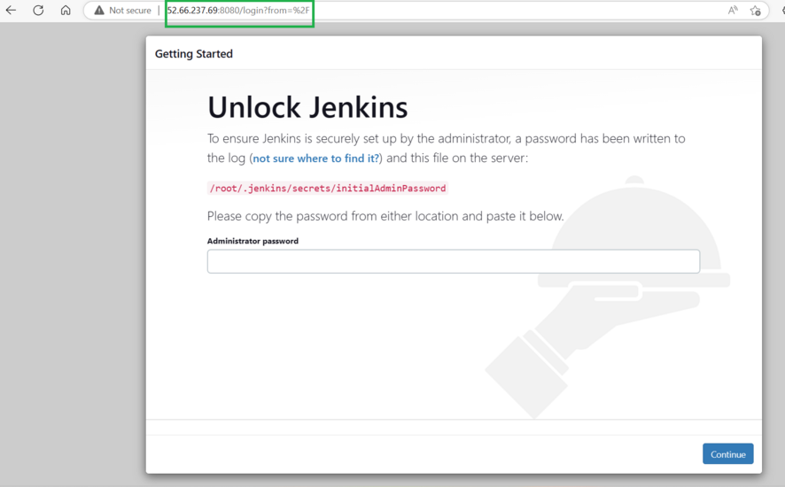

**Trouble Shooting of Dockerfile Issues**

The following are the some of the trouble shooting of Dockerfile Issues:

* **Check Build Logs**: Review the build logs for identifying the error through error messages and with log details. It helps in with providing the valuable information.
* **Validate Syntax and Instructions:** It helps in ensring the dockerfile syntax and the instructions are in the proper order, It helps in addressing the common issues including the missing commands or in correct parameters.
* **Optim**i**ze Layer Caching:**Try to verify whether the caching is using effectively. Through reordering the instructions we can reduce the changes in frequently modified layers to speed up the build process.
* **Dependency Management:**Through ensuring all the dependencies correctly placing as accessable, we can avoid the build failures.

**Dockerfile Vs Docker Compose:**

**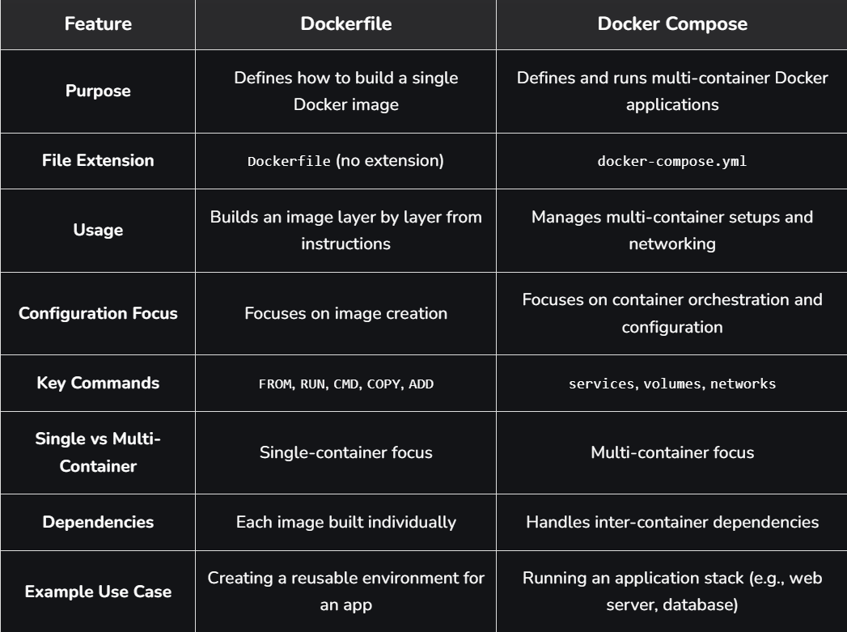**

**==================================================================================**

1. **Docker Image:**

A Docker Image is a lightweight, standalone, and executable software package that includes everything needed to run an application: the code, a runtime, system tools, libraries, and settings.

The docker image includes the following to run a piece of software. A docker image is a platform-independent image that can be built in the Windows environment and it can be pushed to the docker hub and pulled by others with different OS environments like Linux.

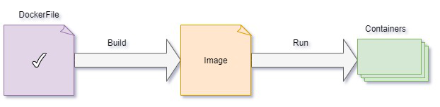

If a Dockerfile is the **recipe**, then a Docker Image is the **perfectly packaged, ready-to-use meal** created from that recipe. This package is completely portable, meaning it will run the exact same way on your laptop, a teammate's computer, or a production server.

**The Anatomy of a Docker Image**

A Docker image isn't one large, monolithic file. It's cleverly constructed from a series of layers and stored in a registry.

**Layers**

An image is composed of a stack of **read-only layers**. Each instruction in a Dockerfile (like FROM, COPY, RUN) creates a new layer on top of the previous one.

* **Efficiency:** When you change an instruction in your Dockerfile, Docker only rebuilds that specific layer and the ones that follow it. This makes builds incredibly fast.
* **Sharing:** If multiple images share the same base layers (e.g., they all start with FROM ubuntu:22.04), those layers are only stored once on your system.

**Base Image**

This is the foundational layer of your image, specified by the FROM instruction in a Dockerfile. It can be a minimal operating system like alpine, a programming language runtime like python:3.9-slim, or an application like nginx.

**Docker Registries**

A **Docker Registry** is a storage and distribution system for Docker images. It's a library where you can pull official images, find images shared by the community, and push your own.

* **Docker Hub:** The default public registry and the largest library of container images.
* **Private Registries:** Companies often use private registries (like Amazon ECR, Google Artifact Registry, or Docker Hub private repos) to store their proprietary application images securely.

**Commands Related to Docker Image Operations:**

**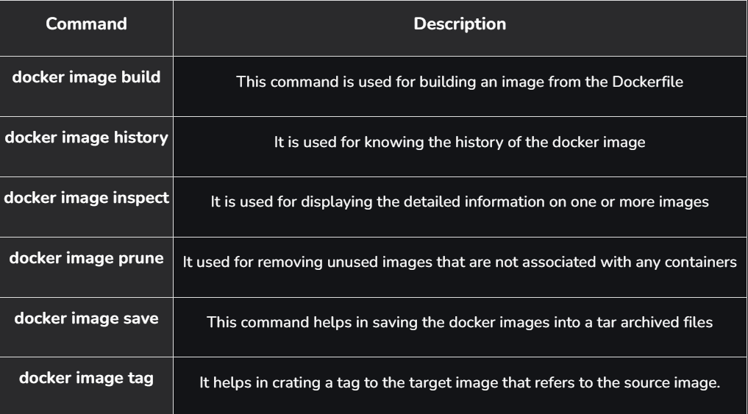**

**Docker Image Prune**

Docker image prune is a command used in the docker host to remove the images that are not used or Docker image prune command is used to remove the unused docker images.

**docker image prune**

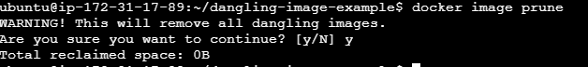

All the unused images are also know as dangling images which re not associated with any containers

**Docker Image Build**

The Following is the command which is used to build the docker image.

**docker build -t your\_image\_name:tag -f path/to/Dockerfile**

**Docker build:**Initiates the build process.

**-t your\_image\_name:tag:** Gives the image you're creating a name and, if desired, a tag**.**

**path/to/Dockerfile . : G**ives the location of the Dockerfile. Give the right path if it's not in the current directory. "(.) DOT" represents the current wordir.

**Docker Image Tag**

Docker tags are labels for container images, used to differentiate versions and variants of an image during development and deployment. Docker tags will help you identify the various versions of docker images and help distinguish between them. Docker image will help us to build continuous deployment very quickly

**Structure Of Docker Image**

The layers of software that make up a Docker image make it easier to configure the dependencies needed to execute the container.

* **Base Image:** The basic image will be the starting point for the majority of Dockerfiles, and it can be made from scratch.
* **Parent Image:**The parent image is the image that our image is based on. We can refer to the parent image in the Dockerfile using the **FROM** command, and each declaration after that affects the parent image.
* **Layers:**Docker images have numerous layers. To create a sequence of intermediary images, each layer is created on top of the one before it.

**Create A Docker Image And Run It As Container:**

**Step 1:**Create a Dockerfile.

**Step 2:**Run the following command in the terminal and it will create a docker image of the application and download all the necessary dependencies needed for the application to run successfully.

**docker build -t <name>:<tag>**

This will start building the image.

**Step 3:**We have successfully created a [Dockerfile](https://www.geeksforgeeks.org/cloud-computing/what-is-dockerfile/) and a respective Docker image for the same.

**Step 4:**Run the following command in the terminal and it will create a running container with all the needed dependencies and start the application.

**docker run -p 9000:80 <image-name>:<tag>**

The 9000 is the port we want to access our application on. 80 is the port the container is exposing for the host to access.

**How to Build Docker Python Images:**

**Step 1: Create A Dockerfile**

Firstly write a dockerfile for supporting python applications and try to python application running instruction with the CMD options for the default run. The following is the sample dockerfile that we are using here:

**Docker File Content:**

# Use the official Python image as a base

FROM python:3.9-slim

# Set the working directory in the container

WORKDIR /app

# Copy the current directory contents into the container at /app

COPY . /app

# Install any needed dependencies specified in requirements.txt

RUN pip install --no-cache-dir -r requirements.txt

# Make port 80 available to the world outside this container

EXPOSE 80

# Define environment variable

ENV NAME World

# Run app.py when the container launches

CMD ["python", "app.py"]

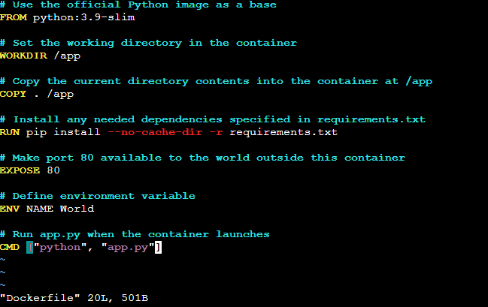

**Step 2: Create requirements.txt and app.py Files**

* Try on provide the requirements.txt with specifying the names of required software names and app.py file with writing the python application. The following are the sample code of those requirements.txt and app.py.

Filename:**requirements.txt** **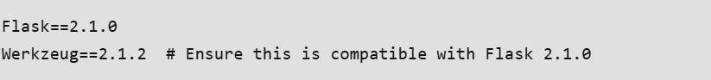**

Filename:**app.py**

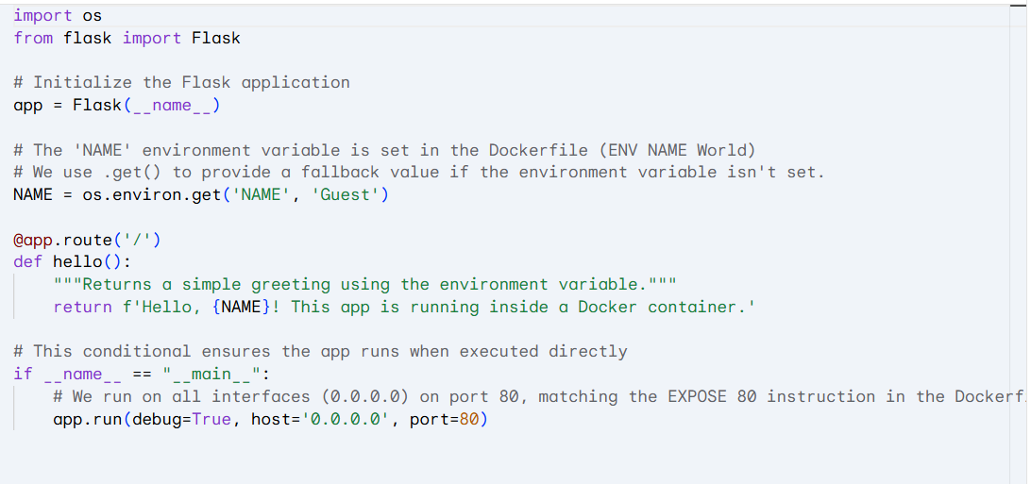

**Step 3: Build a Docker Image**

docker image build -t mypython-app:v1 .

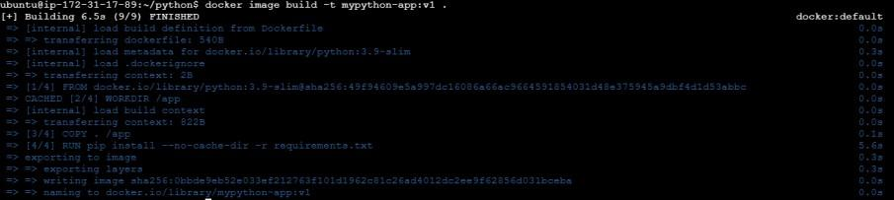 **Step 4: Verify the Docker Image**

docker images

The following screenshot shows the success build of python based docker image.



**Step 5: Run a Python based Docker Container**

docker run -dit -p 80:80 --name mycontainer1 mypython-app:v1



**Step 6: Access the Docker Container**

* Now, try on access the docker container with public IP of the host system with the exposed port to see the successful run of the containerized python application. The following screenshot illustrates the successful accessing of it.



**Docker Image commands:**

**docker images** - List Docker Images

**docker image pull** **<image-name>** - Pull a Docker Image From a Registry

**docker image prune** - Docker Images Prune

**docker image ls -f "reference=mypython-app"** - Docker Images Filter

**docker rmi <id-of-image>** - Remove an Image from Docker

**docker search ubuntu** - Searching for a specific image on Docker Hub

**Troubleshooting Common Issues Related to Docker Images:**

The following are the some of the troubleshooting common issues related to docker images:

* **Large Image Sizes:**Use multi-stage builds and clean up unnecessary files to reduce image size.
* **Dependency Conflicts:** Ensure compatibility by specifying exact versions of dependencies in the Dockerfile.
* **Build Failures:**Check Dockerfile syntax and command correctness, and verify all required files are included.
* **Slow Performance:** Optimize Dockerfile instructions order and leverage caching to improve build times.

===================================================================================

1. **How To Optimize Docker Image ?**

Optimizing Docker images is crucial for building efficient and secure applications. The primary benefits include:

* **Faster Deployment:** Smaller images take less time to pull from a registry and deploy, significantly speeding up CI/CD pipelines and scaling operations.
* **Reduced Resource Consumption:** Optimized images consume less disk space on host machines and in container registries, lowering storage costs and reducing network bandwidth usage.
* **Enhanced Security:** By removing unnecessary files, tools, and dependencies, you reduce the image's attack surface, making it less vulnerable to security exploits.
* **Improved Scalability:** Lighter images allow container orchestration platforms like Kubernetes to launch new container instances more quickly, enabling applications to scale efficiently in response to demand

**How do I optimize Docker images?**

Image minimization without loosing functionality is possible using [Docker image optimization.](https://www.geeksforgeeks.org/devops/how-to-use-dockerfile-best-practices-for-efficient-image-building/) To optimize images for Docker, use the following techniques. Many commands and techniques, including the following, can be utilized to optimize a Docker image:

1. **Minimize the Number of Layers:**

Minimize the number of levels in your [Dockerfile](https://www.geeksforgeeks.org/cloud-computing/what-is-dockerfile/) by combining instructions into a single RUN directive for related instructions. Each instruction in a Dockerfile **(like RUN, COPY, ADD)**creates a new layer in the image. To reduce image size and improve build performance, consolidate related commands into a single RUN instruction using the && operator.

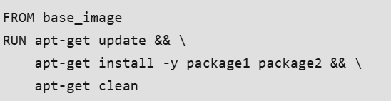

1. **Use Minimal Base Images:**

Always start with the smallest, most appropriate base image for your application. Using a full-featured OS image like ubuntu can add hundreds of megabytes of unnecessary files. Instead, opt for minimal images like alpine, distroless, or slim variants of official images.

* **Alpine Linux** is a popular choice due to its incredibly small size (around 5-7 MB).

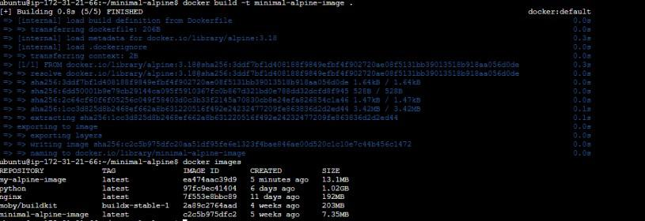

**Example:**  
FROM alpine:latest

1. **Use Docker Multistage Builds**

For speeding up the image building process, use Docker's multi-stage builds, that separate build needs from the final running environment. Multistage builds are a powerful feature for creating lean production images. They allow you to use one container image with a full build environment (the "builder" stage) to compile your code or build assets, and then copy only the necessary artifacts into a separate, minimal production image.

This separates build-time dependencies (like compilers, and development libraries) from runtime dependencies, drastically reducing the final image size.

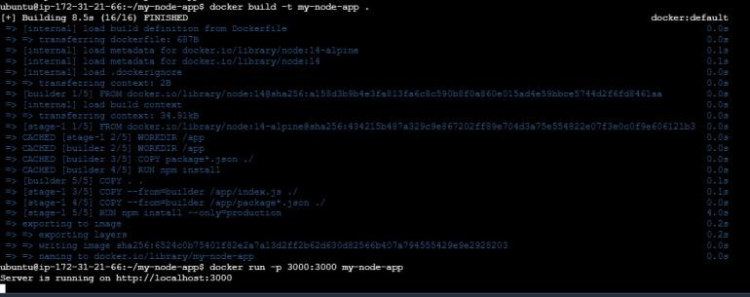

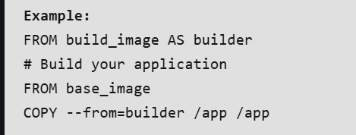

1. **Remove unnecessary files & Clean up Layers**

After installing packages, always clean up caches and temporary files within the *same* RUN instruction. If you create a cleanup instruction in a new layer, the previous layer containing the unnecessary files will still be part of the image, and the size won't be reduced.

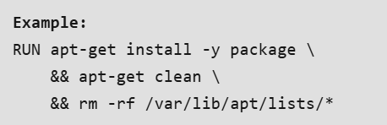

1. **Use Dockerignore:**

A **.dockerignore**file prevents unnecessary files and directories from being sent to the Docker daemon during the build process. This is crucial for avoiding the inclusion of local development files, logs, and build artifacts (node\_modules, .git directory, etc.), which can unintentionally increase image size and pose security risks.

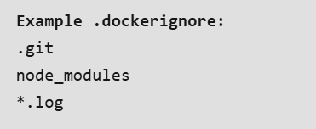

1. **Docker Build Arguments:**

Use ARG to pass variables to the Docker build process. This allows for more flexible and reusable Dockerfiles, enabling you to customize builds for different environments (e.g., development vs. production) without altering the Dockerfile itself.

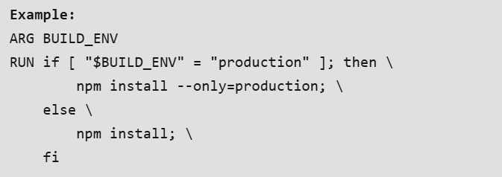

1. **Update Base Images:**

Regularly update your base images to ensure you have the latest security patches and performance improvements. Specify a version tag (e.g., node:18-alpine) instead of latest to ensure your builds are predictable and reproducible. Periodically pull the latest version of your chosen tag and rebuild your images.

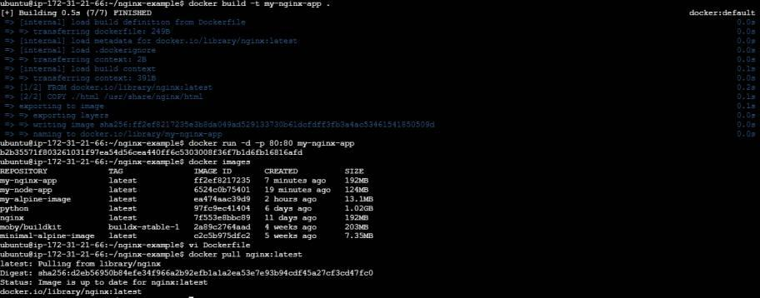

**Example:**  
docker pull base\_image:latest

**Docker Image Optimization Tools**

The top three instruments for docker image optimization are presented here.

* **Docker Slim**: Reduces the size of your Docker image by removing unnecessary dependencies and files after inspection.
* **Dive**: Assists in recognizing chances for decreasing size through the elimination of superfluous or redundant layers through analyzing and visualizing a Docker image's layer design.
* **Hadolint**: A Dockerfile linter that examines Dockerfiles for possible problems and best practices, allowing simplify build operations.

===================================================================================

1. **Docker Container:**

Docker is a set of platforms as a service (PaaS) products that use Operating system-level virtualization to deliver software in packages called containers. Containers are isolated from one another and bundle their own software, libraries, and configuration files; they can communicate with each other through well-defined channels. All containers are run by a single operating system kernel and therefore use fewer resources than a virtual machine.

**What Is Docker?**

[Docker](https://www.geeksforgeeks.org/devops/introduction-to-docker/)is a containerization platform that allows you to package code and dependencies into a [Docker image](https://www.geeksforgeeks.org/devops/what-is-docker-image/)that can be run on any machine. Docker allows your application to be separated from your infrastructure. The image that you created is portable, so you can run it on any machine that has Docker installed. To know how to install Docker refers to [How to Install Docker.](https://www.geeksforgeeks.org/cloud-computing/how-to-install-docker-on-windows/)

**What Are Containers?**

Containers are lightweight piece of software that contains all the code, libraries, and dependencies that the application needs to run. Containers do not have their own operating system, they get resources from the host operating system. Because they do not have an operating system of their own they are lightweight. They are also easily portable as they contain all the libraries and the dependencies to run the application.

**What Are Shells?**

Shell is a program that is responsible for executing the command provided in the command prompt. It breaks down the command into smaller units called tokens and then executes them. It is an interface between the operating system and the user. The command prompt takes input from the user and gives it to the shell to execute it and the shell then returns the response to be displayed on the command prompt.

**==================================================================================**

1. **Difference between Docker Image and Container:**

**What is Docker Image?**

The concept of Image and Container is like class and object, in which an object is an instance of a class, and a class is the blueprint of the object. Images are different in Virtual Machines and dockers. In virtual machines, images are just snapshots of running virtual machines at different points in time, but Docker images are a little bit different. The most important and major difference is that Docker images are immutable. That is they can not be changed. In the real world, it happens a lot that software works on one computer but it does not work on others due to different environments. This issue is completely solved by docker images and using this, the application will work the same on everyone’s PC. Every developer on a team will have the exact same development instance. Each testing instance is exactly the same as the development instance. Your production instance is exactly the same as the testing instance. Also, developers around the world can share their Docker images on a platform called DockerHUB.

**What is Docker Container?**

They are actually Docker Virtual Machines but are commonly called Docker Containers. If a Docker image is a map of the house, then a Docker container is an actually built house, or in other words, we can call it an instance of an image. As per the official website, a container is a runnable instance of an image. You can create, start, stop, move, or delete a container using Docker API or CLI. You can connect a container to one or more networks, attach storage to it, or even create a new image based on its current state. An application runs using a cluster of containers that are self-isolated from one another and also from the host machine where they are running.

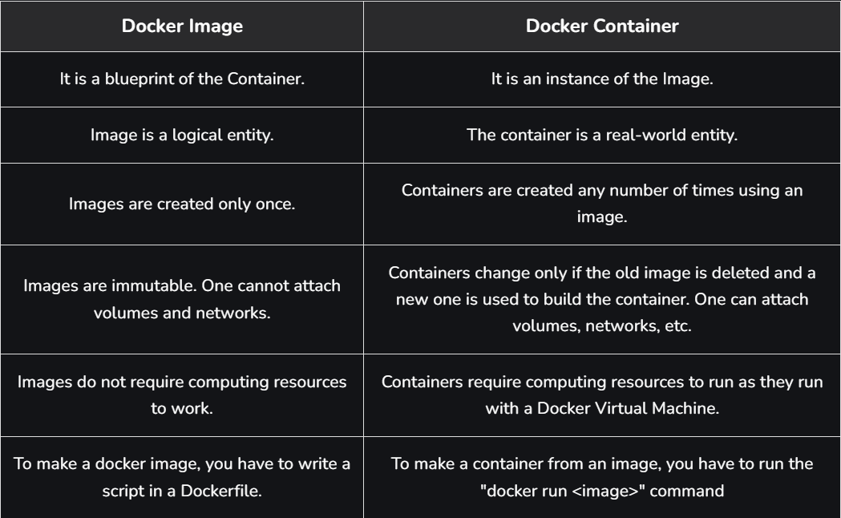

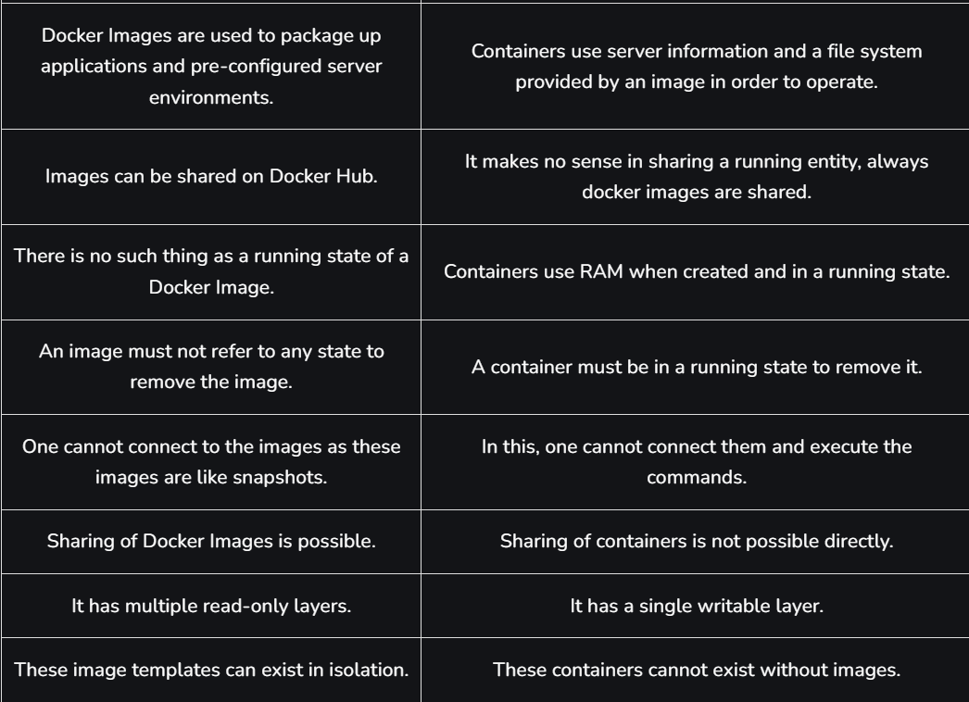

**Difference between Docker Container and VM Image:**

**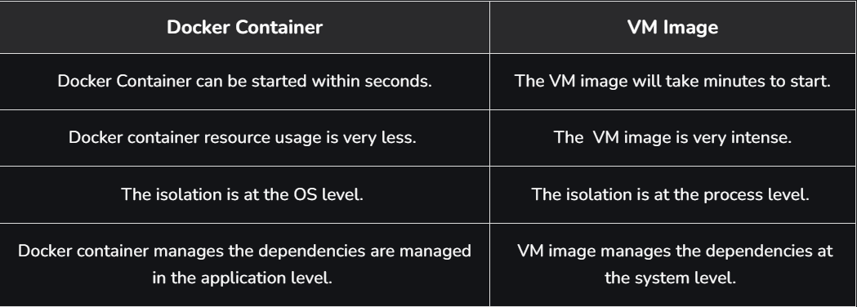**

**==================================================================================**

1. **How to Build a Web Server Docker File?**

**Step 1:** The first step is to build our Docker file for which you can use vim editor.

**vim Dockerfile**

**Note:-**Name of the file has to be "Dockerfile"

Write the below information into the Docker file,

FROM ubuntu

ENV DEBIAN\_FRONTEND=noninteractive

RUN apt-get update

RUN apt-get install apache2 -y

RUN apt-get install apache2-utils -y

RUN apt-get clean

EXPOSE 80

CMD ["apache2ctl","-D","FOREGROUND"]

**Description of the** **above commands**

* Ubuntu is our base image in which we are launching our server.
* In the second line, is to set a non-interactive environment.
* In the third line, the apt-get update command is used to update all the packages on Ubuntu.
* In the fourth line, we are installing apache2 on our image.
* In the fifth line, we are installing all the necessary utility Apache packages.
* In the sixth line, the apt-get clean command cleans all the unnecessary files from the system.
* In the seventh line, the EXPOSE command is used to expose the port 80 of Apache in the container.
* The last command is used to run apache2 in the background.

**Step 2:** Next step is to build the docker file by using the docker build command.

docker build -t="mywebserver"

Command:

**-t:** this option is to tag the image, mywebserver is the tag to our image.

**Step 3:**

The web server file has built, the next step is to create a container from the image for that we use the docker run command.

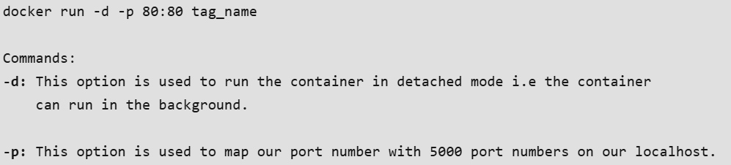

If you go to your web browser and write localhost\_ip:80 your Apache server is up and running on that port.

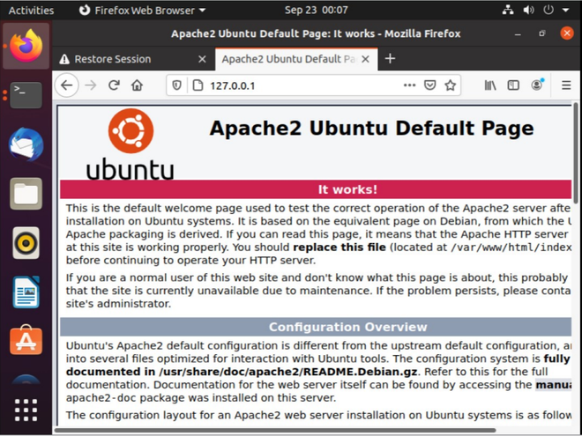

\*\*\*\*\*\*\*\*\*\*\*\*\*\*\*\*\*\*\*\*\*\*\*\*\*\*\*\*\*\*\*\*\*\*\*\*\*\*\*\*\*\*\*\*\*\*\*\*\*\*\*\*\*\*\*\*\*\*\*\*\*\*\*\*\*\*\*\*\*\*\*\*\*\*\*\*\*\*\*\*\*\*\*\*\*\*\*\*\*\*\*\*\*\*\*\*\*\*\*\*\*\*\*\*\*\*\*\*\*\*\*\*\*\*\*\*\*\*\*\*\*\*\*\*\*\*\*\*\*\*\*\*\*\*\*\*\*\*\*\*\*\*\*\*\*\*\*\*\*\*\*\*\*\*\*\*\*\*\*\*\*\*\*\*\*\*\*\*\*\*\*\*\*\*\*\*\*\*\*\*\*\*\*\*\*\*\*\*\*\*\*\*\*\*\*\*\*\*\*\*\*\*\*\*\*\*\*\*\*\*\*\*\*\*\*\*\*\*\*\*\*\*\*\*\*\*\*\*\*\*\*\*\*\*\*\*\*\*\*\*\*\*\*\*\*\*\*\*\*\*\*\*\*\*\*\*\*\*\*\*\*\*\*\*\*\*\*\*\*\*\*\*\*\*\*\*\*\*\*\*\*\*

**Section 4: Docker Hub:**

1. **Docker Hub:**

Docker Hub is a cloud-based repository service where developers and teams can push (upload) and pull (download) Docker container images anytime via the internet.

* It allows images to be stored as public or private, acting like centralized storage that ensures accessibility and version control.
* Developers can create Docker images with all dependencies included, push them to Docker Hub, and make them available for testing or deployment.
* The testing team can directly pull the same image, eliminating the need for additional files, software, or plugins, since the image already contains everything required to run.
* This workflow makes project sharing seamless, consistent, and efficient, which is why enterprises are rapidly adopting Docker as part of their development and deployment pipelines.

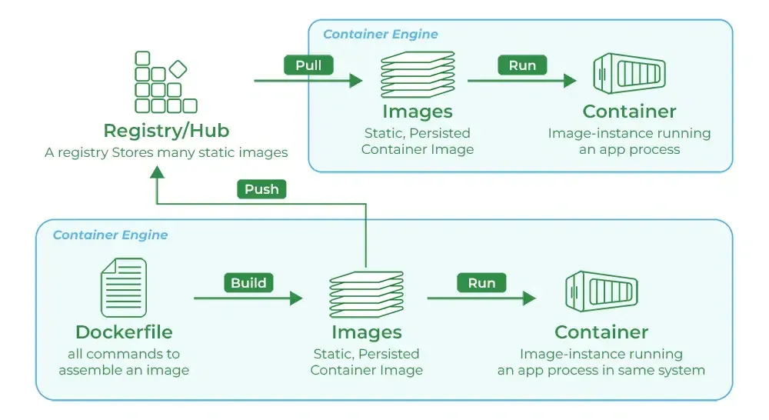

**Creating Repository in Docker Hub**

**Step 1:**Firstly navigate to the Dockerhub and sign in with your credentials and then select Create Repository.

**Step 2:**After that, we will be taken to a screen for configuring the repository, where we must choose the namespace, repository name, and optional description.

* In the visibility area, as indicated in the picture, there are two options: Public and Private. We can choose any of them depending on the type of organization you are in.
* If you chose Public, everyone will be able to push-pull and use the image because it will be accessible to everyone. If you select the private option, only those with access to that image can view and utilize it. it.

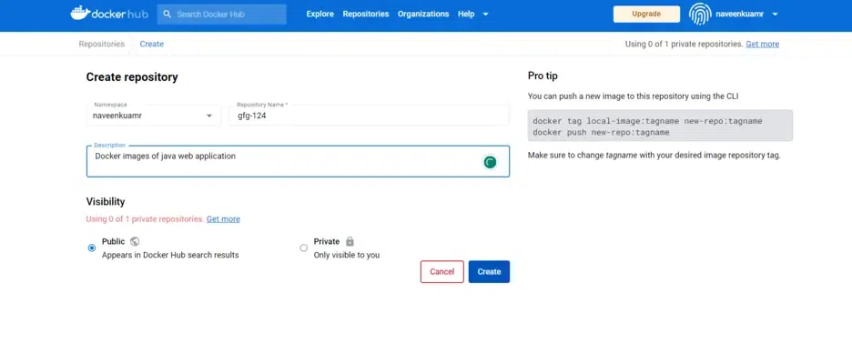

**Step 3:**At finally repository is created with the help of the [Docker Commands](https://www.geeksforgeeks.org/devops/docker-instruction-commands/) we can push or pull the image. The following command is used for pushing the docker image that exists in local to the Dockerhub.

docker push <your-username>/my-testprivate-repo>.

**Push Docker Images to Docker Hub:**

**Step 1:**Open Docker in your system. Locate the Images that you want to push using the below command:

**docker images**

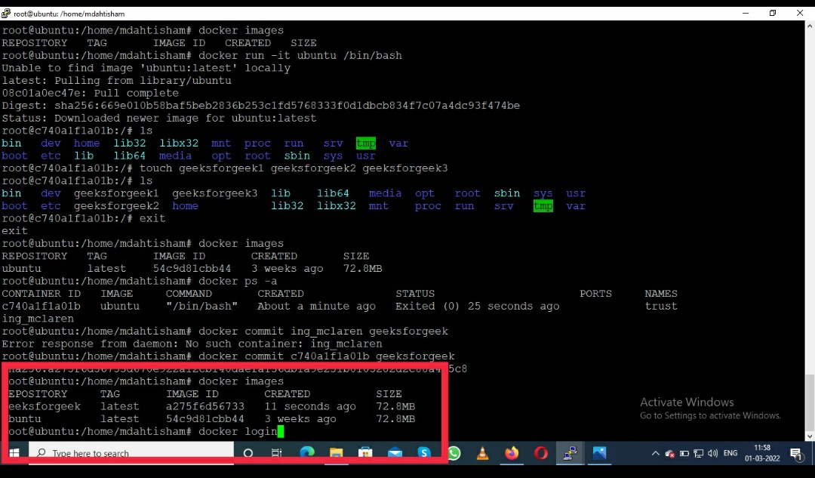

**Step 2:**Go to the browser and search *hub.docker.com.*

**Step 3:**Sign up on the docker hub if you do not have a docker hub account, after login on to docker hub.

**Step 4:**Back to the docker terminal and execute the below command:

**docker login**

**Step 5:**Then give your credential and type in your docker hub username or password.

* **username**
* **password**

**Step 6:**After that hit the Enter key you will see login success on your screen.

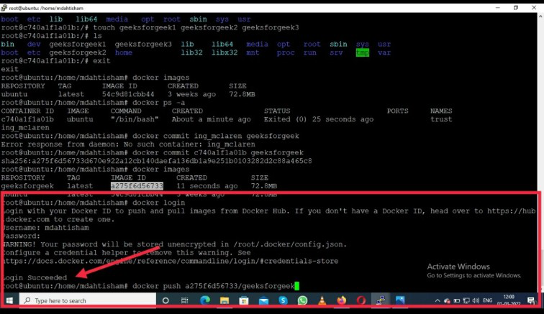

**Step 7:** Then type the tag images name, docker hub username, and give the name it appears on the docker hub using the below command:

# docker tag geeksforgeek mdahtisham/geeksimage  
 geeksforgeek - Image name  
 mdahtisham - Docker hub username  
 geeksimage - With this name Image will appear on the docker hub

**Step 8:** Now push your image using the below command:

# docker push mdahtisham/geeksimage

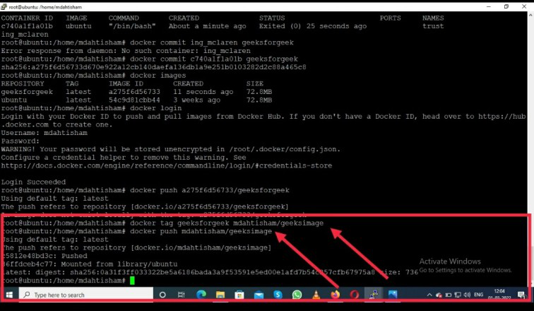

**Note:**Below you can see the Docker Image successfully pushed on the docker hub: mdahtisham/geeksimage

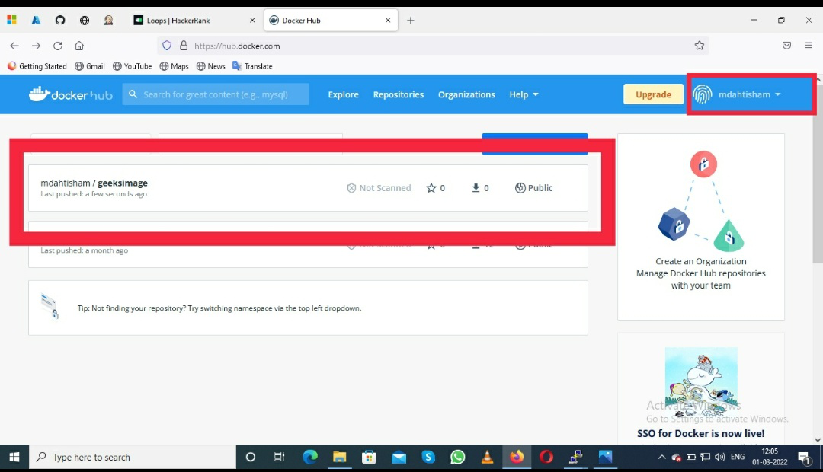

**Pull Docker Images From Docker Hub :**

**Step 1:**Now you can search the image using the below command in docker as follows:

**# docker search *imagename***

**Step 2:** Now pull the image see the below command.

# docker pull mdahtisham/geeksimage  
 mdahtisham - Docker Hub username  
 geeksimage - With this name Image will appear on the docker hub

**Step 3:** Now check for the pulled image in the local docker environment using the below command:

# docker images

**Docker Hub Web Services:**

* **Image Repositories:** Docker Hub primarily serves as a registry where you can store and access container images. You have the option to create both public and private repositories, browse official images, and upload your custom images.
* **Automated Builds:**Docker Hub can link directly to code repositories like [GitHub](https://www.geeksforgeeks.org/git/introduction-to-github/) or [Bitbucket](https://www.geeksforgeeks.org/git/introduction-to-bitbucket/) to build images automatically. When you update your code, Docker Hub can build new images to keep everything in sync, making continuous deployment easier.
* **Webhooks:**[Webhook](https://www.geeksforgeeks.org/blogs/what-is-a-webhook-and-how-to-use-it/)integrations on Docker Hub allow you to trigger specific actions, such as deploying an image or sending notifications, whenever an image is updated. This can be useful for automating steps in CI/CD pipelines.
* **Image Scanning:** Docker Hub offers security scanning (for Pro and Team accounts), which checks images for known vulnerabilities. This provides insights into any security risks within your images.
* **Team Collaboration:** Docker Hub includes tools for managing users, teams, and permissions within an organization, making it easier for teams to share and control access to Docker images.
* **Official and Verified Publisher Images:** Docker Hub hosts trusted images from software vendors and the community. These verified and official images are reliable starting points for building applications.
* **Activity Monitoring:**Each repository on Docker Hub includes an activity log. It records when images are pushed, pulled, or updated, helping you keep track of who accessed or modified your images.

**Difference Between Github and Docker Hub:**

**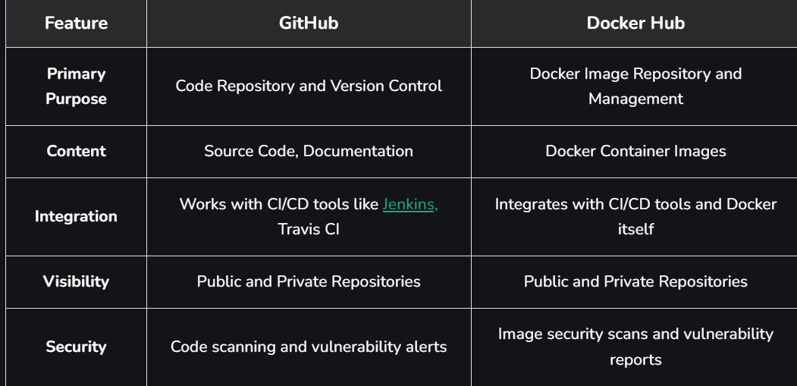**

**Difference Between Dockerhub and Docker Registry**

**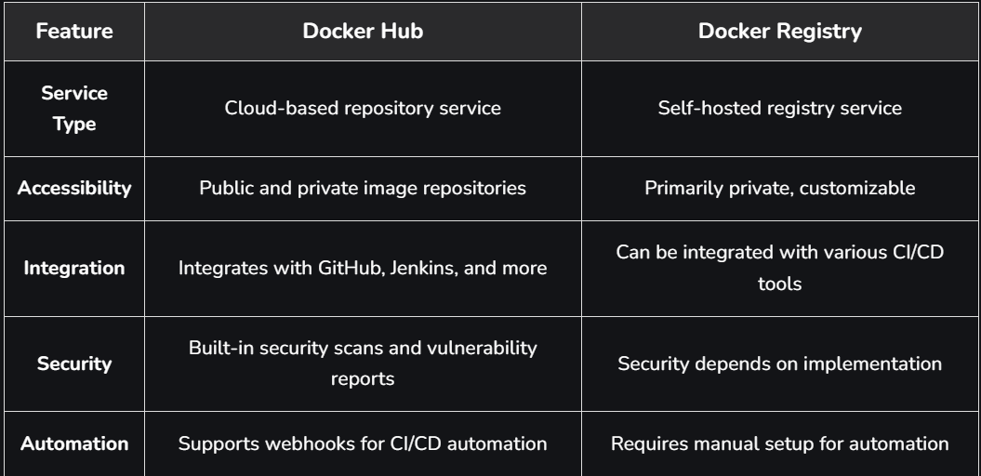**

**\*\*\*\*\*\*\*\*\*\*\*\*\*\*\*\*\*\*\*\*\*\*\*\*\*\*\*\*\*\*\*\*\*\*\*\*\*\*\*\*\*\*\*\*\*\*\*\*\*\*\*\*\*\*\*\*\*\*\*\*\*\*\*\*\*\*\*\*\*\*\*\*\*\*\*\*\*\*\*\*\*\*\*\*\*\*\*\*\*\*\*\*\*\*\*\*\*\*\*\*\*\*\*\*\*\*\*\*\*\*\*\*\*\*\*\*\*\*\*\*\*\*\*\*\*\*\*\*\*\*\*\*\*\*\*\*\*\*\*\*\*\*\*\*\*\*\*\*\*\*\*\*\*\*\*\*\*\*\*\*\*\*\*\*\*\*\*\*\*\*\*\*\*\*\*\*\*\*\*\*\*\*\*\*\*\*\*\*\*\*\*\*\*\*\*\*\*\*\*\*\*\*\*\*\*\*\*\*\*\*\*\*\*\*\*\*\*\*\*\*\*\*\*\*\*\*\*\*\*\*\*\*\*\*\*\*\*\*\*\*\*\*\*\*\*\*\*\*\*\*\*\*\*\*\*\*\*\*\*\*\*\*\*\*\*\*\*\*\*\*\*\*\*\*\*\*\*\*\*\*\*\***

**Section 5: Docker Compose:**

1. **Docker Compose:**

**Docker Compose**is an orchestration tool for defining and running multi-container Docker applications**.** Imagine you have a complex application with separate components—a web server, a backend API, a database, and a caching layer. Each component runs in its own isolated container. The challenge isn't just running these containers individually, but making them work together as a single, cohesive application.

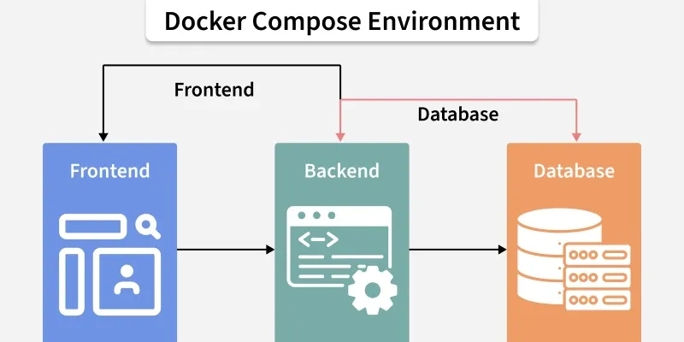

**Overcoming the Complexity of Multi-Container Setups**

Docker is excellent at creating and running individual containers, managing the lifecycle and communication between them manually presents significant challenges:

* **Complex Configuration:** Running each container requires long and complex docker run commands with flags for networking, ports, volumes, and environment variables. This becomes difficult to manage and reproduce consistently.
* **Manual Networking:** To make containers talk to each other, you would have to manually create Docker networks, find the internal IP address of each container, and hardcode these fragile, temporary IPs into your application's code.
* **Lack of Reproducibility:** A manual setup is prone to human error and makes it incredibly difficult to ensure that the application runs the same way on a developer's machine, a testing server, and in production. This is the classic "it works on my machine" problem.

Docker Compose directly addresses these issues by providing adeclarative, automated, and reproducible way to manage your entire application stack. You declare the *desired state* of your application in the YAML file, and Docker Compose handles the rest.

**Example docker-compose.yml:**

**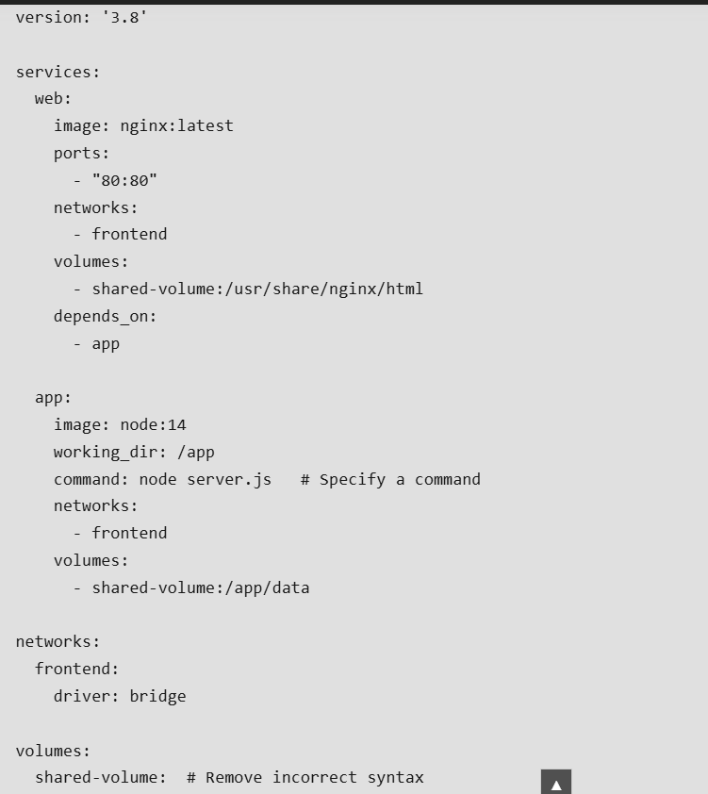**

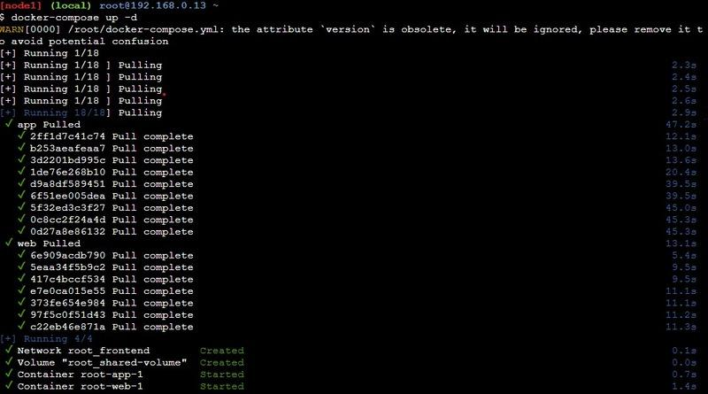

**Explanation:**

* The web service runs an Nginx container, and app runs a Node.js container.
* Both services connect through the frontend network, allowing them to communicate.
* The shared-volume volume is mounted in both containers, providing shared storage for files.

**Docker Compose Services**

* In Docker Compose, every component of your application operates as a separate service, with each service running a single container tailored to a specific role—such as a database, [web server](https://www.geeksforgeeks.org/node-js/web-server-and-its-type/), or cache.
* These services are defined within the `services` section of the `docker-compose.yml` file. This section lets you configure each service individually, specifying details like the Docker image to pull, environment variables, network connections, and storage options.
* Through this setup, you can control how each part of your application interacts, ensuring smooth communication and resource management across the services.

**Key Service Configuration Options**

* **Image:**Image option defines which Docker image we are going to use by the service from the Docker Hub or any other registry.
* **Build:** Instead of pulling an image, you can build one locally by specifying a directory containing a Dockerfile. The build is ideal for including custom code in your application.
* **Ports:** This setting maps a container's internal ports to those on the host machine, enabling access to services from outside the container.
* **Volumes:**Volumes attach persistent storage to a service ensuring that the data remains accessible even when a container restart.
* **Environment:** Environment variables allow you to pass configurations or sensitive information, like database credentials or API keys, to the service.
* **Depends\_on:**Depends\_on controls the startup order of services, ensuring that certain containers are running before others begin.

**Docker Compose Networks**

Docker Compose deployments use **networks** to allow secure communications between the services. Services defined in a docker-compose.yml file are by default placed on one network and are able to connect to each other without any additional setup. For more strict control, you can create additional networks and assign services to them in order to control the way they communicate or to separate some groups of services as the need arises.

**Key Network Configuration Options**

* **Driver**: Driver are used in the network driver type, such as bridge (the default for local networks) or overlay (for multi-host networks in [Docker Swarm](https://www.geeksforgeeks.org/devops/introduction-to-docker-swarm-mode/)), which determines how services connect to each other.
* **Driver Options (driver\_opts)**: Driver Options(driver\_opts) allows for additional settings on the network driver, useful for fine-tuning network behavior to meet specific needs.
* **IP Address Management (ipam)**:IP address management configures network-level IP settings, like subnets and IP ranges, to give you greater control over the IP address space assigned to your services.

**Example docker-compose.yml with Custom Networks:**

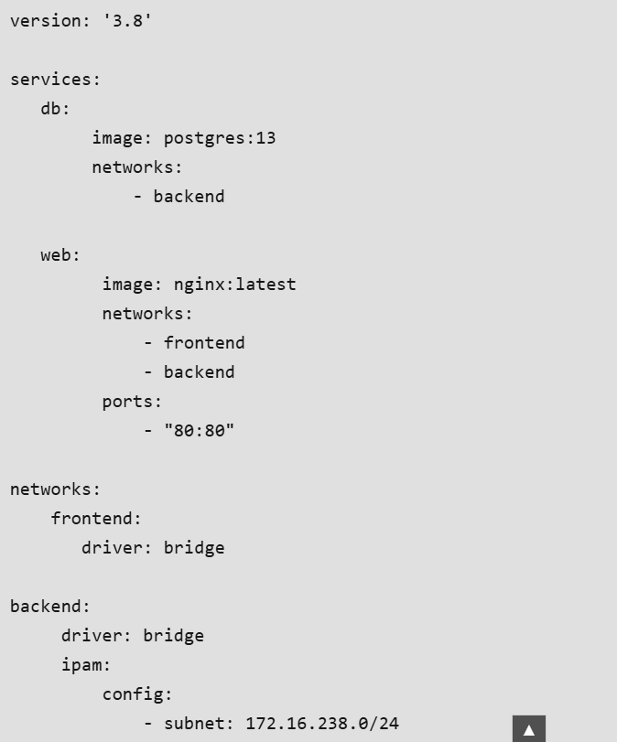

**Explanation:**

* The **db** service uses the**backend** network, isolating it from the **frontend** network to limit access.
* The **web** service is connected to both **frontend** and **backend** networks, allowing it to communicate with the **db** service while remaining accessible via the **frontend** network.
* The **backend** network includes IPAM settings with a specific subnet range, ensuring custom IP address management.

**Docker Compose Volumes**

[**Volumes**](https://www.geeksforgeeks.org/devops/what-is-docker-volume/)in docker compose are used to persist data created or used by the docker containers. By doing so they enable the data to persist even if containers are stopped or removed in your docker-compose. Within a docker-compose. yml file, the volumes section describes all the volumes that are attached to the services allowing you to manage data that exists independently of the container lifecycle.

**Key Volume Configuration Options**

* **External:** Set true to signify that the volume was created externally, outside of Docker Compose (such as via docker volume create) and simply referenced in the configuration.
* **Driver:** This indicates which volume driver the volume should use, and it controls how are these volumes being handled. By default, the driver is local, but other options are also available.
* **Driver Options (driver\_opts):** Additional options to customize the volume driver like filesystem type or different storage parameters.

**Example docker-compose.yml with Volumes:**

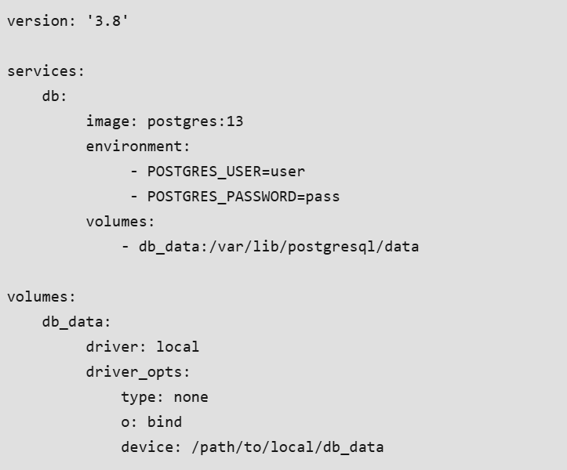

**Explanation**

* The **db** service runs a PostgreSQL container, with its data stored in the **db\_data** volume. This setup ensures that the database information remains intact across restarts or removals of the container.
* The **db\_data** volume is configured to use the **local**driver, and it has driver options set to create a bind mount pointing to a specific path on the host system **(/path/to/local/db\_data).** This means that all database files are saved in that designated directory on the host.
* By using volumes in this way, you can keep essential data safe and easily accessible, separate from the container itself.

**Set Environment Variables in Docker Compose**

Environment variables are a simple and effective way to pass configuration settings from your host operating system through Docker Compose in order to get to your services. You can set these variables directly on the service definition by using the environment section or load them from an external file.

* **Inline:** you may declare env vars directly in the service definition.This approach is simple and gives everything in one place.
* **env\_file**: This option allows you to load environment variables from an external file, making it easier to manage configuration, especially when dealing with many variables.

**Example docker-compose.yml Using Environment Variables**:

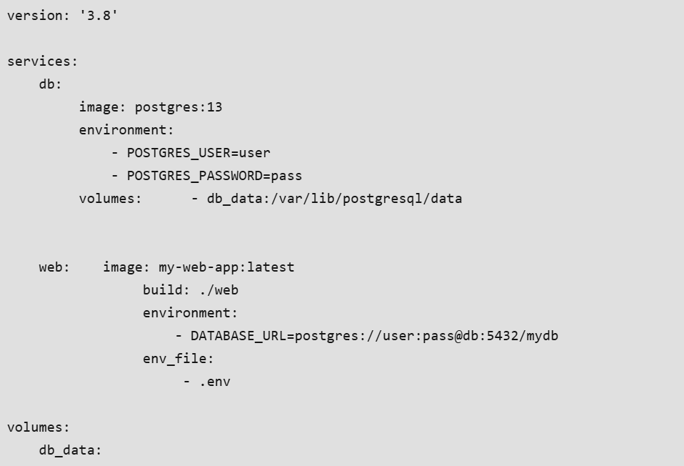

**Explanation**

* In the **db** service, the **POSTGRES\_USER** and **POSTGRES\_PASSWORD** environment variables are defined inline, specifying the database credentials directly.
* The **web** service uses an inline variable for **DATABASE\_URL**, which connects to the PostgreSQL database. Additionally, it loads environment variables from an external file named **.env**. This file can contain various settings, such as API keys, application configurations, and other sensitive information.

**How to Use Docker Compose?**

**Step 1: Create Project Directory**

First, Create a separate directory for our complete project. Use the following command.

mkdir dockerComposeProject

Move inside the directory.

cd dockerComposeProject

**Step 2: Create API**

we will create a custom image that will use [**Python**](https://www.geeksforgeeks.org/python/python-programming-language-tutorial/) to serve our**Restful API**defined below. Then the service will be further configured using a[**Dockerfile**](https://www.geeksforgeeks.org/cloud-computing/what-is-dockerfile/)**.**

Then create a subdirectory for the service we will name it product. and move into the same.

mkdir product

cd product

Create requirements.txt

Inside the product folder, create a file named requirements.txt and add the following dependencies:

flask

flask-restful

**Step 3: Build Python  api.py**

* Create a Dockerfile to define the container in which the above API will run.

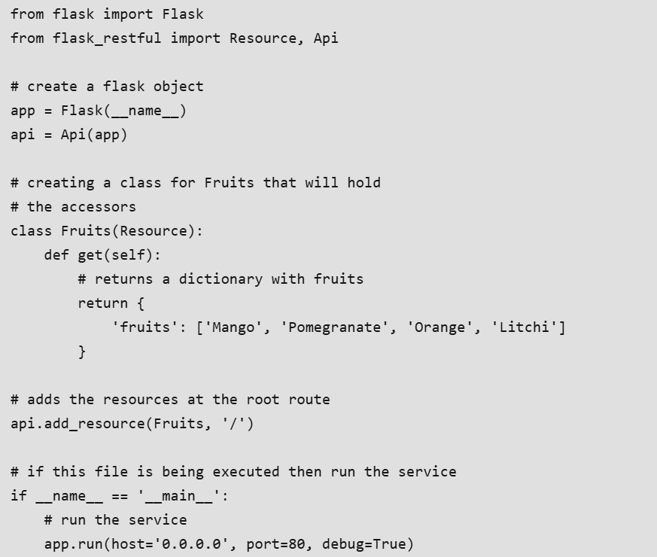

**Step 4: Create Dockerfile For Python API**

FROM python:3

WORKDIR /usr/src/app

COPY requirements.txt .

RUN pip install --no-cache-dir -r requirements.txt

COPY . .

CMD ["python", "api.py"]

FROM accepts an image name and a version that the docker will download from the docker hub. The current working directory's contents can be copied to the location where the server expects the code to be by using the copy command. Moreover, the CMD command takes a list of commands to start the service once the container has been started.

**Step 5: Create PHP HTML Website**

Let's create a simple website using[PHP](https://www.geeksforgeeks.org/php/php-tutorial/) that will use our [API.](https://www.geeksforgeeks.org/node-js/rest-api-introduction/)

Move to the parent directory and create another subdirectory for the website.

cd ..

mkdir website

cd website

**index.php**

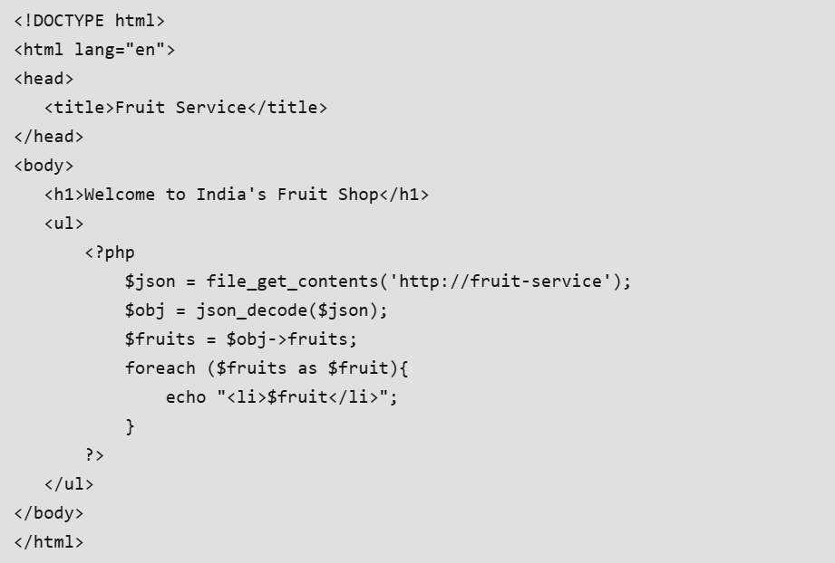

Now create a compose file where we will define and configure the two services, API and the website.

Move out of the website subdirectory using the following code.

cd ..

And then create the file name as .**docker-compose.yaml**

**Step 6: Create Docker-compose.yaml file**

**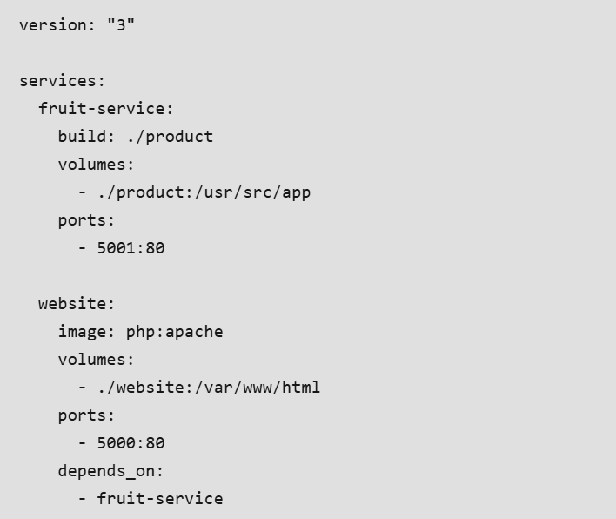**

**Docker-compose.yaml File**

The first line is optional where we specify the version of the docker-compose tool. Next **services** define a list of services that our application is going to use. The first service is fruit service which is our API and the second one is our website. The fruit service has a property build that contains the dockerfile that is to be built and created as an image. Volumes define storage mapping between the host and the container so that we can make live changes. Finally, port property exposes the containers port 80 through the host's 5001.

The website service does not use a custom image but we download the PHP image from the Docker hub and then map the websites folder that contains our index.php to /var/www/html (PHP expects the code to be at this location). Ports expose the container port. Finally, the depends\_on specifies all the services on which the current service depends.

* The folder structure after creating all the required files and directory will be as follows:

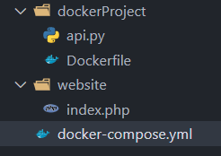

**Run the application stack with Docker Compose:**

Now that we have our docker-compose.yml file, we can run it.

To start the application, enter the following command.

**docker-compose up -build**

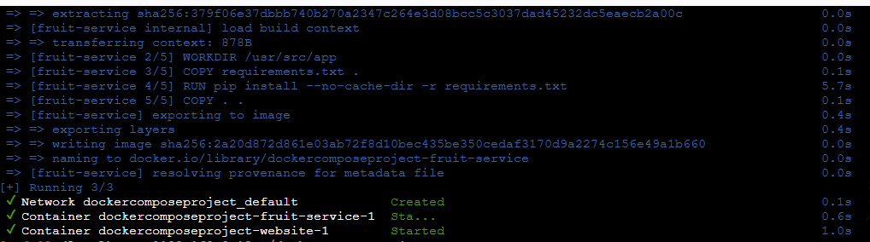

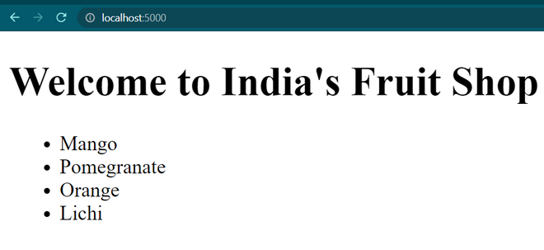

To stop the application, either press CTRL + C or

**docker-compose stop**

**Important Docker Compose Commands:**

**docker-compose up**

* Starts all services defined in docker-compose.yml. Creates containers, networks, and volumes if missing. Add -d to run in background.  
  *Example:* docker-compose up -d

**docker-compose down**

* Stops and removes all containers, networks, and volumes created by up. Cleans resources when not needed.  
  *Example:* docker-compose down

**docker-compose ps**

* Lists all containers in the Compose app with status details. Useful for monitoring running services.  
  *Example:* docker-compose ps

**docker-compose logs**

Shows logs from services. Add service name to filter logs for troubleshooting.  
*Example:* docker-compose logs web

**docker-compose exec**

Runs a command inside a running service container. Good for debugging or direct interaction.  
*Example:* docker-compose exec db psql -U user -d mydb

**docker-compose build**

Builds/rebuilds images defined in docker-compose.yml. Use after Dockerfile changes or updates.  
*Example:* docker-compose build

**docker-compose pull**

Pulls the latest images from registries to ensure up-to-date versions.  
*Example:* docker-compose pull

**docker-compose start**

Starts already-defined containers without recreating them. Quick restart for stopped services.  
*Example:* docker-compose start

**docker-compose stop**

Stops running containers but keeps them intact. Can be restarted later with start.  
*Example:* docker-compose stop

**docker-compose config**

Validates and displays the configuration from docker-compose.yml. Helps check errors before deployment.  
*Example:* docker-compose config

\*\*\*\*\*\*\*\*\*\*\*\*\*\*\*\*\*\*\*\*\*\*\*\*\*\*\*\*\*\*\*\*\*\*\*\*\*\*\*\*\*\*\*\*\*\*\*\*\*\*\*\*\*\*\*\*\*\*\*\*\*\*\*\*\*\*\*\*\*\*\*\*\*\*\*\*\*\*\*\*\*\*\*\*\*\*\*\*\*\*\*\*\*\*\*\*\*\*\*\*\*\*\*\*\*\*\*\*\*\*\*\*\*\*\*\*\*\*\*\*\*\*\*\*\*\*\*\*\*\*\*\*\*\*\*\*\*\*\*\*\*\*\*\*\*\*\*\*\*\*\*\*\*\*\*\*\*\*\*\*\*\*\*\*\*\*\*\*\*\*\*\*\*\*\*\*\*\*\*\*\*\*\*\*\*\*\*\*\*\*\*\*\*\*\*\*\*\*\*\*\*\*\*\*\*\*\*\*\*\*\*\*\*\*\*\*\*\*\*\*\*\*\*\*\*\*\*\*\*\*\*\*\*\*\*\*\*\*\*\*\*\*\*\*\*\*\*\*\*\*\*\*\*\*\*\*\*\*\*\*\*\*\*\*\*\*\*\*\*\*\*\*\*\*\*\*\*\*\*\*\*\*

**Section 6: Docker Engine and Storage:**

1. **Docker Storage:**

Docker images are built-in form of layers and docker containers store all the data being used, on the container writable layer which is only persisted till the lifespan of the container i.e. it is no longer accessible once the container is removed. This also makes it difficult to get the data out of the container if it is required by some other processes.

To persist the data irrespective of the container's lifecycle so that the files are available in the host filesystem even if the container is no longer available, Docker provides two options:

1. **Docker volumes**
2. **Bind mounts**

Though we can also use***tmpfs mount***if you're using Docker on Linux and ***named pipes*** if using Docker on Windows.

**1. Docker Volume**

Volumes are the directories or files that exist on the host filesystem and are mounted to the containers for persisting data generated or modified by them. They are stored in the part of the host filesystem **managed specifically by Docker and it should not be modified by non-Docker processes**. Volumes are the most preferred way to store container data as they provide efficient performance and are isolated from the other functionalities of the Docker host.

We can use the following command to create docker volume -:

**docker volume create <volume\_name>**

We can mount a volume to multiple containers simultaneously and Docker doesn't remove them even if they're not being used by any running container. To remove a volume, we can use the following command -:

**docker volume prune**

**2.) Bind Mounts**

This is also a mechanism provided by Docker to store container data on localhost, but the directory or file mounted using bind mounts**can be accessed by non-Docker processes as well** and it relies on the host machine's filesystem having a specific directory structure available because**it uses absolute path for binding**.

Bind mounts have limited functionality and can't be managed directly through Docker CLI, thus making it less preferable in comparison to volumes. Moreover, **it allows the container to modify the *host* filesystem i.e. it can create, modify or delete important file directories which can impact security and non-Docker processes as well**.

**3.) tmpfs mounts**

When using Docker in Linux, you can also create storage volume for containers using *tmpfs*mount. But contrary to bind mounts and volumes, **this type of mount is temporary and persists on host memory.**

Once the container is stopped, the *tmpfs*mount is removed and files stored using it won't be available anymore. This type of mount has very limited use and can only be used by Linux users. Moreover, **it does not allow sharing of mounted data among containers**.

**4.)  Named pipes**

**When to use Volumes**

Following are some potential use cases for volumes -:

* Volumes can be used to share data among multiple containers in a secure manner without affecting the host filesystem.
* They provide convenient backup and data migration from one Docker host to another.
* We can easily manage volumes using Docker CLI and Docker APIs, which is a limitation in terms of bind mounts.
* The insignificance of host filesystem structure provides decoupling of Docker host configuration from container runtime.
* It provides volume drivers which help in storing data to remote hosts or cloud providers.
* Volumes are stored in Linux VM thus providing lower latency and higher throughput. They are highly performant on the Docker desktop, thus making them a better choice for write-intensive applications like data storage.

**When to use Bind Mounts**

Despite limited functionalities, we can use bind mounts in the following cases -:

* It can be used to provide shared configuration files between host and container. Ex- Docker mounts **'*/etc/resolv.conf '*** to containers for DNS resolution.
* In case the host file system is guaranteed to remain consistent and the mounted volume is not accessed by non-Docker processes, we can use bind mounts for storing data.

===================================================================================

1. **Backing up a Docker Container:**

If you are a Docker Developer, you would surely know how important it is to backup your Docker Container file system. If you are working on an important Docker Application, it becomes very necessary to backup all the files and folders related to it so that in case anything goes wrong, you can get back all those files. It also helps you in managing different versions of your project and also sharing the files and folders of your project among your team members.

**Step 1: Create a Docker Container**

For our example, we are going to create an Ubuntu Container with a single file inside it.

**sudo docker run -it ubuntu bash**

After you fire up the bash, use the below command to create a file.

**echo "geeksforgeeks" > geeksforgeeks.txt**

**ls**

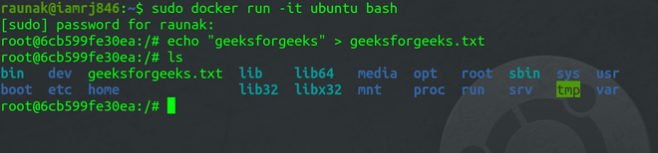

**Step 2: Get the Container ID**

You will need the Container ID in order to create the backup.

**sudo docker container ls**

Note that if the container is not running, you can start the Container using the below command.

**sudo docker start <container-id>**

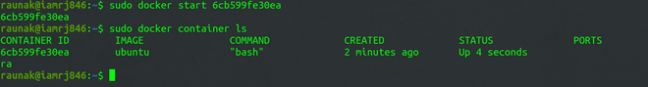  
**Step 3: Commit the Docker Container**

To create a snapshot, you need to commit the Container.

**sudo docker commit -p 6cb599fe30ea my-backup**



**Step 4: Saving backup as a Tar file**

You can use this command, to save the backup as a Tar File in your local machine.

**sudo docker save -o ~/my-backup.tar my-backup**



You will find the backup Tar file in your Home Directory.

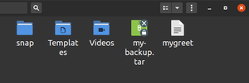

**Step 5: Pushing Image to Docker Hub**

In order to push it back to the Docker Hub, you need to have an account on Docker Hub.

Login using your command line and push the Tar File.

**sudo docker login**

**sudo docker push my-backup:latest**

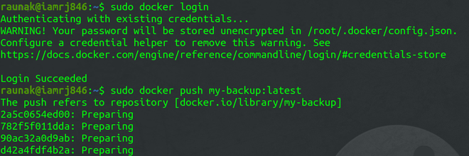

===================================================================================

1. **Using CLI to Manage Docker Volumes:**

**What are Docker Volumes?**

Docker volumes are the ones meant to provide a persistent storage mechanism. It is used for managing data and storing them outside the container's system ensuring it data persistence even when the container is removed or recreated. These are essential for maintaining data consistency and sharing the data between multiple containers. Docker volumes add features to docker for managing stateful applications in docker.

**Why use Docker Volumes?**

* **Persistent Storage**: Volumes helps in making the data persists after completing the lifecycle of a container. It allows us to retain important data even if the container is deleted or updated.
* **Data Sharing**: Volumes facilitates with easy sharing of data between multiple containers, facilitating communication and coordination among different services within an application.
* **Performance**: On Using volumes we can improve I/O operational performance compared to storing data in the container’s writable layer, as volumes are optimized for storage operations.
* **Backup and Recovery**: Volumes can be easily backed up and restored, making it simpler to manage and protect your data.

**Commands of Docker Volumes:**

**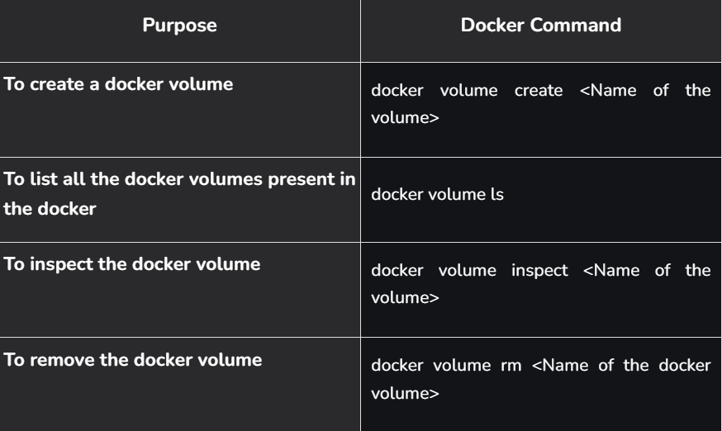**

**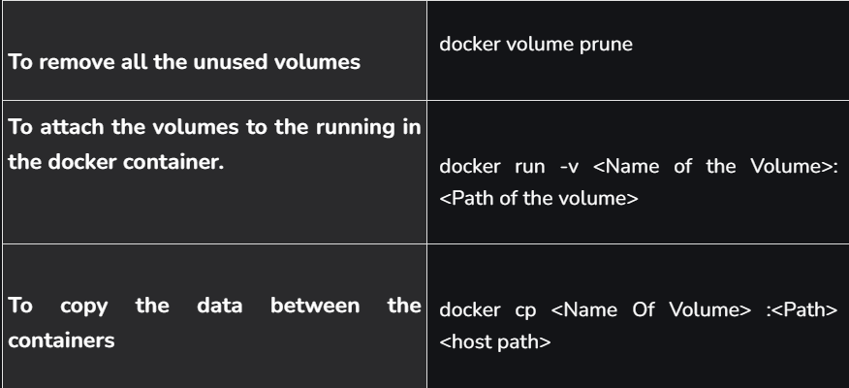**

**How Does Volume Work in Docker?**

Docker volumes are used to store the data which is produced by the application which is containerized in the docker All the data will be stored in the docker of the dedicated directory on the host system.

**/var/lib/docker/volumes**

Volumes in the docker will be mounted to the particular host path of the application where the data of the application is going to the stored. This implies that since the volume is kept independently on the host and may be directly accessed with manual tools or remounted to another container, the written data will remain accessible even if the container terminates.

**Examples to Implement Docker Volume Commands:**

**1. Creating Docker Volume**

To create a Docker Volume, you can use the Volume Create command as shown below.

sudo docker volume create vol-demo



**2. Mounting Volume with a Container**

After you have created a Volume, you can mount it with a[Docker Container](https://www.geeksforgeeks.org/blogs/containerization-using-docker/) **-v** flag along with the [Docker run](https://www.geeksforgeeks.org/devops/docker-run-command/) command.

sudo docker run -it -v <volume-path-in-local-machine>:<dest-path-in-container> <image-name>

or

docker run -itd --mount type=volume,source=source\_file\_path,target=target\_file\_path <image\_name>



To verify if the volume has been successfully mounted or not, you can move to the destination directory inside the Container.

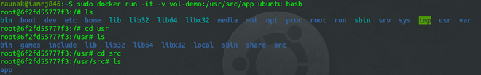

**3. Listing all the Docker Volumes**

You can list all your Docker Volumes using the Docker Volume **ls** command.

sudo docker volume ls

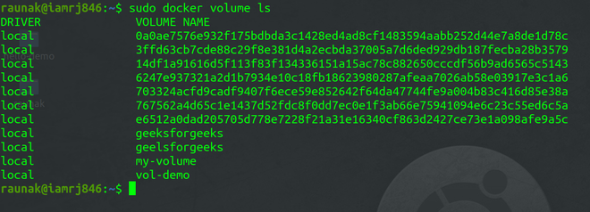

**4. Inspecting Docker Volumes**

You can get the details of your Docker Volumes using the Volume Inspect Command.

sudo docker volume inspect <volume-name>

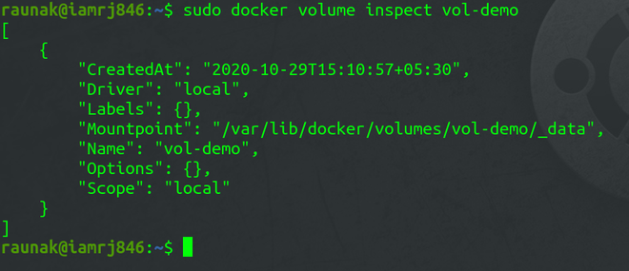

**How to Removing specific Docker Volume?**

For removing a specific volume in docker, execute the following docker volume rm command with specifying the volume name.

sudo docker volume rm <volume-name>

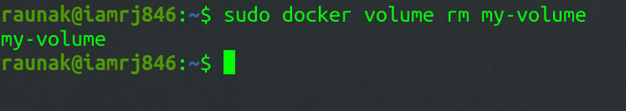

**Advantages of Docker Volumes**

* **Persistence:**The volumes which are attached to the container will be there even if the containers in the docker recreated so the data of the application will not be lost and also with the help of docker volumes you can deploy and maintain the state-full applications such as databases, configuration files, and logs.
* **Isolation:**If the two state-full application are deployed in the docker then to that two application containers we need to attach the docker volumes in that cases docker can ensure you that there will be no conflict between two volumes it will isolate from each other.
* **Portability:** The volume which are attached to the docker volumes are portable from one host to the another host or from one environment to another environments. Which make it easy for the data migration between development, staging, and production environments without modifying the container images.
* **Dynamic Data Management:**Throughout a container's lifecycle, dynamic data management is made possible by Docker volumes. Data handling is made more flexible and dynamic by the ability to add, edit, and remove data without changing the container itself.

**How do you clean up docker volumes?**

**Step 1:** Firstly list all the docker volumes with the following command

docker volume ls

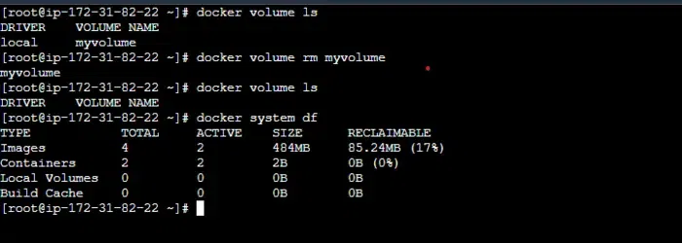

**Step 2:** To remove all the unused volumes with docker volume prune with the following command

docker volume prune

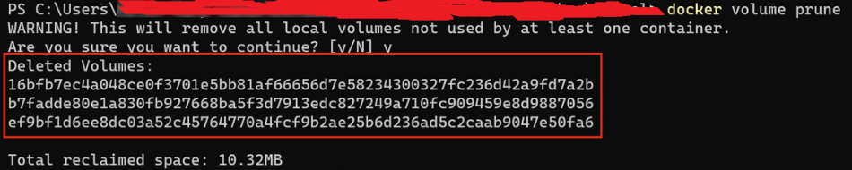

**Step 3:** For removing specific volumes in the docker specify the volume name with docker volume rm command as follows

docker volume rm <volume\_name>

**Step 4:** To associated volumes with the stopped containers using following command

docker rm -v <container\_id>

**Why to clean Docker Volumes?**

* **Free Up Space**: Unused volumes can consume significant disk space, so cleaning them helps to free up valuable storage resources.
* **System Performance**: Removing unnecessary volumes can improve system performance by reducing clutter and ensuring that Docker operates efficiently.
* **Resource Management**: Regularly cleaning up volumes helps in better resource management, preventing the accumulation of outdated or irrelevant data.
* **Security**: Old volumes might contain sensitive data that could pose security risks if not properly managed or deleted. Cleaning volumes helps mitigate such risks.

\*\*\*\*\*\*\*\*\*\*\*\*\*\*\*\*\*\*\*\*\*\*\*\*\*\*\*\*\*\*\*\*\*\*\*\*\*\*\*\*\*\*\*\*\*\*\*\*\*\*\*\*\*\*\*\*\*\*\*\*\*\*\*\*\*\*\*\*\*\*\*\*\*\*\*\*\*\*\*\*\*\*\*\*\*\*\*\*\*\*\*\*\*\*\*\*\*\*\*\*\*\*\*\*\*\*\*\*\*\*\*\*\*\*\*\*\*\*\*\*\*\*\*\*\*\*\*\*\*\*\*\*\*\*\*\*\*\*\*\*\*\*\*\*\*\*\*\*\*\*\*\*\*\*\*\*\*\*\*\*\*\*\*\*\*\*\*\*\*\*\*\*\*\*\*\*\*\*\*\*\*\*\*\*\*\*\*\*\*\*\*\*\*\*\*\*\*\*\*\*\*\*\*\*\*\*\*\*\*\*\*\*\*\*\*\*\*\*\*\*\*\*\*\*\*\*\*\*\*\*\*\*\*\*\*\*\*\*\*\*\*\*\*\*\*\*\*\*\*\*\*\*\*\*\*\*\*\*\*\*\*\*\*\*\*\*\*\*\*\*\*\*\*\*\*\*\*\*\*\*\*\*

**Section 7: Docker Networking:**

1. **Docker Networking:**

At its core, Docker networking is the system that allows Docker containers to communicate with each other, with the Docker host, and with the outside world. It's a powerful feature that enables you to build complex, multi-container applications that are isolated yet interconnected.

When you create a container, Docker gives it its own isolated network environment. This means each container has its own IP address and network interfaces. By default, containers running on the same host can communicate with each other without needing to expose ports to the host machine, creating a secure virtual network.

**Core Networking Concepts:**

* **Network Namespaces:** This is a Linux kernel feature that provides network isolation. Each container gets its own network namespace, complete with its own network interfaces, IP addresses, and routing tables. This is why a container can't see the network traffic of another container or the host.
* **Virtual Ethernet Devices (veth pairs):** To connect a container's isolated namespace to the host's network, Docker uses a veth pair. Think of it as a virtual patch cable. One end is plugged into the container's namespace (appearing as eth0), and the other is plugged into the host's main namespace, usually attached to a virtual bridge.
* **iptables:** Docker uses the host's iptables rules (a firewall utility) to manage port mapping and network address translation (NAT). When you expose a port (e.g., -p 8080:80), iptables rules are created to forward traffic from port 8080 on the host to port 80 inside the container.

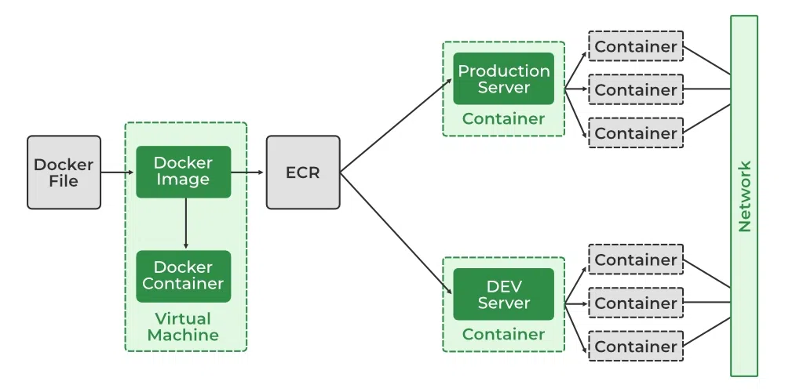

**Network Drivers:**

Docker uses different **network drivers** to create and manage various types of networks.

* **bridge (Default):** This is the default driver for standalone containers. It creates a private, internal network on the host. Containers on the same bridge network can communicate with each other using their internal IP addresses. To access them from outside the host, you must map ports. **It's highly recommended to create your own user-defined bridge networks rather than using the default one.**
* **host:** This driver removes network isolation entirely. The container shares the host's network namespace. This means the container uses the host's IP address directly, and any port the container listens on is opened on the host. This can be simpler and offer better performance but sacrifices the security of network isolation.
* **none:** This driver gives the container a network stack but attaches it to no network. The container is completely isolated and cannot communicate with other containers or the outside world. It's useful for running batch jobs or tasks that require no network access.
* **overlay:** This driver is used for multi-host networking and is the preferred choice for **Docker Swarm** services. It creates a distributed network that spans multiple Docker hosts, allowing containers (and Swarm services) on different hosts to communicate directly and securely.
* **macvlan:** This advanced driver allows you to assign a MAC address to a container, making it appear as a physical device on your network. This is useful for integrating with legacy applications or network monitoring tools that expect devices to have a physical network presence.

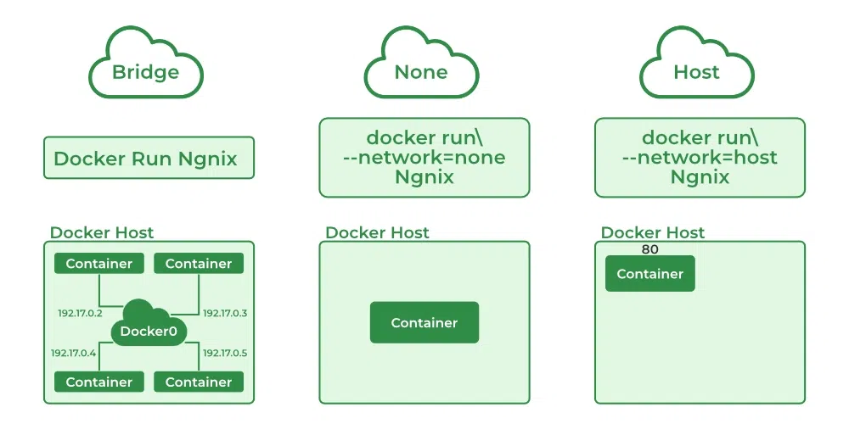

**Launch a Container on the Default Network:**

**1. Understanding the Docker Network Command:**

The Docker **Network** command is the main command that would allow you to create, manage, and configure your Docker Network. Let's see what the sub-commands can be used with the Docker Network command. to know more about [Creating a Network in Docker and Connecting a Container to That Network.](https://www.geeksforgeeks.org/linux-unix/creating-a-network-in-docker-and-connecting-a-container-to-that-network/)

sudo docker network

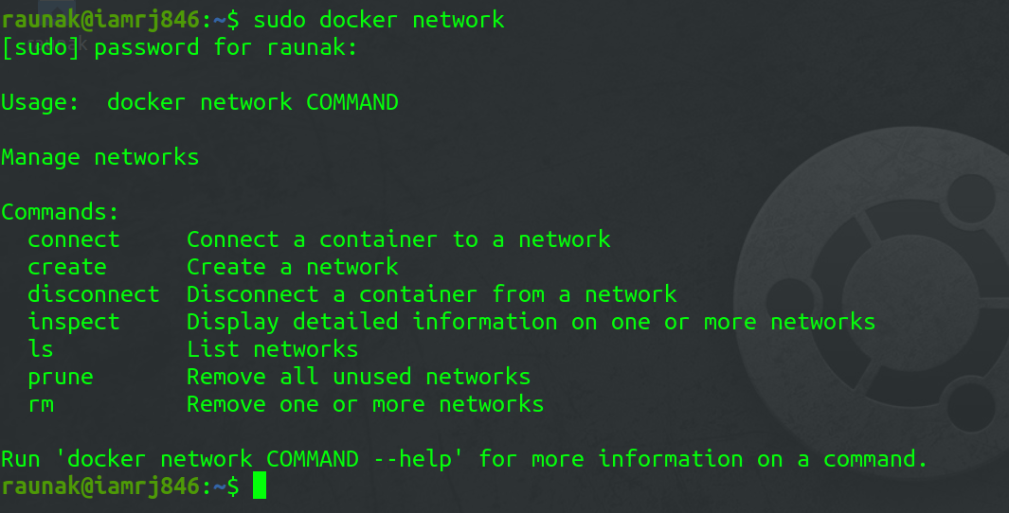

**2. Using Docker Network Create command**

With the help of the **"Create"**command, we can create our own docker network and can deploy our containers in **it.**

sudo docker network create --driver <driver-name> <bridge-name>

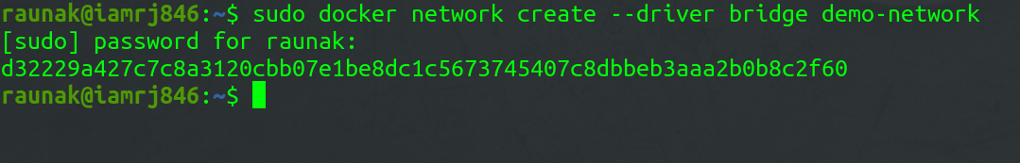

**3. Using the Docker Network Connect command**

Using the **"Connect"** command, you can connect a running Docker Container to an existing Network.

sudo docker network connect <network-name> <container-name or id>



**4. Using the Docker Network Inspect command**

Using the Network Inspect command, you can find out the details of a Docker Network.

sudo docker network inspect <network-name>

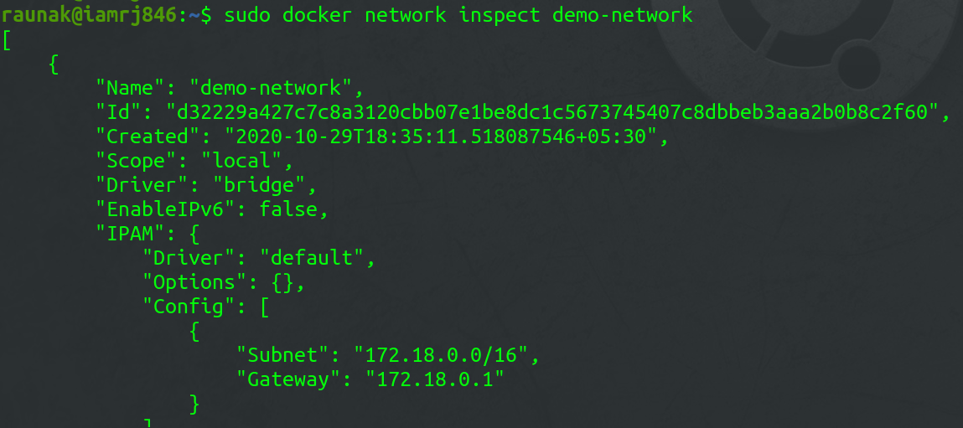

You can also find the list of Containers that are connected to the Network.

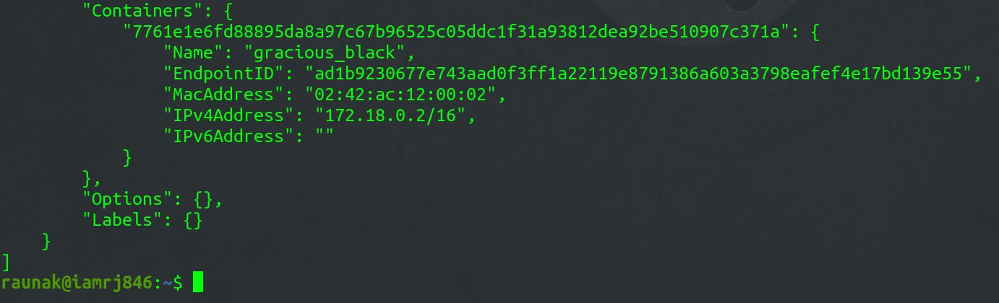

**5. Using the Docker Network ls  command**

To list all the Docker Networks, you can use the **list**command.

sudo docker network ls

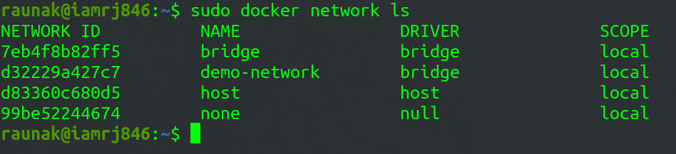

**6. Using the Docker Network Disconnect command**

The **disconnect** command can be used to remove a Container from the Network.

sudo docker network disconnect <network-name> <container-name>



**7. Using the Docker Network rm command**

You can remove a Docker Network using the **rm** command.

sudo docker network rm <network-name>

*Note that if you want to remove a network, you need to make sure that no container is currently referencing the network.*

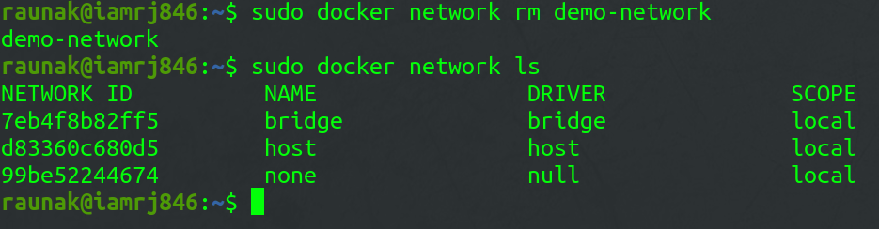

**8. Using the Docker Network prune command**

To remove all the unused Docker Networks, you can use the **prune** command.

sudo docker network prune

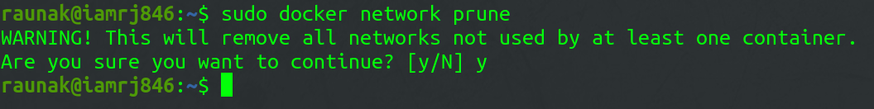

**Common Operations :**

* **docker network inspects:** We may examine the configuration information of a specific network, such as the name of the network, the containers that have linked to this network, the type of driver used to construct this network, and other characteristics, by using the**"docker network inspect"** command.
* **docker network ls:** We can see all of the networks that are available on the current host by using **"docker network ls"**.
* **docker network creates:**Using the command **"docker network create"** and the name of the driver, such as bridge, overlay, or macvlan, we can establish a new network.
* **docker network connects:** In order to use this command, we must first confirm that the appropriate network has already been formed on the host. Then, using docker **"network connect"**, we may attach the container to the necessary network.

===================================================================================

1. **Docker Ports:**

Docker is a set of platform-as-a-service products that use OS-level virtualization to deliver software in packages called containers. These containers may need to talk to each other or to services outside docker, for this we not only need to run the image but also expose the container's port and make it accessible by other services or containers which are on a different network.

Note: If you need to run docker as the root user, please remember to prepend sudo to the commands

**Pulling Image From Docker Hub:**

**Step 1.** Use the command to pull the Nginx image.

**Step 2:** Running A Container From The Pulled Image



Let us break this command to understand better:

1. *Docker run Nginx:*will start the container from the Nginx image.
2. *-p 8080:80:* will **map TCP port 80 in the container to port 8080 on the Docker host**.
3. *--name webhost:*will name our container webhost, if not specified docker will give it a random name.
4. -d:  flag will run docker in a detached mode that is,  in the background.

**How To Know Which Port Is Exposed?**

The one question which still remains is, *how will we know which port in the container should we map our computers port to?* Usually, this detail is provided on the image repository or using the inspect command.

* Go to the Nginx repository on the docker hub and try to locate the expose port section:

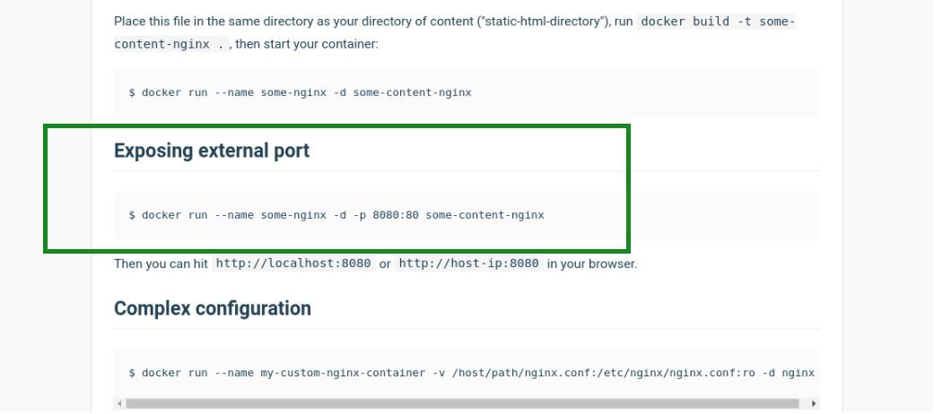

Using the docker inspect command:

$ docker inspect nginx

This will list all configurations of the Nginx image, from where we can locate the ExposedPort property.

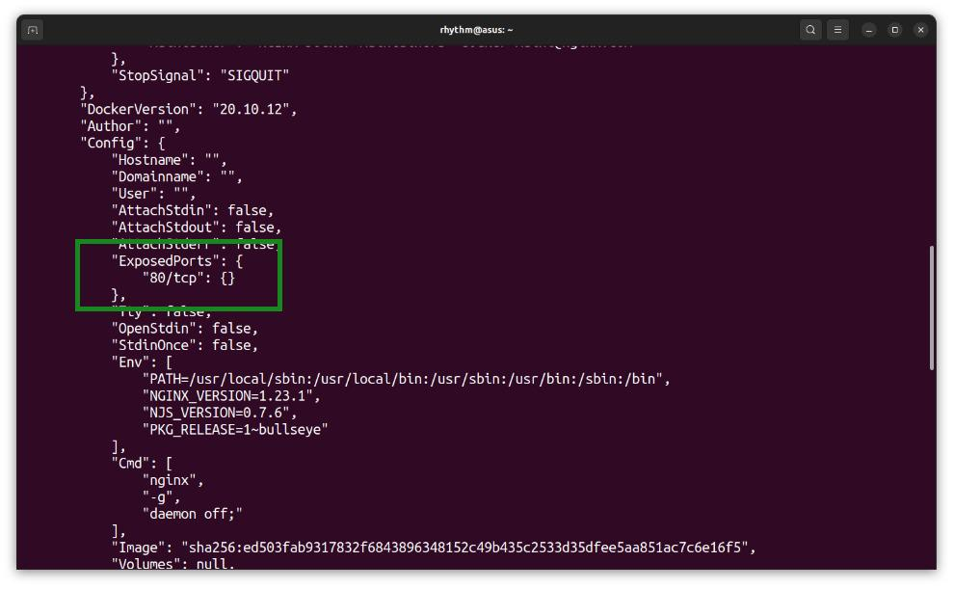

===================================================================================

1. **Creating a Network in Docker and Connecting a Container to That Network:**

Networks are created so that the devices which are inside that network can connect to each other and transfer of files can take place. In docker also, we can create a network and can create a container and connect to the respective network and two containers that are connected to the same network can communicate with each other.

These containers can also communicate with the host in which the docker is deployed. The communication will take place by using the IP address of each other. A container can connect to one or more networks in that docker host.

Step1: In the first step we run a command to see the list of networks in your docker host.

sudo docker network ls

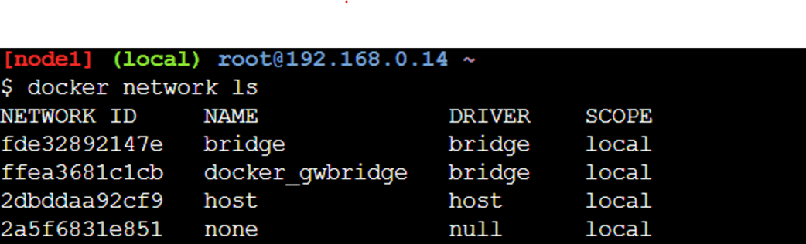

**2: Creating a Network:**

**docker network create my-app-network**

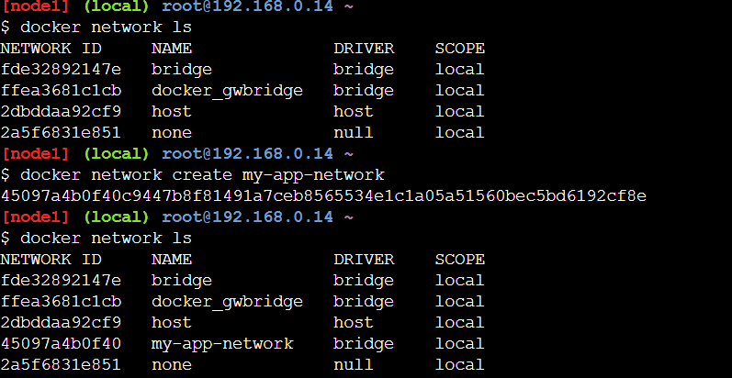

**3. Running Containers on a Network**

docker run -d --name web-server-1 --network my-app-network nginx

docker run -d --name web-server-2 --network my-app-network nginx

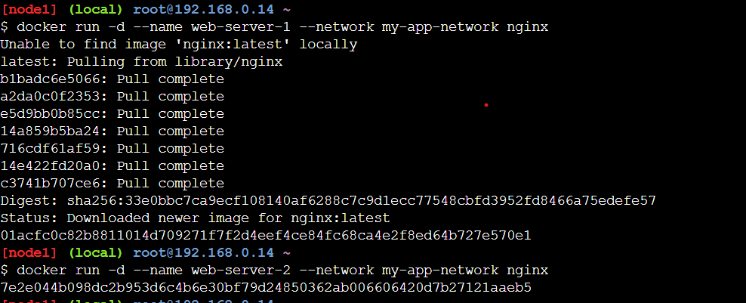

**4. Inspecting a Network**

docker network inspect my-app-network

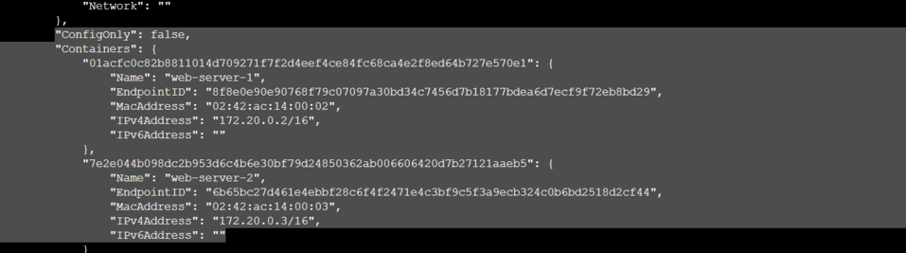 **5. Testing Container-to-Container Communication**

**docker exec -it web-server-1 curl http://web-server-2**

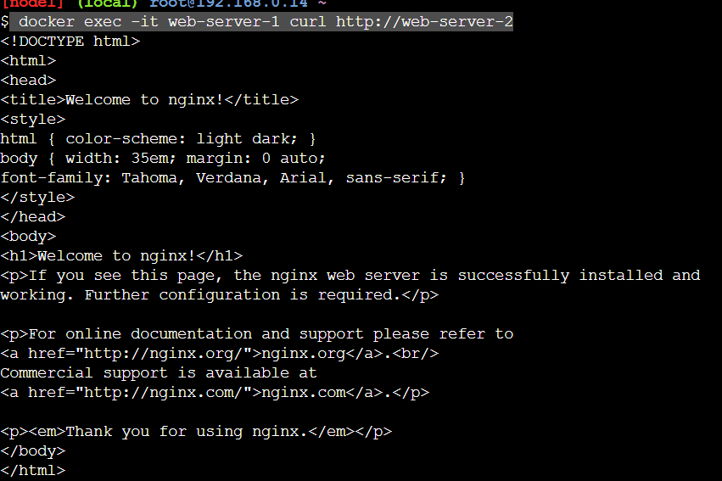**6. Connecting a Running Container to a Network**

docker network connect my-app-network <container-name-or-id>

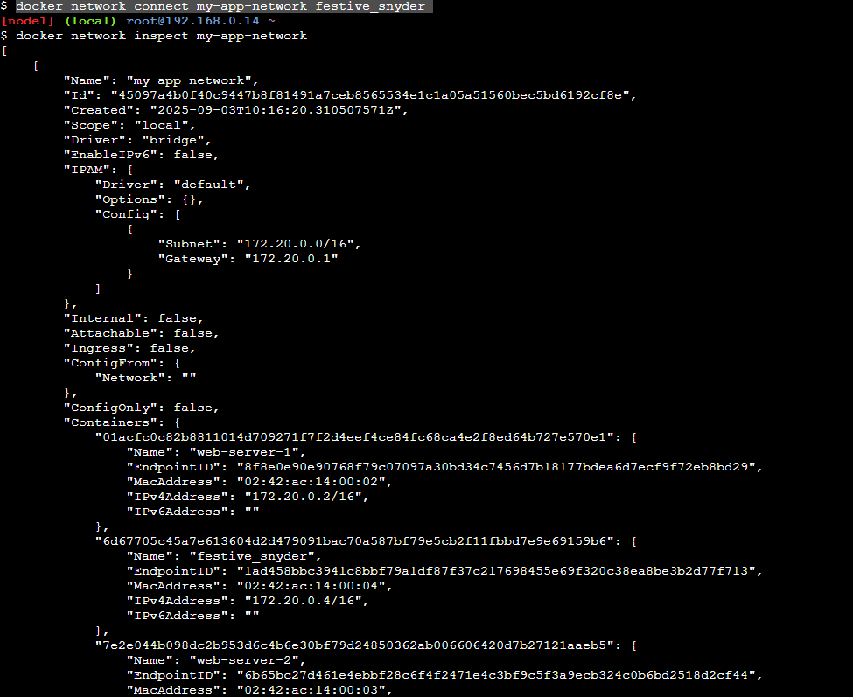

**7. Disconnecting a Container**

To remove a container from a network:

docker network disconnect my-app-network web-server-1

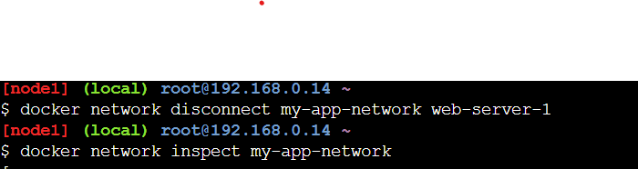

===================================================================================

1. **Differences Between User-Defined Bridges And The Default Bridge:**

**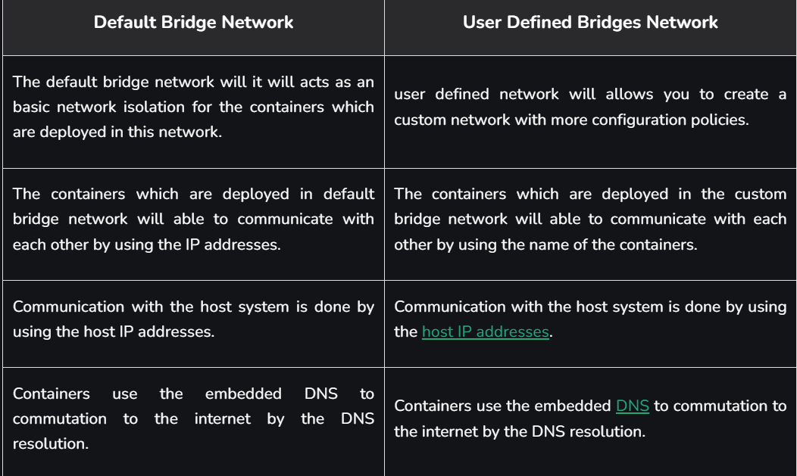**

**Difference between Docker Network Host and Bridge**

**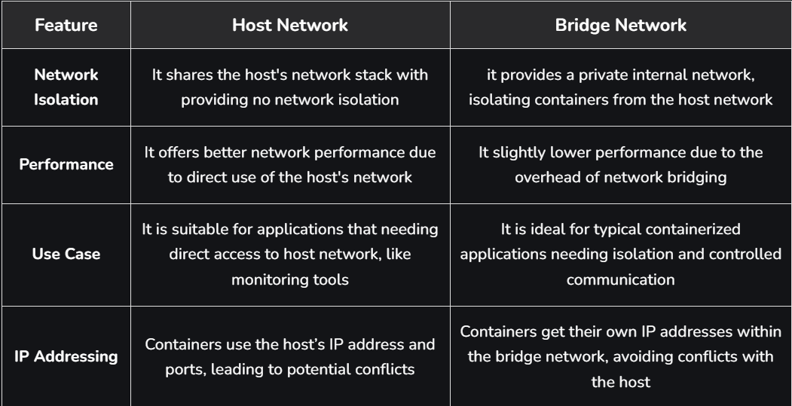**

**Difference between Docker network bridge and Overlay**

**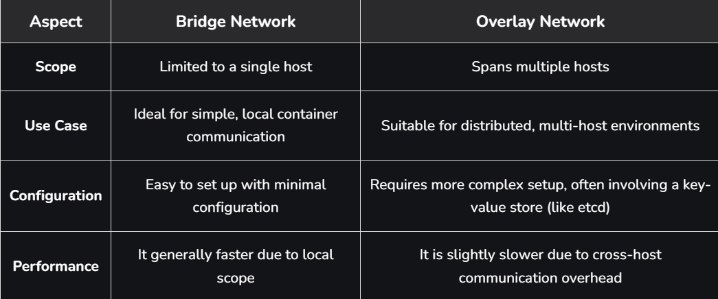**

**\*\*\*\*\*\*\*\*\*\*\*\*\*\*\*\*\*\*\*\*\*\*\*\*\*\*\*\*\*\*\*\*\*\*\*\*\*\*\*\*\*\*\*\*\*\*\*\*\*\*\*\*\*\*\*\*\*\*\*\*\*\*\*\*\*\*\*\*\*\*\*\*\*\*\*\*\*\*\*\*\*\*\*\*\*\*\*\*\*\*\*\*\*\*\*\*\*\*\*\*\*\*\*\*\*\*\*\*\*\*\*\*\*\*\*\*\*\*\*\*\*\*\*\*\*\*\*\*\*\*\*\*\*\*\*\*\*\*\*\*\*\*\*\*\*\*\*\*\*\*\*\*\*\*\*\*\*\*\*\*\*\*\*\*\*\*\*\*\*\*\*\*\*\*\*\*\*\*\*\*\*\*\*\*\*\*\*\*\*\*\*\*\*\*\*\*\*\*\*\*\*\*\*\*\*\*\*\*\*\*\*\*\*\*\*\*\*\*\*\*\*\*\*\*\*\*\*\*\*\*\*\*\*\*\*\*\*\*\*\*\*\*\*\*\*\*\*\*\*\*\*\*\*\*\*\*\*\*\*\*\*\*\*\*\*\*\*\*\*\*\*\*\*\*\*\*\*\*\*\*\*\***

**Section 8: Docker Registry:**

1. **Docker Registry:**

Docker Registry is a centralized storage and distributed system for collecting and managing Docker images. It acts as a server-side application that stores, manages, and distributes container images across environments. It is an essential component in the containerization workflow for streamlining the deployment and management of applications. Features of a Docker Registry are :

* Stateless and scalable
* Organized into repositories, where each repository contains multiple versions (tags) of an image.
* Accessible to users for pushing (uploading) and pulling (downloading) images.

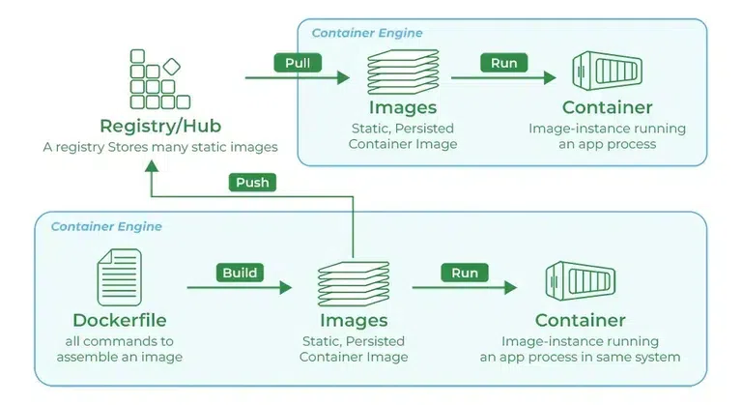

* **Docker Image**: A Docker Image is a template (blueprint) used to create Docker Containers.
* **Docker Images Registry**: A Docker Registry is a storage system where Docker Images are pushed (uploaded) and pulled (downloaded).
* **Docker Hub :**It is the official cloud-based Docker Registry service provided by Docker Inc. It is the default registry where Docker looks for images when you run docker pull or docker run without specifying a registry.
* **Docker Login**: It is a Docker CLI command used to authenticate your local Docker client with a Docker Registry (like Docker Hub, AWS ECR, GCP GCR, Azure ACR, or a private registry). It allows you to push (upload) and pull (download) Docker images securely by verifying your username and password or access token.
* **Authentication of Dockerhub** : Authentication in Docker Hub ensures secure pushing and pulling of Docker images, especially when dealing with private repositories and DevOps pipelines.

**Different Types of Docker Registries**

* **Cloud-Hosted / Public Registries:** These are managed services that are easy to use and integrate with other cloud platforms.
* **Docker Hub:** The default and largest public registry, hosting millions of official and community images.
* **Amazon Elastic Container Registry (ECR):** AWS's managed registry, integrated with its cloud ecosystem.
* **Google Container Registry (GCR):** Google Cloud's offering, tightly integrated with GKE.
* **Azure Container Registry (ACR):** Microsoft's registry service for its Azure platform.
* **GitLab Container Registry:** Integrated directly into the GitLab CI/CD platform.
* **Private / Self-Hosted Registries:** These are registries you run on your own infrastructure for maximum control, security, and speed.
* **Docker Registry Image:** Docker provides an official open-source image (registry:2) that allows you to run a basic registry yourself.
* **Harbor:** An open-source, enterprise-grade registry with advanced features like vulnerability scanning and role-based access control.

**Basic commands for Docker registry:**

**1. Starting your registry**

This command effectively starts a Docker registry on your local machine or server, accessible via port 5000.

docker run -d -p 5000:5000 --restart=always --name registry registry:2

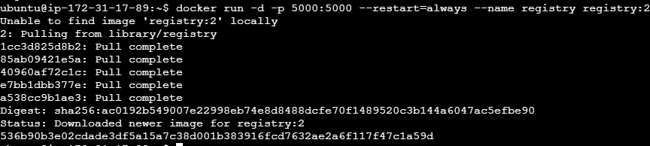

* It instructs Docker to start a registry named registry:2 in detached mode with the name registry. Map the registry's port 5000 to a local port 5000 and restart it immediately if it dies.

1. **Pulling some images from the hub**

The following is the command used for pulling the image from the public docker registry, Here we pulling the ubuntu image.

docker pull ubuntu:latest

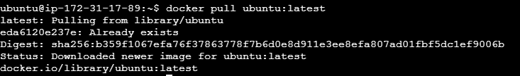

**3. Tagging that image and point to your registry**

The following command is used for tagging the image and point to your registry:

docker image tag ubuntu:latest localhost:5000/gfg-image

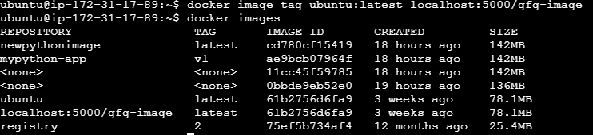

**4. Pushing the image**

The following command is used for pushing the image from the dockerhub:

docker push localhost:5000/gfg-image



**5. Pulling that image back**

This command instructs Docker to pull the image named gfg-image from the local registry running on localhost at port 5000.

docker pull localhost:5000/gfg-image

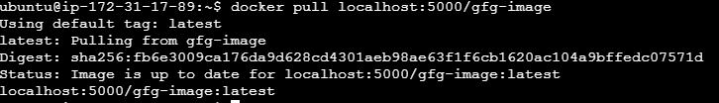

**6. Stop the registry**

This command instructs Docker to stop the container named registry**:**

docker container stop registry



**7. Stop the registry and remove the data**

The following is the command is used for stopping the registry and remove the associated data effectively:

docker container stop registry && docker container rm -v registry



**How does Docker Registry Work?**

A Docker Registry stores and distributes Docker images. Users can push images to the registry and pull them when needed.

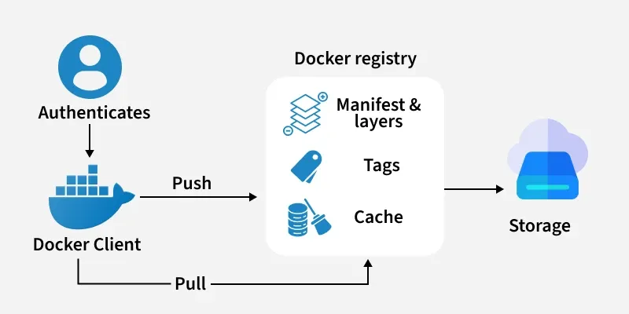

* Docker Registry provides a storage and distribution platform for Docker images.
* Users can upload their Docker images to the registry, and these images can be tagged with a version number and a name.
* Other users can then search for and download these images from the registry.
* Docker Registry can be self-hosted or used as a cloud-based service.
* Docker Registry helps the administrators to implement access controls and permissions ensuring only authorized users and systems.
* Docker Registry facilitates with seamless integration through Continuous Integration/Continuous Deployment (CI/CD) pipelines.

**Why Registries are Important?**

* **CI/CD Automation:** Registries are the bridge in CI/CD pipelines. A CI process builds a new image and pushes it to the registry; a CD process then pulls that image to deploy it to staging or production environments.
* **Centralized Management & Collaboration:** They provide a single source of truth for all container images, making it easy for teams to share and collaborate on applications.
* **Version Control:** By using tags, registries allow you to version your images, ensuring you can track changes and roll back to previous versions if needed.
* **Enhanced Security:** Private registries give you full control over who can access your images. Many hosted registries also offer built-in vulnerability scanning to detect security issues before deployment.

===================================================================================

**2. Public Registry:**

**Docker Image**

In order to run these applications, we first need to create an image of the current application state. An image can be sometimes referred to as a snapshot of our project. Images are read-only in nature and consist of file that contains the source code, libraries, dependencies, tools, and other files needed for an application to run. A [Docker image](https://www.geeksforgeeks.org/devops/what-is-docker-image/) is a read-only template that contains a set of instructions for creating a container which can run on the [Docker platform.](https://www.geeksforgeeks.org/blogs/containerization-using-docker/)

**What is Docker Registry?**

A Docker registry is a service that stores and manages Docker images. A Docker registry could be hosted by a third party, as a [public or private registry.](https://www.geeksforgeeks.org/devops/docker-private-registries/) Some examples of Docker registries are as follows:

* [Docker Hub](https://www.geeksforgeeks.org/devops/docker-tutorial/)
* GitLab
* [AWS Container Registry](https://www.geeksforgeeks.org/devops/introduction-to-amazon-elastic-container-registry/)
* Google Container Registry
* [Docker - Private Registries](https://www.geeksforgeeks.org/devops/docker-private-registries/)
* Git Hub container Registry

**Docker Hub:**

* **Public Repositories:** These imitate public shelves where anyone can take a picture. Just know the name of the Jenkins continuous integration server, like "jenkins/jenkins."
* **Private Repositories**: These like locked storage spaces to which only specific individuals possess the key. They are handy if you want to restrict who can view and access your images.
* **Official Repositories:** Consider themselves to be the standard. They undergo security and best practices checks, so you can be sure they are reliable. You only need to provide the image name, such as "nginx," without providing the user name or company.
* **Automated Builds:** One of DockerHub's many distinctive characteristics is its capacity to produce images automatically anytime the source code is updated. It feels like a robot is doing the hard work for you!
* **Security Scanning:** Like a security guard checking packages for any hidden threats, [DockerHub](https://www.geeksforgeeks.org/devops/what-is-docker-hub/" \t "_blank) can also check your images for vulnerabilities.

**Common Operations Using DockerHub:**

* **Pushing Images:** You can push your locally produced Docker image to DockerHub. This enables you just to set up it on additional machines and makes it accessible to others.
* **Pulling Images:** Images can be downloaded to your local system from DockerHub. When you need to start a service or application that is available as a Docker image, this is useful.
* **Creating Repositories:**You may arrange your Docker images through setting up repositories with DockerHub. According to your requirements, you may create both private and public repositories.
* **Managing Repositories:** Repositories can be controlled by adding contributors to private repositories, editing their descriptions, and changing their visibility settings (public or private).
* **Enabling Automated Builds:** When changes are posted to a connected source code repository (such as GitHub), DockerHub may automatically construct Docker images. This feature makes automated builds possible. By doing this, you can be sure that your Docker images reflect the most recent modifications to your code.
* **Monitoring Build Logs:** DockerHub offers build logs upon the initiation of automated builds, enabling you to track the progress of the build and address any potential problems.
* **Security Scanning:** Docker images can have their known vulnerabilities automatically scanned by DockerHub. It offers a thorough analysis that lists all security flaws in the picture layers and ranks them according to severity.
* **Versioning:** You may easily manage different versions of your application or service by tagging images with version numbers using DockerHub.
* **Integration with Source Control:**Source control systems such as [GitHub and Bitbucket](https://www.geeksforgeeks.org/git/difference-between-bitbucket-and-github/) can be integrated with DockerHub, giving you the ability to schedule builds in response to changes in your code and guaranteeing that your Docker images are always updated with your source code.
* **Collaboration:** DockerHub facilitates teamwork by enabling numerous users to collaborate on the same repository. In addition to managing settings and pulling and pushing photos, collaborators can participate in the development process.

**Private Registries**

* **Internal Network Distribution:**You wish to distribute Docker images inside your company without using the internet. This maintains speed and security.
* **Faster CI/CD Pipelines:** Using an on-premise private registry will speed up the development process. In particular for on-premise environments, pulling and pushing pictures within your own network quicker results in quicker deployments.
* **Large Cluster Deployments:** A private registry makes the process of deploying a new image across several devices more streamlined and effective. Deployments occur more quickly and with more dependability since you are not reliant on external servers.
* **Tight Control Over Storage:**Your are in full ownership of where images are kept while using a private registry. For security and compliance objectives, this is important.

**How Do I Choose the Right Container Registry?**

* **Know Your Needs:**Identify the features you require in the register. Which should you prefer—on-site or in the cloud? What features are required for your procedure?
* **Check Features:** Essential characteristics to look for include access control, security scanning, and interaction with current tools. Select a registry which has the features you require.
* **Security First:** Ensuring that security and compliance come first in the registry. Check for encryption, access controls, and compliance to regulations such as HIPAA and GDPR.

**What are the Top Container Registries Available?**

Docker Hub

Millions of Docker images are hosted on the biggest public container registry, Docker Hub. It provides automatic builds, image vulnerability scanning, interaction with Bitbucket and GitHub, and both public and private repositories. Official repositories with validated images for security and best practices are also made available by Docker Hub.

Amazon ECR

AWS offers a completely managed container registry service called Amazon ECR. The seamless integration of Amazon ECS and Amazon EKS with other AWS services facilitates the deployment of containerized applications on AWS with ease. ECR provides features like lifecycle policies for image management, image scanning with Amazon ECR Public Vulnerability Insights, and encryption at rest.

Google Container Registry (GCR)

Google Kubernetes Engine (GKE) and additional Google Cloud Platform (GCP) services are integrated with Google Cloud's managed container registry service, GCR. Features provided by GCR include vulnerability scanning using Container Analysis, access control with IAM roles, and connection with Google Cloud Build for automated builds.

Azure Container Registry (ACR)

Azure Kubernetes Service (AKS) and further Azure services are integrated with Microsoft's managed container registry service, ACR. High availability geo-replication, role-based access control (RBAC) with Azure Active Directory, and image signing with Docker Content Trust are just a few of the capabilities that ACR provides.

Harbor

Harbor is an open-source container registry project that includes enterprise-grade capabilities such as role-based access control, image replication, vulnerability screening, and policy-based image preservation. Harbor can be deployed on-premises or in the cloud and interfaces with Kubernetes, Docker, and other container technologies.

GitLab Container Registry

Because GitLab's integrated container registry and CI/CD pipelines are tightly coupled, developers can create, test, and launch containerized applications right from GitLab. It has built-in container scanning, access control with project permissions, and picture versioning, among other things.

JFrog Artifactory

Docker images are supported by JFrog Artifactory, an all-purpose artifact repository manager that also works with other package formats including Maven, npm, and NuGet. Features like replication, access control, metadata management, and sophisticated search capabilities are offered by Artifactory.

**Pushing Image to Public Repository:**

Step 1: Create a account in docker hub.

Step 2: Create a repository inside docker hub and copy the repo name.

Step 3: Pull any image from docker hub or use the already existing image.

Step 4: Run that image and create a container and modify that container.

Step 5: Now convert the container to image using the commit command.

docker commit new\_image\_name container\_name

step 6: Now use the tag command to change the image name to docker hub repo name

docker tag image\_name:tag docker\_hub\_userbname/image\_name:tag

Step 7: Now push the image using push command.

docker push image\_name.

Step 8: Now the image is pushed to the public repository.

===================================================================================

1. **Private Registry:**

**What is Docker Private Registry?**

A Docker Private Registry is a dedicated storage and distribution system for your container images, hosted on your own infrastructure or private cloud. While Docker Hub is an excellent public resource, professional development teams require a secure, fast, and controlled environment for their proprietary application images. A private registry is the cornerstone of a secure and efficient software supply chain.

**Why Choose a Private Registry?**

* **Security & Compliance:** This is the primary reason. A private registry allows you to host images within your own network perimeter. This is essential for applications in air-gapped environments or those subject to strict data-privacy regulations like HIPAA or GDPR. You have complete control over access, authentication, and security policies.
* **Performance & Network Latency:** When your CI/CD pipelines and production servers are constantly pulling images, network speed matters. Pulling a multi-gigabyte image from an internal network registry is significantly faster than pulling it from the public internet. This drastically reduces build and deployment times, especially for large-scale Kubernetes or Swarm deployments.
* **Cost Control at Scale:** Cloud-hosted private repositories often charge per repository or based on storage and data transfer. For an organization with hundreds of microservices and thousands of image builds, these costs can spiral. A self-hosted registry can be more cost-effective in the long run.
* **Control & Customization:** A private registry gives you full control. You can integrate it with your organization's existing authentication systems (like LDAP or Active Directory), customize storage backends (like S3 or Google Cloud Storage), and implement custom garbage collection or security scanning policies.

**Steps To Setup Private Docker Registry:**

**Step 1:**Pull the Docker registry image using the below request:

$ docker pull registry

This command will pull the docker latest image from the docker registry

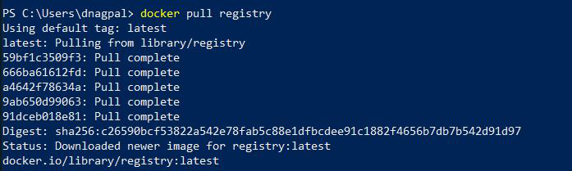

**Step 2:**Configure and run the docker registry image using the below command:

$ docker run -d -p 5000:5000 --name localregistry registry



This command will start the docker container registry on localhost port 5000. The base image used is the registry. The local registry will be the container name.

Now we will also look into how you can pull, push and delete images from the local registry container. When the local registry container is pushed successfully, it will return the container ID in the console.

You can verify by running the below command:

$ docker ps

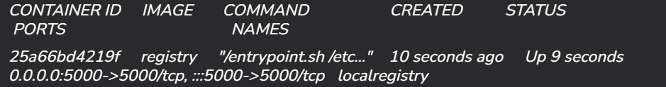

**Step 3:**Pull images from DockerHub. 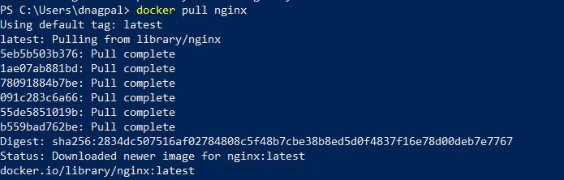

**Push an Image to the Private Registry**

**Step 1:** Tag the images which were pulled from DockerHub. 

* localhost:5000 -> host for your docker private registry
* ubuntu: repository name
* 18.04: tag to identify the version

**Step 2:**Push the tagged images to your docker private registry.

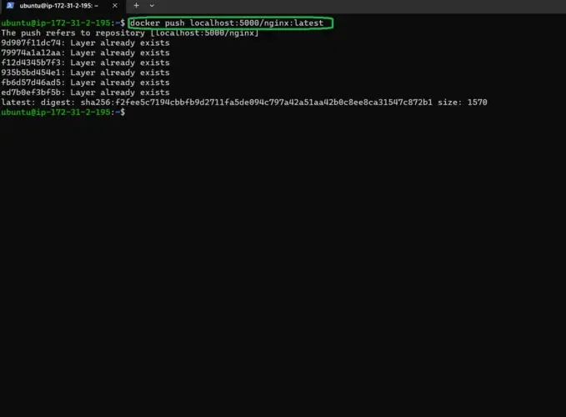

**Pull an Image to the Private Registry**

**Step 1:**Pull the docker [nginx](https://www.geeksforgeeks.org/operating-systems/what-is-nginx-web-server-and-how-to-install-it/) image from the private docker registry. We are here pulling the docker image of Nginx: latest hosted at private registry i.e at [localhost](https://www.geeksforgeeks.org/computer-networks/what-is-local-host/):5000

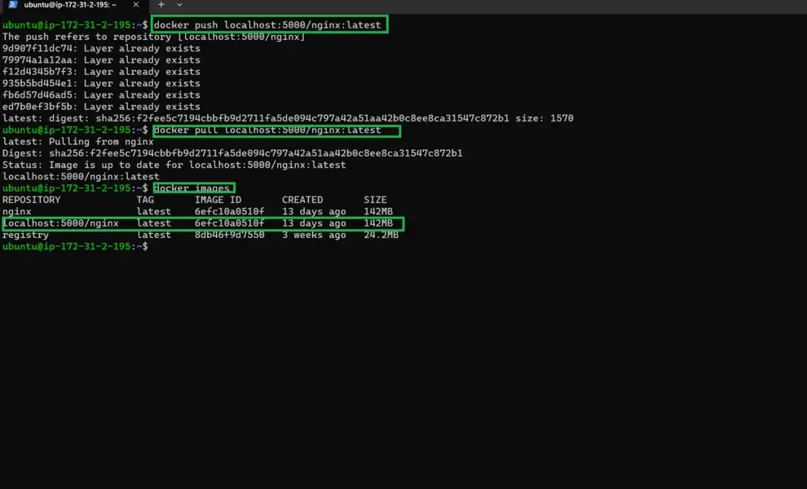

\*\*\*\*\*\*\*\*\*\*\*\*\*\*\*\*\*\*\*\*\*\*\*\*\*\*\*\*\*\*\*\*\*\*\*\*\*\*\*\*\*\*\*\*\*\*\*\*\*\*\*\*\*\*\*\*\*\*\*\*\*\*\*\*\*\*\*\*\*\*\*\*\*\*\*\*\*\*\*\*\*\*\*\*\*\*\*\*\*\*\*\*\*\*\*\*\*\*\*\*\*\*\*\*\*\*\*\*\*\*\*\*\*\*\*\*\*\*\*\*\*\*\*\*\*\*\*\*\*\*\*\*\*\*\*\*\*\*\*\*\*\*\*\*\*\*\*\*\*\*\*\*\*\*\*\*\*\*\*\*\*\*\*\*\*\*\*\*\*\*\*\*\*\*\*\*\*\*\*\*\*\*\*\*\*\*\*\*\*\*\*\*\*\*\*\*\*\*\*\*\*\*\*\*\*\*\*\*\*\*\*\*\*\*\*\*\*\*\*\*\*\*\*\*\*\*\*\*\*\*\*\*\*\*\*\*\*\*\*\*\*\*\*\*\*\*\*\*\*\*\*\*\*\*\*\*\*\*\*\*\*\*\*\*\*\*\*\*\*\*\*\*\*\*\*\*\*\*\*\*\*\*

**Section 9: Docker Volumes:**

1. **Docker Volumes:**

[**Docker Volumes**](https://www.geeksforgeeks.org/videos/what-is-docker-volume/) are persistent data stores for containers, created and managed by Docker, They provide a reliable and efficient way to ensure data persistence when working with containers. Docker volumes are file systems that are mounted on [Docker containers](https://www.geeksforgeeks.org/blogs/containerization-using-docker/) to preserve the data generated by the container.

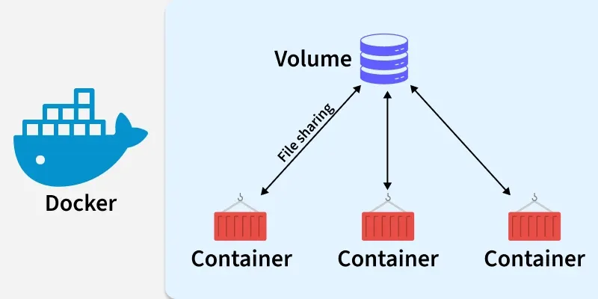

**Why Do We Need Docker Volumes?**

By design, **Docker containers are ephemeral,** meaning they are **temporary and stateless**. Any changes you make **inside a running container**, such as adding files, installing software, or modifying data, will be lost once the container is removed.

In a typical workflow, if you want to apply changes to a container, you:

* Update the Docker image,
* Remove the old container, and
* Launch a new one from the updated image.

While this approach works well for **stateless applications**, it becomes problematic for containers that need to **retain state** such as **databases** (e.g, MySQL, PostgreSQL) or services that generate or store user data.

Docker **volumes** solve this problem by allowing you to **store data outside the container's filesystem**, in a persistent and reusable location managed by Docker. Even if the container is stopped, removed, or rebuilt, the data in the volume remains intact.

This ensures:

* Data durability across container restarts or replacements.
* Separation of application logic (in containers) from persistent data (in volumes).
* A scalable and production-ready way to manage storage for stateful applications.

**Independent Lifecycle of Docker Volumes**

Unlike a container, which has a specific lifecycle that ends when it’s stopped or removed, a **volume's lifecycle** is independent of any particular container. This means that the data stored in a volume persists beyond the container that uses it, making it ideal for retaining important information like databases, configuration files, or logs.

* **Persistence Beyond Containers**: When a container is destroyed, its writable layer is also deleted, but any data stored in a **volume** remains intact. This ensures that your data is not lost even if the container is removed.
* **Shared Access**: A volume can be mounted into **multiple containers** at the same time, enabling easy data sharing across different applications or services.
* **Volume Cleanup**: Even if no container is currently using a volume, it remains available to Docker and won’t be automatically removed. If you need to free up space, you can remove unused volumes using the docker volume prune command.

This behavior allows you to manage and protect your data independently from the container lifecycle, making volumes an essential tool for ensuring data persistence and flexibility.

**Bind Mounts Vs. Docker Volumes:**

**Bind Mounts**

Bind mounts link a **specific directory or file** from the host system directly into the container. This means that any changes made inside the container or on the host will be instantly reflected on both sides.

* **Best for development**: Bind mounts are great for development workflows where live code changes need to be reflected immediately. For instance, if you're actively coding, you can bind mount your local source code into a container to test changes without needing to rebuild the image.
* **Flexibility but risk**: Since bind mounts are tied to the host’s file structure, they are often more flexible but also more prone to issues. Changes made outside the container (by the host) can sometimes interfere with the container's functioning, making them less reliable for production workloads.
* **Example use case**: Sharing configuration files or logging directories between the host and container.

**Docker Volumes**

Volumes, on the other hand, are **managed by Docker** and are independent of the host filesystem. Docker handles their creation and management, providing a more stable and isolated solution for persistent data storage.

* **Best for production**: Volumes are a better choice when you need to ensure data persists beyond container lifecycles. They’re perfect for databases, application states, or any data that needs to remain consistent even if the container is stopped or removed.
* **Automatic management**: Docker automatically handles volume creation, backups, and removal, reducing the risk of accidental data loss. Volumes are also less susceptible to errors caused by host-specific filesystem issues.
* **Performance & scalability**: Volumes often offer better performance than bind mounts, especially when using **volume drivers** that allow for advanced features like **network storage** or **remote data locations**.
* **Isolation & security**: Since volumes are managed by Docker and exist outside the host’s file structure, they offer better isolation and security compared to bind mounts.

**Key Differences**

* **Use Case**: Bind mounts are perfect for **temporary or development storage**, while volumes are designed for **persistent, production-level storage**.
* **Management**: Volumes are easier to manage since Docker takes care of their lifecycle. Bind mounts require manual handling of host directories.
* **Performance**: Volumes generally offer better I/O performance, particularly in production environments.

**Types Of Mounts in Docker:**

The data appears the same from within the container in all mount modes. In the filesystem of the container, it is shown as a directory or a single file.

* **Volumes:** Docker manages volumes kept in a section of the host filesystem (/var/lib/docker/volumes on Linux). This portion of the filesystem shouldn't be altered by non-Docker processes. In Docker, volumes are the most effective way to store data. Using the docker volume create command, we may directly create a volume, or Docker can do it for us when it creates a container or service.
* **Named Pipes:**To facilitate communication between a container and the Docker host, a named pipe mount can be employed. Using a named pipe to connect to the Docker Engine API while running a third-party program inside a container is the typical use case.
* **Bind Mounts:** On the host system, bind mounts can be kept anywhere. These might be crucial system folders or files. They are always modifiable by non-Docker processes running on a[Docker host](https://www.geeksforgeeks.org/devops/docker-containers-hosts/)or in a Docker container. Comparatively speaking, bind mounts are less useful than volumes.
* **Tmpfs Mounts:** These mounts are never written to the host system's filesystem; instead, they are kept solely in the memory of the host system. Neither on the Docker host nor in a container is it stored on a disc. Sensitive or non-persistent state data can be stored on the tmpfs mount for the duration of the container.

**Named Vs. Anonymous Volumes:**

Docker supports two types of volumes: **named** and **anonymous**. While both serve the same purpose—persisting data outside of a container’s lifecycle—they behave differently when it comes to management and reuse.  
  
**Named Volumes**

* Created with a specific name you assign.
* Easy to reference and reuse across multiple containers.
* Ideal for **persistent data** that needs to be accessed or managed long-term (e.g., db-data, app-config).

**Anonymous Volumes**

* Automatically assigned a **random name** (e.g, 13f6a8c5b6b7e0e22349c1...) by Docker.
* Useful for **temporary storage** when you don’t need to manage the volume manually.
* Persist even after the container is removed, unless the container was run with the --rm flag, in which case the volume is deleted along with the container.

**Note:** Each container using an anonymous volume gets its **own unique volume**, so they are **not shared automatically** between containers. To share an anonymous volume, you must explicitly use its **generated volume ID** when running other containers.

**Interacting With Docker Volumes:**

Each volume's name and the storage driver that supports it will be shown. Use docker volume inspect to obtain more in-depth details about a particular volume instead:

**Inspecting Volumes**

To inspect volumes in Docker, you can use the docker volume inspect command followed by the name or ID of the volume you want to inspect. For example:

docker volume inspect my\_vol

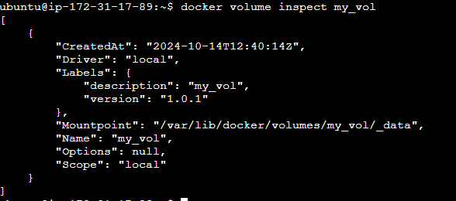

**Removing Volumes**

To remove volumes in Docker, you can use the docker volume rm command followed by the name or ID of the volume you want to remove. For example:

docker volume rm my\_vol

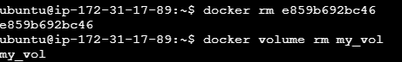

**Pruning Volumes**

To [prune volumes in Docker,](https://www.geeksforgeeks.org/devops/docker-prune/) you can use the docker volume prune command. This command removes all volumes not used by at least one container. Here's how you can use it:

docker volume prune

**Starting a Container with a Volume**

**On Using -v Option**

We may start a container with a bind mount using the -v option:

$ docker run -v $(pwd):/var/opt/project bash:latest \  
 bash -c "ls /var/opt/project"

**Using The –mount Option**

To indicate the volume we want to mount, we might find it easier to use the more obvious –mount option:

$ docker run --mount \  
 'type=volume,src=data-volume,\  
 dst=/var/opt/project,volume-driver=local,\  
 readonly' \   
 bash -c "ls /var/opt/project"

===================================================================================

1. **Mounting a Volume Inside Docker Container:**

When you are working on a micro-service architecture using Docker containers, you create multiple Docker containers to create and test different components of your application. Now, some of those components might require sharing files and directories. If you copy the same files in all the containers separately, it might lead to an unnecessary increase in the image size, and also, changing a file in one container will not create the corresponding change in the same file in other containers.

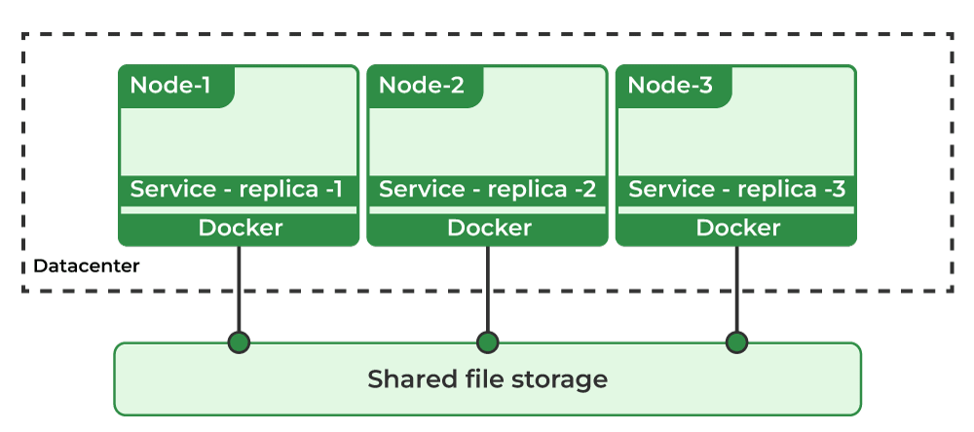 Hence, you required a shared directory or volume that you can mount on multiple [Docker Containers](https://www.geeksforgeeks.org/blogs/containerization-using-docker/), and all of them have shared access to a particular file or directory. Docker allows you to mount shared volumes in multiple containers. In this article, we will mount a volume to different containers and check whether the changes in the file are shared among all the containers or not.

**Volumes**

Volumes in docker are the preferred way to deploy a stateful set application in the form of containers. You can manage and persist the docker data outside of the docker life cycle. Volumes are completely managed by docker, unlike the bind mounts. Docker volumes will allow you to share the data between the docker containers and the docker host. They are two types of volumes in the docker. You [store the data in Docker.](https://https/www.geeksforgeeks.org/data-storage-in-docker)

* Named volumes.
* Bind volumes.

**Create and manage volumes | Step By Step Instructions**

**Step 1: Display all the existing Docker Volumes**

To display all the existing [Docker Volumes,](https://www.geeksforgeeks.org/devops/what-is-docker-volume/) you can use the list command as follows.

sudo docker volume ls

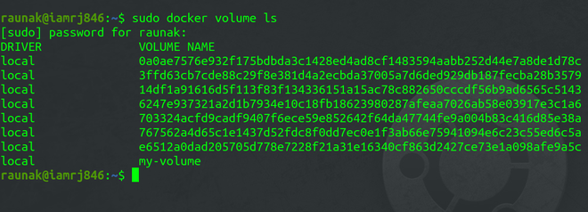

**Step 2: Creating a Volume**

To create a new Docker Volume, you can use the Volume Create Command.

sudo docker volume create geeksforgeeks

**Step 3: Inspecting Docker Volumes**

To get the details of the Volumes you have created, you can use the Volume Inspect Command.

sudo docker volume inspect geeksforgeeks

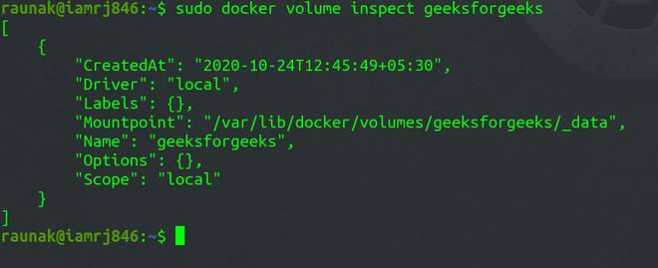

**Step 4: Mounting Docker Volumes**

After creating the Volume, the next step is to mount the Volume to Docker Containers. We will create a Docker Container with the Ubuntu base Image which you will mention in [Dockerfile](https://www.geeksforgeeks.org/cloud-computing/what-is-dockerfile/) and mount the ***geeksforgeeks***Volume to that Container using the -v flag. You can [install the Linux package](https://www.geeksforgeeks.org/installation-guide/how-to-install-linux-packages-inside-a-docker-container/) by using the Dockerfile.

sudo docker run -it -v geeksforgeeks:/shared-volume --name my-container-01 ubuntu

The above command mounts the ***geeksforgeeks***volume to a directory called **shared-volume**inside the Docker Container named **my-container-01.**

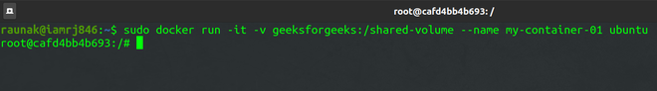

**Step 5: Create a file inside the Docker Volume**

 Inside the bash of the Container, create a new file and add some content.

ls  
cd /shared-volume  
echo “GeeksforGeeks” > geeksforgeeks.txt  
ls  
exit

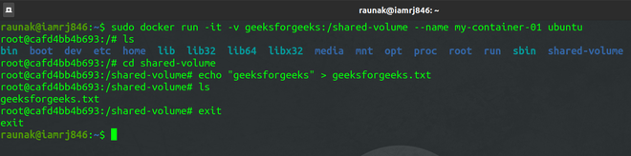

**Step 6: Create another Container and Mount the Volume**

Create another Docker Container called **my-container-02 geeks for geeks**inside the Container.

sudo docker run -it -v geeksforgeeks:/shared-volume --name my-container-02 ubuntu

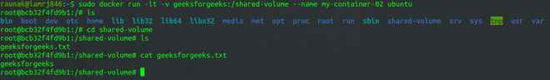

If you go to the **shared-volume** directory and list the files, you will find the **geeksforgeeks.txt**file that you had created in the same volume but mounted in **my-container-01** earlier and it also has the same content inside it. This is so because the volume is shared among the two Containers.

**Step 7: Remove a volume**

Before removing the volume you should make sure you have taken the backup of the volume because it is going to delete permanently the data stored in it. By using the following command you can remove the docker volume. To know more commands in Docker refer to Docker Commands.

docker volume rm volume\_name\_or\_id

In the place of volume\_name\_ or \_id, you should use your volume name and volume id.

**Step 8: Start a Container With a Volume**

Before starting a container with the help of volume you should create volume first. After that, you use the following command to create a container. Before creating a container you need a [Docker image.](https://www.geeksforgeeks.org/devops/what-is-docker-image/)

docker run -d --name mongo -v mongovol:/data/db -e MONGO\_INITDB\_ROOT\_USERNAME=devdb -e MONGO\_INITDB\_ROOT\_PASSWORD=devdb123

**"-v mongovol:/data/db"**represents the name of the volume and "**/data/db"**represents the directory with which the volume is going to be mounted**"-e"**represents the environmental variable which is written by the developers them selfs it can**"user name and password".**

**Step 9: Use a Volume With Docker Compose**

While writing the [docker-compose](https://www.geeksforgeeks.org/devops/docker-compose/) file you canmount the volume which is created to store the data as shown following.

services:  
 frontend:  
 image: node:lts  
 volumes:  
 - mongovol:/data/db  
volumes:  
 mongovol:

* **services:** This section defines the services or containers that compose your application. In this case, there's one service named "[frontend.](https://www.geeksforgeeks.org/blogs/frontend-vs-backend/)"
* **frontend:**This is the name of the service. It could be any name you choose to represent this container within your application.
* **image:** node:lts: Specifies the Docker image used to create the container. Here, it's using the official Node.js image tagged with "lts" (Long-Term Support), which typically includes the latest LTS version of Node.js.
* **volumes:**This subsection specifies any volumes that should be mounted into the container. Volumes allow for [persistent data storage](https://www.geeksforgeeks.org/cloud-computing/what-is-persistent-storage/) that persists even if the container is removed.
* **- mongovol:/data/db:** This line defines the volume named "mongovol" to be mounted into the container at the path "/data/db". Here, "/data/db" likely represents the default data directory for a [MongoDB container.](https://www.geeksforgeeks.org/installation-guide/how-to-run-mongodb-as-a-docker-container/) This volume mounting ensures that data stored within the container at "/data/db" is persisted outside of the container's lifecycle.
* **volumes:**This section defines named volumes that can be used by the services defined above.
* **mongovol:**This line defines a named volume named "mongovol." Named volumes provide a way to persist data beyond the lifetime of a single container. This volume can be shared among multiple containers or services, allowing data to be shared and persisted across them.

In the above compose file you can see the column "**volumes"**In that area you should mention the name of the volume and directory or the path of the volume you should mention.

**Differences between -v and --mount behavior**

The -v and --mount options in Docker both serve the purpose of attaching volumes to containers, but they have some key differences in behavior and capabilities:

1. **Syntax:**
   * **-v**: The -v option is the shorthand syntax for specifying volume attachments. It takes two arguments: the volume name or host directory path, and the container directory path.
   * **--mount**: The --mount option provides a more explicit and flexible way to attach volumes. It allows for finer control over volume options and can be used to mount volumes from various sources.
2. **Capabilities:**
   * **-v**: The -v option is more straightforward and suitable for basic volume mounting. It supports mounting volumes from the local host machine or named volumes created using docker volume create.
   * **--mount**: The --mount option is more versatile and powerful. It allows for specifying various options such as volume driver, read-only mounts, mount propagation, and more. This option can mount volumes from different sources like local directories, named volumes, or remote volume services like [AWS EBS](https://www.geeksforgeeks.org/devops/introduction-to-aws-elastic-block-storeebs/) or [Azure File Storage.](https://www.geeksforgeeks.org/devops/microsoft-azure-map-a-network-file-share-to-azure-windows-vm/)
3. **Volume Options:**
   * **-v**: With the -v option, you can only specify basic volume options such as read-only mounts and caching behavior.
   * **--mount**: The --mount option offers a broader range of volume options, including specifying volume drivers, read-only mounts, mount propagation modes, and more advanced options like specifying volume labels and setting custom volume permissions.
4. **Flexibility:**
   * **-v**: The -v option is more concise and easier to use for simple volume mounting tasks.
   * **--mount**: The --mount option provides more flexibility and control, making it suitable for complex volume mounting scenarios where specific configurations are required.

**Populate a Volume Using a Container:**

**Step 1:**Create a docker volume.

docker volume create my\_volume

**Step 2:**Create a container to populate the volume.

docker run -d --name mongo -v mongovol:/data/db   
-e MONGO\_INITDB\_ROOT\_USERNAME=devdb MONGO\_INITDB\_ROOT\_PASSWORD=devdb123

**Step 3:**Verify the populated volume.

docker run --rm -v mongovol:/data/db busybox ls /data/db

**Share Data Between Machines:**

When you deploy a fault tolerance application you need to give permission to the multiple replicas of the same service to the same files for that you can use some services like [S3](https://www.geeksforgeeks.org/devops/introduction-to-aws-simple-storage-service-aws-s3/), [NFS](https://www.geeksforgeeks.org/operating-systems/network-file-system-nfs/), and so on as shown in the following figure.

**Use a volume driver**

You can create the docker volumes by using the following command before creating a container. If you want to create a volume while creating the container you achieve that by using the volume drivers in the docker. You can create a volume by using a volume driver as shown in the following.

docker volume create --driver vieux/sshfs <name of the vlome you want to create>

**Create a Service Which Creates an NFS Volume:**

**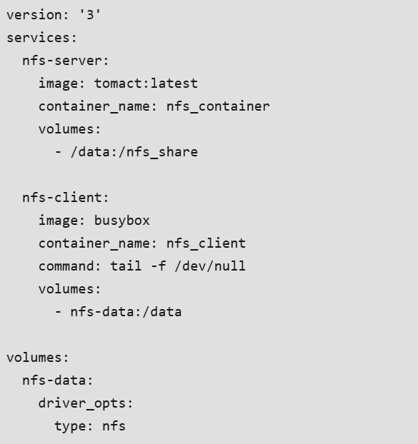**

* **NFS Server:**
  + **Image:** Uses an image named "[tomact](https://www.geeksforgeeks.org/devops/how-to-start-tomcat-server/" \t "_blank)" (probably a typo for "tomcat") with the latest version.
  + **Container Name:** Sets the name of the container running the NFS server to "nfs\_container".
  + **Volumes:** Maps the host directory "/data" to the container directory "/nfs\_share", allowing data to be shared between the host and the container.
* **NFS Client:**
  + **Image:** Uses the "busybox" image, which provides a minimal Linux environment.
  + **Container Name:** Sets the name of the container running the NFS client to "nfs\_client".
  + **Command:** Specifies a command to keep the container running ("tail -f /dev/null").
  + **Volumes:** Creates a named volume named "nfs-data" and mounts it to the "/data" directory inside the container. This volume uses the NFS driver for sharing data with the NFS server.
* **Volumes:**
  + **nfs-data:** Defines a named volume named "nfs-data".
  + **Driver Options:** Specifies options for the volume driver, setting the type to "nfs". This indicates that the volume will be managed by the [NFS (Network File System)](https://www.geeksforgeeks.org/operating-systems/network-file-system-nfs/) driver, allowing the container to access files stored remotely on an NFS server.

**How to Use Docker Volumes to Persist Changes:**

**Create a Volume:** First, create a Docker volume using the docker volume create command. For example:

docker volume create my\_volume

**Mount the Volume to a Container:** When running a container, use the -v flag to mount the volume to a specific directory within the container. For example:

docker run -d -v my\_volume:/app my\_image

**Make Changes Inside the Container:** Access the running container using docker exec -it <container\_id> /bin/bash or similar commands. Then, make changes to files or directories within the mounted volume.

**Verify Persistence:** Exit the container and start another instance using the same volume. Verify that the changes made in the previous container are persisted. For example:

docker run -d -v my\_volume:/app my\_image

===================================================================================

1. **Sharing Data between Docker Containers:**

When you use Docker, each container runs separately, like its own small computer. This helps keep things organized and secure, but it can be a problem when containers need to work together. For example, if one container saves data (like a database) and another needs to use that data (like a web app), they need a way to share it. Without that, they can't talk to each other properly, and your app won’t run as it should.

Also, any data stored inside a container disappears when the container stops. So if you want to keep files, logs, or database records even after stopping or restarting, you need a way to store that data safely.

**Methods of Sharing Data between Docker Containers:**

Below are 2 ways to share data between containers using [Docker volumes](https://www.geeksforgeeks.org/what-is-docker-volume/) and [Bind Mount](https://www.geeksforgeeks.org/how-to-use-bind-mount-in-docker/):

**Which One Should You Use?**

Use **volumes** for most cases, especially in production they're managed by Docker, portable, and ideal for sharing persistent data between containers. Use **bind mounts** during **development** when you need to sync files from your host, like live code changes. Volumes are more secure and stable; bind mounts offer more flexibility but are host-dependent.

**Method 1: Share Data Using Docker Volumes**

**Step 1: Create a Docker Volume**

docker volume create shared-data

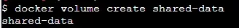

**Step 2: Run Container A with the Volume**

Mount the volume to a path inside Container A

docker run -d --name container-a -v shared-data:/data busybox sleep 3600

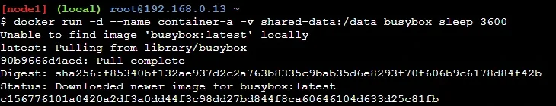

**Step 3: Add Data in Container A**

We are putting a message inside the volume folder from Container A. This file (message.txt) is saved in /data, which is the shared volume.

docker exec container-a sh -c "echo 'Hello from A' > /data/message.txt"

**Step 4: Run Container B with the Same Volume**

Now, you start Container B and connect it to the same volume. It will also see whatever is in /data, just like Container A.

docker run -d --name container-b -v shared-data:/data busybox sleep 3600



**Step 5 : Access the Data in Container B**

Inside Container B, you read the file message.txt. This shows the message written by Container A. That means sharing worked!

docker exec container-b cat /data/message.txt



**Method 2: Share Data Using Bind Mounts**

This method is best for sharing host directories across containers. The following are the steps you can follow to share data using bind mounts:

**Step 1: Create a Directory on the Host**

Make a folder on your own computer (outside Docker) and save a file in it. This folder will be shared with containers.

mkdir /tmp/shared-dataecho "Hello from host" > /tmp/shared-data/host.txt

**Step 2: Run Container A with Bind Mount**

You start Container A and link it to your host folder. Inside the container, that folder will appear as /data.

docker run -d --name container-a -v /tmp/shared-data:/data busybox sleep 3600

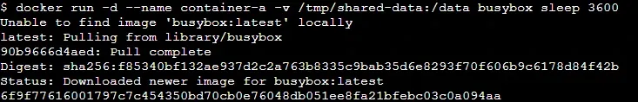

**Step 3: Run Container B with Same Bind Mount**

Now, Container B also connects to the same host folder. Both containers are now seeing the same /tmp/shared-data content.

docker run -d --name container-b -v /tmp/shared-data:/data busybox sleep 3600



**Step 4: Check Shared File in Container B**

Inside Container B, you check if it can read the file placed by the host. If you see the message, the data sharing worked.

docker exec container-b cat /data/host.txt



===================================================================================

1. **How to Use Bind Mounts and Volumes in Docker?**

Bind mounts and the host filesystem are tightly related. The host filesystem is immediately impacted by changes made to a bind mount, and vice versa. When you use a bind mount to remove a container, the related data stays on the host.

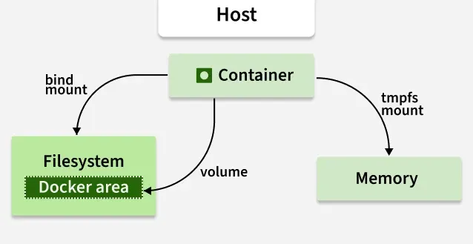

**What is Bind Mount in Docker?**

Bind mounts may be stored anywhere on the host system. They may even be important system files or directories. Non-Docker processes on the Docker host or a [Docker](https://www.geeksforgeeks.org/devops/introduction-to-docker/) container can be modified at any time. You can create a file on the host system and attach it to the container where you want to maintain the state of the Docker. You can also use the bind mount for stateful applications.

**Types of Docker Volume Driver Plugins are Available**

In docker we mainly use two docker driver volume plugins, They are:

**1. Local Driver (Steps To Create Custom Docker Volume Using Local Driver)**

The Local Driver is a built-in Docker volume plugin that allows users to create volumes using local storage on the host machine. Follow the steps below to use the local driver to create the volume using a local driver.

**Steps to Create Custom Volume:**

1. Use the command docker volume create -d local <Name\_Of\_the\_Volume> to create a Docker volume using the Local Driver.
2. Replace <Name\_Of\_the\_Volume> with the desired name for the volume.

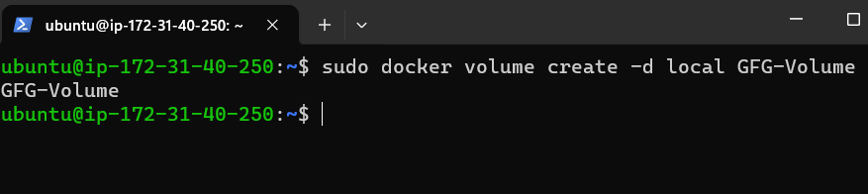

docker create volume -d local <Name Of the Volume>

**Usage Example:** Creating a volume named "GFG-Volume" using the Local Driver: docker volume create -d local GFG-Volume.

**2. REX-RAY Driver**

* **Description:** REX-Ray is an external Docker volume plugin that provides support for various storage solutions, including cloud storage and networked storage.
* **Usage:** REX-Ray needs to be installed separately and configured to integrate with Docker.
* **Benefits:** REX-Ray simplifies the management of volumes by allowing Docker to interact with external storage systems seamlessly.
* **Usage Example:** Once REX-Ray is installed and configured, Docker users can utilize its capabilities to create and manage volumes across different storage platforms.

**How to List the Docker Volumes?**

The docker volume ls command is used to list all the volumes created on the Docker host. It provides detailed information about each volume, including its name, driver, and optionally other properties such as mount point. You can list all the docker volumes that are available in the docker by using a simple command as shown below.

docker volume ls

"docker volume ls" will list all the docker volumes which are available in the docker host and also it will list the volume which are managed out side of the docker host as shown in the image below.

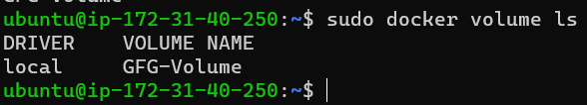

**Steps to Create And Attach Bind Mount To The Docker Container:**

**Step 1: Create an Empty Directory on the Docker Host**

This command creates an empty directory on the Docker host. This directory will act as a volume that can be mounted to the container.

Mkdir <Name Of the Volume You wan to Create>

**Step 2: Attach the Bind Mount to the Docker Container**

Know this directory will act as an volume on the docker host you need to mount this to the path where the data will be stored in the application as show in the image below you can use the following command to do this.

sudo docker run -d <Container ID> --name <Name Of the Container> -v <Host Path>:<Container Path>

* **<Container\_ID>:** The ID of the container to which you want to attach the bind mount.
* **<Name\_Of\_the\_Container>:** The name you want to give to the container.
* **<Host\_Path>:** The path of the directory on the Docker host that you created in step 1.
* **<Container\_Path>:**The path inside the container where you want to mount the volume.

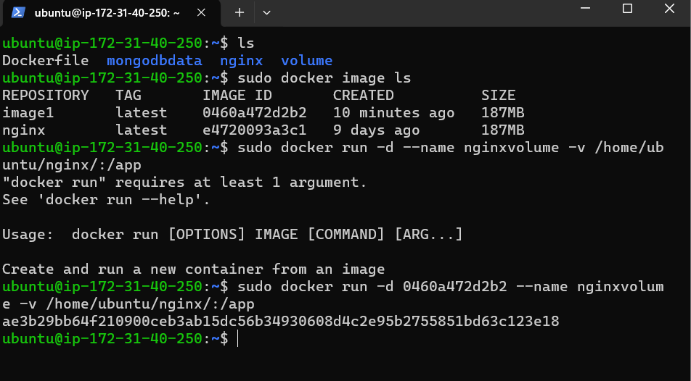

/home/ubuntu/nginx is the host path where my directory of volume is located and the /app is the container path.

**Choose the -v or --mount flag**

When working with Docker, choosing between the -v and --mount flag depends on your specific needs and the complexity of your volume requirements.

Here's a simple breakdown to help you choose:

* **-v Flag:**
  + This is the shorthand notation for specifying volumes.
  + It's easier to use and more commonly used for basic volume mounting tasks.
  + It's suitable for simple volume setups, such as mounting a single directory from the host into a container.

docker run -v /host/directory:/container/directory ...

* **--mount Flag:**
  + Provides more flexibility and options for defining volumes.
  + It allows you to specify additional options like read-only, consistency, and volume driver.
  + Suitable for advanced volume configurations and scenarios where finer control over volume properties is needed.

docker run --mount type=bind,source=/host/directory,target=/container/directory ...

This is particularly useful when you need to define more complex volume configurations or when using volume plugins like NFS or REX-Ray.

**Differences between -v and --mount behavior:**

* **-v is shorthand** and simpler to use. It's great for quick tasks like mounting a host directory or named volume. Example: -v /host:/container.
* **--mount is more verbose** but clearer and more flexible. You must specify type, source, and target, which makes the intent easier to understand. Example: --mount type=bind,source=/host,target=/container.
* **-v offers fewer options**. It doesn’t easily support advanced features like read-only access, consistency settings, or specifying a volume driver.
* **--mount supports advanced features** such as read only, volume driver, and better handling of different mount types (like tmpfs, bind, and volume).
* **Use -v for quick, simple containers**, especially during development or testing.
* **Use --mount when you need precision**, like in production environments, or when writing Docker Compose files and scripts.

**Where are Docker bind mounts stored?**

Docker bind mounts are stored on the host machine where Docker is running. When you create a bind mount, you specify a path on the host machine that you want to share with the container. Docker then links this path to a location inside the container.

Docker bind mounts are stored in directories on your computer's file system, and these directories are accessible both inside the Docker container and from outside, allowing easy sharing of files and data between the container and the host machine.

**How to mount a host directory in a Docker container**

To mount a host directory in a Docker container using a [Docker Compose](https://www.geeksforgeeks.org/devops/docker-compose/)file, you can specify the volumes configuration within the services section. Here's a simple example:

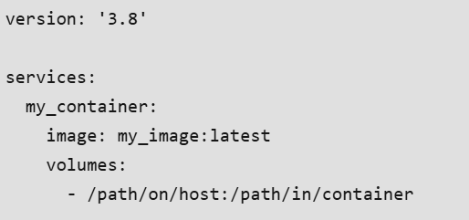

* **my\_container:**This is the name of your container service.
* **image:**Specifies the [Docker image](https://www.geeksforgeeks.org/devops/what-is-docker-image/) to use for the container.
* **volumes:**Defines the volumes to mount into the container.
  + **/path/on/host:**This is the path to the directory on the host machine that you want to mount.
  + **/path/in/container:**This is the path inside the container where you want to mount the directory.

===================================================================================

1. **Docker Volume VS Bind Mount:**

Docker volume and Bind mount are the docker components. Using bind mounts, you may mount a file or directory from your host computer onto your container and access it using its absolute path. Because Docker does everything independently, it is not dependent on the host computer's operating system or your directory structure. The Docker CLI commands or the Docker API may be used to manage Docker Volumes. It is safer to share quantities among many containers. The host computer's absolute path to the file or directory serves as a point of reference. Conversely, when a volume is used, Docker makes a new directory in the host machine's storage directory and keeps it updated.

**Difference between Docker volume and Bind mount:**

**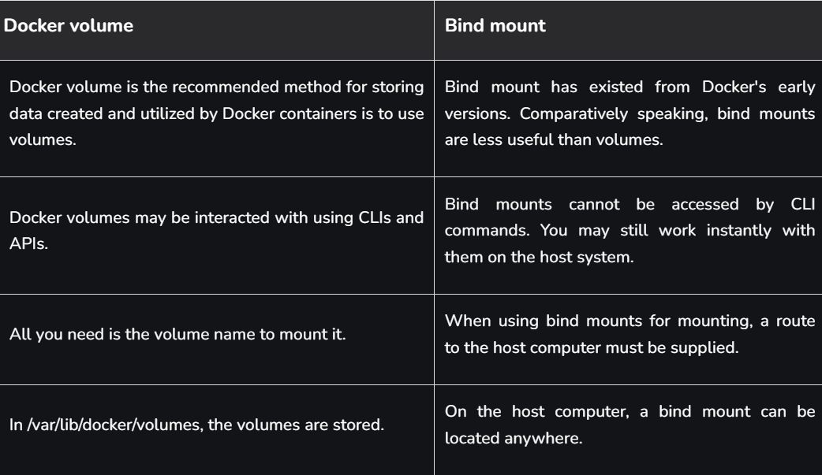**

**What is Docker volume?**

[Docker volume](https://www.geeksforgeeks.org/devops/what-is-docker-volume/) is the recommended method for storing data created and utilized by Docker containers is to use volumes. Docker manages volumes entirely, whereas bind mounts rely on the host machine's operating system and directory structure. Bind mounts are more difficult to transfer or backup than volumes. Volumes may be managed via the Docker API or Docker CLI commands. Volumes are compatible with Windows and Linux containers. Sharing volumes among several containers is safer.

**Use Cases of Docker volume**

* A volume should be used to store the data that your application creates, such as documents, profile pictures, and file uploads.
* By mirroring /var/lib/docker/volumes to a different place, Docker's centralized volume storage makes it simple to back up container data. The operation may be automated with community tools and Docker Desktop extensions, making it far easier than manually transferring each bind-mounted directory.
* It is recommended that you mount a volume to the storage directories that Mongo, Postgres, and MySQL databases utilize. Your data will remain intact even after the container shuts down thanks to this.
* It is possible to mount Docker volumes to several containers at once. Containers can see modifications made by their neighbors in real time.

**Advantages of Docker volume**

* [Docker Desktop](https://www.geeksforgeeks.org/devops/docker-desktop-sample-image/) volumes perform far better than bind mounts from Windows and Mac computers.
* Docker Volume drivers enable you to add more functionality, encrypt the contents of volumes, and store volumes on distant hosts or cloud providers.
* For flexibility and scalability, Docker volumes may be set up to leverage external storage options like cloud storage services or network-attached storage.
* Docker Volumes may be managed via the Docker API or Docker CLI commands.

**Disadvantages of Docker volume**

* The Docker platform is open source overall, certain container solutions are not compatible with others, mostly because of competition between the companies who provide support for them.
* It may be difficult to move volumes across various Docker environments, particularly if the underlying storage drivers or settings change.
* Docker Volumes may raise security issues depending on how they are configured, particularly if they are shared by several containers.
* The only monitoring solution offered by Docker is the stats command. If we just need the bare minimum of information about the containers, then that is adequate.

**What is Bind mount?**

Bind mounts have existed from Docker's early versions. Comparatively speaking, bind mounts are less useful than volumes. A file or directory on the host computer gets mounted into a container when you use bind mount. The absolute path of the file or directory on the host computer is used as a reference. On the other hand, when you utilise a volume, Docker creates and maintains a new directory within the host machine's storage directory.

**Use Cases of Bind mount**

* Bind mounts replicate the website's directory into the home directory of a jailed user, therefore limiting access to specific areas of the website for selected users.
* Processes operating within a container allow you to modify the host filesystem.
* The instant a file is saved, the container is notified of the modifications you make to the code.
* This includes adding, removing, and altering system folders and files, all of which might have dangerous security repercussions.

**Advantages of Bind mount**

* Bind mounts are frequently used in local development environments. One benefit is that not all build environments and tools need to be installed on the developer workstation.
* These allow you to reference a file or directory on your host system through its absolute path, which is mounted onto your container.
* Docker gathers tools and dependencies with a single docker run command.
* Bind mounts offer a simple method of linking particular directories or files from the host to the container, and they are quick to set up.

**Disadvantages of Bind mount**

* In order to provide a way to distribute server programmes without a graphical user interface, Docker bind mount was developed.
* Security issues may arise from improperly setup bind mounts. The host's files and folders are accessible to the container.
* Numerous feature requests are being worked on, such as file transfer from the host to the container, self-inspections and registration of containers, and many more.
* Performance may be impacted by bind mounts, particularly when handling big volumes of data.

===================================================================================

**Section 10: Docker Swarm:**

1. **Docker Swarm:**

[Docker Swarm](https://www.geeksforgeeks.org/devops/introduction-to-docker-swarm-mode/) is a container orchestration engine that was included by Docker as a part of its container runtime. Docker Swarm was included in the Docker container runtime in June of 2016.

Docker Swarm is also included in the Mirantis Container Runtime (formerly called the Docker Enterprise Engine) which is also referred to as MCR, which takes a Docker Engine and adds additional features and capabilities including security hardening to make it enterprise-ready.

**Why we need Docker Swarm?**

Let us take an example to understand the need of Docker Swarm. Let us say you have an application that is divided into 100 containers, now you will need to manage and control multiple containers at a time as a single service. This is called Orchestration - managing and controlling multiple containers as a single service. And this is what we use Docker Swarm for.

We use Docker Swarm for the following tasks:

1. Health check on every container
2. Ensure all containers are up on every system
3. Scaling the containers up or down
4. Adding updates/changes to all the containers
5. Deploying a fixed set of containers
6. Performing rolling update of the containers
7. Load Balancing of the containers

**Features of Docker Swarm**

We have many Container Orchestration tools in the market like [Kubernetes](https://www.geeksforgeeks.org/devops/introduction-to-kubernetes-k8s/), Apache Mesos etc. Kubernetes is even more popular Orchestration tool, Then why should Docker? Here are a few reasons to use [Docker](https://www.geeksforgeeks.org/blogs/containerization-using-docker/) and some features of Docker:

**1.**Docker Swarm schedules the containers, sets up Network Predictions, Monitors for Container health and also restarts any container that have died or are deemed to be unhealthy. If an entire node goes down Docker Swarm will reschedule those workloads on a different node.

**2.**Docker Swarm becomes even more useful when you want to orchestrate your containers and don't want to download and install a separate software package since it is already installed with Docker. All you need to do is turn the Docker Swarm on.

**3. Docker Swarm works with both Linux and Windows worker nodes.**

**4.**Swarm can be extended with Networking Plugins, Storage Plugins, Logging Plugins etc. What does it actually solves is it lets you declare your state instead of having to do everything manually and all your resources, your services, labeling or constraints can be declared in a *'yaml'* file.

**5.**Swarm also handles provisioning and manages where containers get deployed so if you have a cluster of several nodes it will try to balance out your workloads across multiple nodes within your cluster. That is great for high availability and scaling. If you have a peak in traffic you need to scale up your web server, you can do that in swarm mode. I can also move containers from one node to another so if one node runs out of resources or the whole node goes down that is when it will act upon that.

**6.**Docker Swarm also load balances traffic across multiple containers.

**7.**Swarm keeps track of the health of the containers. It also allows us to expose services with an ingress solution.

**Docker Swarm Architecture**

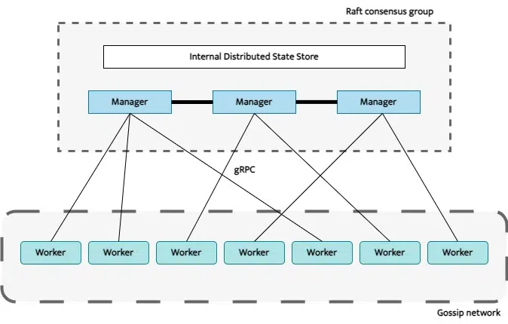

This is a high-level architectural view of Docker Swarm. In the diagram we have three manager nodes (similar to the Master nodes of Kubernetes). A node is an individual Docker Engine participating in the swarm. Swarm is a Mode which consists of multiple Docker hosts which run in a cluster. We always have an odd number of manager nodes. If we have a development or test environment where availability is not a big concern we can only use one manager node, but in production we will generally have either three or five manager nodes. Worker nodes are nodes where where the actual workloads are run. The workers nodes communicate with each other using the gossip protocol.

**Swarm Nodes Breakdown**

Docker Swarm has two types of nodes - Manager nodes and Worker nodes.

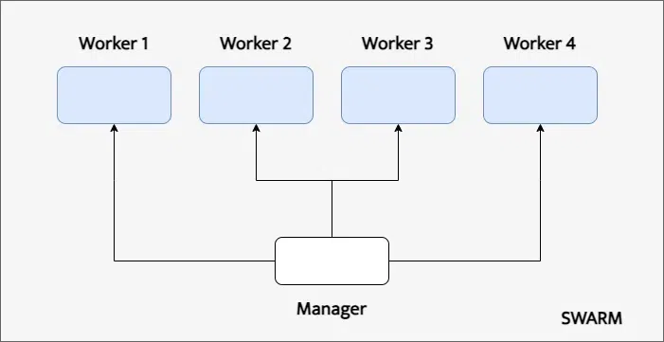

**1. Manager nodes**

Manager nodes are the machines that we communicate with. Manager nodes are used to assign work to the other nodes. It accepts command from client and creates service object(s).

Manager nodes handle cluster management tasks like maintaining the cluster state, scheduling the services, and serving the swarm mode HTTP API endpoints. It maintains a consistent state of the swarm and services running on it. It Allocates IP addresses to tasks, Assigns nodes to tasks and Checks in on workers

**2. Worker nodes**

Worker nodes are the nodes where the containers run actually. Worker nodes connects to the dispatcher to check the assigned tasks and executes the tasks assigned to it.

**Swarm tasks and stacks**

**Swarm Tasks**

Swarm Tasks are the atomic unit of scheduling in a Swarm. In simpler terms, a Task is a container and the commands that are running it and it's a small schedule unit in Swarm. Swarm manager nodes will assign a task to a Worker node and the worker nodes will run it and report on its status. A Task progresses sequentially through a series of states these are assigned, prepared, running, etc.

**Example of a task:**

docker service create -name redis -replicas=3 redis:3.0.6

We will learn more about tasks in the tutorial section of this article.

**Swarm Stacks**

Swarm Stacks is used to define a number of services that make up complete application in a specific environment and is a convenient way to automatically deploy multiple services that are linked to each other, without needing to define each one separately.

Swarm Stack is used to build more complex objects. For example, a stack can include a few replicas of nginx and an instance of mysql and it's all assembled in a docker compose file. It is a similar to the concept of *'yaml'* file in Kubernetes that could include multiple deployments and other resources and objects that the application might need.

**Tutorial - How to use Docker Swarm**

**Step 1.** So this is the Syntax of the command we need to create a new swarm on our docker desktop:

docker swarm init --advertise-addr <MANAGER-IP>

Hence we will enter the following command in our terminal:

docker swarm init --advertise-addr 192.168.99.100

If this doesn't work in your computer, you can use:

docker swarm init --advertise-addr 127.0.0.1

Our swarm is now created. you will get a similar output:

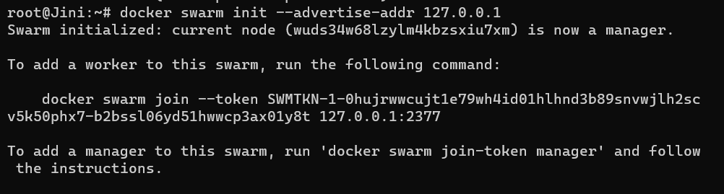

**Step 2.** Now we can enter the following to check the state of the swarm:

docker info

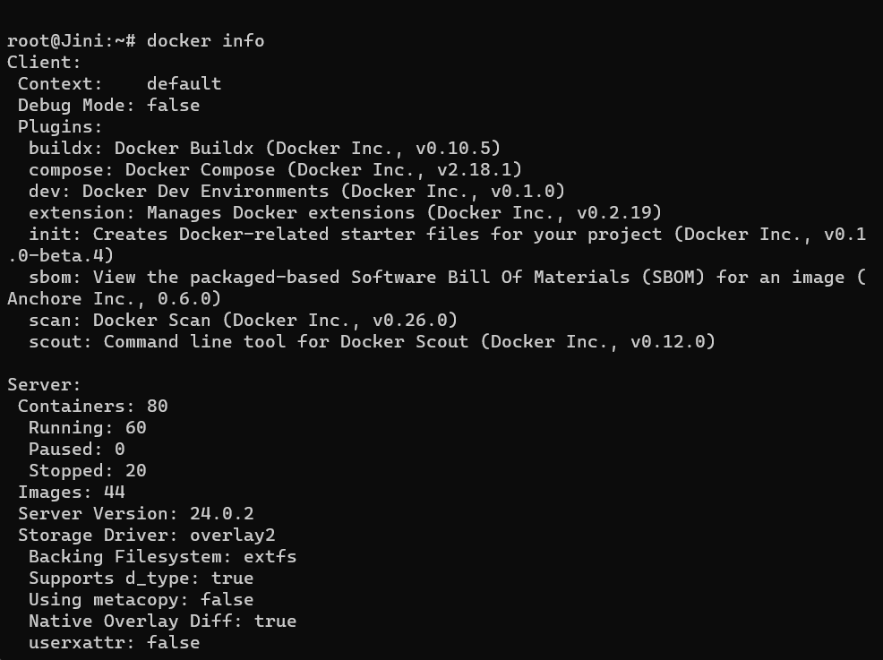

**Step 3.** if we enter

docker node ls

on the terminal. It will give us the list of nodes running and we can see our leader node there:

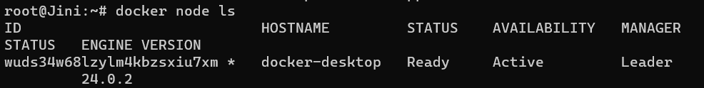

**Step 4.** In order to add a worker nodes to swarm you can enter the following command in your terminal

docker swarm join --token SWMTKN-1-49nj1cmql0jkz5s954yi3oex3nedyz0fb0xx14ie39trti4wxv-8vxv8rssmk743ojnwacrr2e7c 192.168.99.100:2377

**Step 5.** Now let's deploy a service in Docker Swarm, in order to deploy any service in swarm, in syntax of the command is:

docker service create --replicas[NUMBER OF REPLICAS] --name [NAME OF SERVICE] [IMAGE]

Therefore, we can enter the following command, to create a alpine service named gfg:

docker service create --replicas 1 --name gfg alpine ping docker.com

and your gfg service will be created:

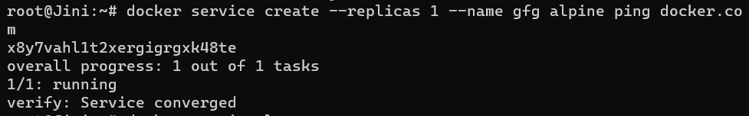

**Step 6.** We can check our list of services using the following command:

docker service ls

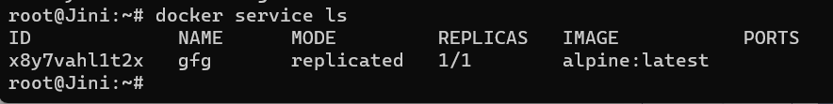

**Step 7.**Now let's scale this service to 2 replicas, to do that the syntax for the command is:

docker service scale [NAME\_OF\_SERVICE] = [NUMBER\_OF\_REPLICAS]

Enter the following command in your terminal to scale our gfg service to 2 replicas:

docker service scale gfg=2

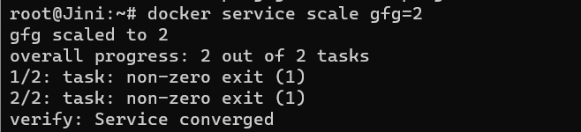

**Step 8.** Now when we check our list of services, we see that our gfg service has 2 replicas:

docker service ls

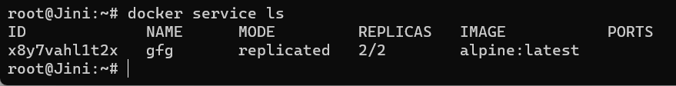

**Step 9.** Finally, we would want to delete our service, for that the syntax of the program is

docker service rm [NAME\_OF\_SERVICE]

To delete our gfg service we can simply enter this command:

docker service rm gfg

Upon checking the list of services, we will not find your gfg service anymore:

docker service ls

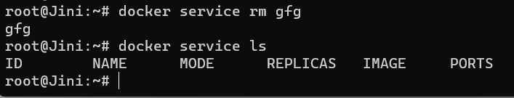

**Comparison between Docker swarm and Kubernetes:**

**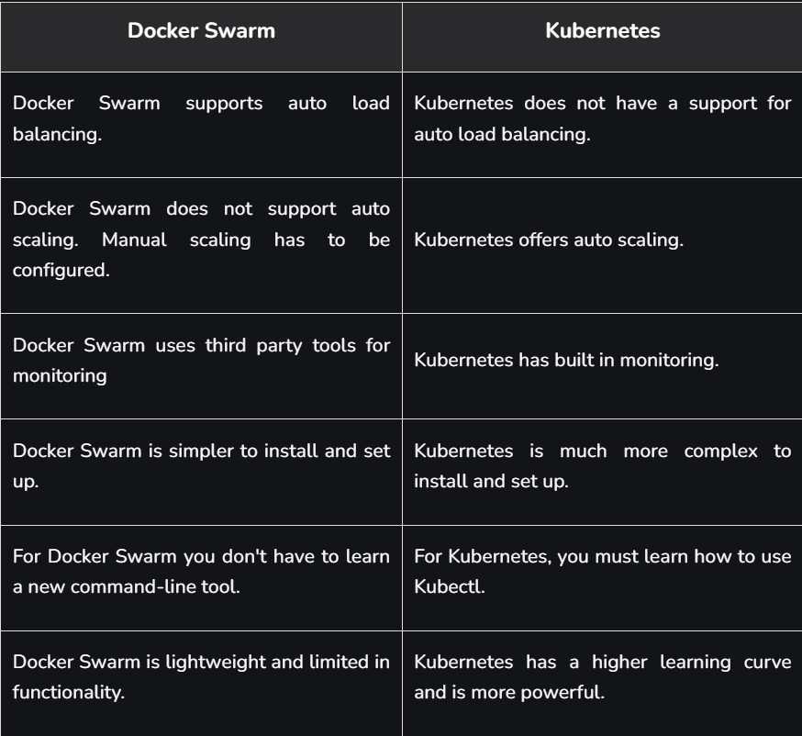**

**==================================================================================**

1. **Docker - Security Best Practices:**

Container security involves implementing a robust set of practices and tools to protect the entire container lifecycle, from the underlying infrastructure to the applications running within them. It focuses on ensuring the integrity, confidentiality, and availability of containerized environments. The need for dedicated container security arises from several core risks :

* **Isolation Breach:** Unlike virtual machines, containers share the host operating system's kernel. This architecture creates a potential single point of failure. Without proper security measures, a kernel exploit could allow an attacker to "escape" a container, gaining access to the host and all other containers running on it.
* **Vulnerability Management:** The speed of modern development means container images are built and deployed frequently. Continuous scanning and monitoring of these images are critical to prevent attacks that exploit vulnerabilities in outdated packages or dependencies.
* **Access Control:** Misconfigured permissions can grant unauthorized access to the Docker daemon or running containers. Proper access management is essential for detecting suspicious behavior and responding promptly to security threats during runtime.

**Securing The Docker Host and Daemon:**

The security of your entire container ecosystem rests on the security of the host machine and the Docker daemon. A compromise at this foundational level can render all other security measures ineffective.

**Hardening the Host System**

Because containers share the host's kernel, a vulnerability at the host level can be catastrophic. Hardening the host is the first line of defense.

* **Keep the Host and Docker Engine Updated:** Regularly apply security patches to the host OS and the Docker Engine. This is the most critical step to protect against known kernel exploits and container escape vulnerabilities.
* **Use a Minimalist Host OS:** Reduce the host's attack surface by using a minimal OS distribution that only includes packages necessary for running Docker.
* **Enforce OS-Level Security:** Activate mandatory access control (MAC) frameworks like SELinux or AppArmor to confine the Docker daemon and mitigate the impact of a compromise.

**Securing the Docker Daemon**

The Docker daemon (dockerd) runs as a root process by default, making it a high-value target. Gaining access to the daemon is equivalent to gaining root access on the host.

**Do Not Expose the Daemon Socket:** The Docker daemon socket (/var/run/docker.sock) is the primary API entry point. Never expose it to containers, as this would allow them to control the Docker host. If remote access is required, secure it with TLS (HTTPS) or SSH.

* **Use a JSON Configuration File:** The preferred method for configuring the daemon is via the /etc/docker/daemon.json file. This centralizes all settings in a version-controllable location.
* **Disable Inter-Container Communication (ICC):** Set "icc": false in daemon.json to prevent containers on the default bridge network from communicating with each other, enforcing a default-deny network posture.

**Advanced Isolation: Rootless Mode and User Namespaces**

* **Rootless Mode:** This feature allows the Docker daemon and containers to run as a non-root user, significantly mitigating vulnerabilities that could lead to privilege escalation on the host. It executes the daemon and containers inside a user namespace, meaning that even if an attacker compromises a container, they won't gain root privileges on the host.
* **User Namespace Remapping (userns-remap):** For environments where rootless mode isn't feasible, userns-remap provides strong isolation. It maps the root user (UID 0) inside the container to a high-numbered, unprivileged user on the host, neutralizing many privilege escalation attacks.

**Building and Managing Secure Images**

The security of a running container begins with the image it's built from. A vulnerability introduced during the build process will be replicated across every container instance.

**Best Practices for Writing Secure Dockerfiles**

* **Use Trusted and Minimal Base Images:** Always start with official images from trusted sources like Docker Hub. Prefer minimal base images like   alpine, slim variants, or "distroless" images, which contain only the application and its runtime dependencies, drastically reducing the attack surface by removing shells and package managers.
* **Run as a Non-Root User:** This is a critical security control. Create a dedicated unprivileged user in the Dockerfile and switch to it using the USER instruction to mitigate privilege escalation risks.
* **Use Multi-Stage Builds:** This technique creates lean production images by separating the build environment from the runtime environment. Only the necessary compiled artifacts are copied to the final image, discarding all build-time dependencies and tools.
* **Pin Image Versions:** Avoid using the latest tag, which is mutable. Pin base images to specific version tags (e.g., alpine:3.19) to ensure reproducible and secure builds.
* **Lint Dockerfiles:** Use tools like Hadolint to statically analyze Dockerfiles for misconfigurations and violations of best practices before the build process begins.

**Vulnerability Scanning with Trivy and Docker Scout**

Integrating automated image scanning into your CI/CD pipeline is essential for a "shift-left" security approach. Tools like Trivy, Clair, Snyk, and Docker Scout analyze image layers for known vulnerabilities (CVEs).

* **What is Trivy?** Trivy is a popular open-source scanner that quickly detects vulnerabilities in container images and other artifacts. It provides structured reports, classifying issues by severity (low, medium, high, critical), and can be easily integrated into CI/CD pipelines for automated checks.
* **What is Docker Scout?** Docker Scout is a tool from Docker that analyzes container images for packages and vulnerabilities, offering suggestions for remediation. It integrates with the Docker toolchain to provide continuous feedback throughout the development lifecycle.

**Ensuring Image Integrity with Docker Content Trust:**

Docker Content Trust (DCT) provides a mechanism for cryptographically signing and verifying images. When enabled ( export DOCKER\_CONTENT\_TRUST=1), the Docker client will refuse to pull or run any image tag that is not signed, preventing man-in-the-middle attacks or the use of tampered images

**What are Control Groups?**

Control groups or groups are the crucial features in Linux that facilitate resource allocation, prioritization, and limitation of the system resources such as[CPU](https://www.geeksforgeeks.org/operating-systems/cpu-scheduling-in-operating-systems/), memory, and I/O bandwidth among the processes. By grouping the processes and assigning the resource limits to these groups, groups enable the administrators to manage the system resources more efficiently.

It helps prevent the individual processes from consuming excessive resources and leading it to system instability. It helps in optimizing the system performance and ensures in equitable resource distribution across the applications and users.

**Securing Running Containers**

Once a container is running, security shifts to hardening its isolation boundaries and monitoring its behavior.

**Applying the Principle of Least Privilege**

Containers should run with the minimum permissions necessary to function.

* **Drop Linux Capabilities:** By default, Docker drops many capabilities, but not all. It is best practice to drop all capabilities (--cap-drop=all) and add back only those that are strictly required (--cap-add=NET\_BIND\_SERVICE).
* **Prevent Privilege Escalation:** Use the --security-opt=no-new-privileges flag to prevent processes inside the container from gaining additional privileges.
* **Use a Read-Only Filesystem:** Running a container with a read-only root filesystem (--read-only) prevents an attacker from modifying application files or writing malware to disk. Use an in-memory tmpfs mount (--tmpfs /tmp) for directories that require write access.
* **Limit Resources:** Set resource quotas for CPU (--cpus), memory (--memory), and process IDs (--pids-limit) to prevent denial-of-service (DoS) attacks where a compromised container exhausts host resources.

**Network Security and Segmentation with Calico**

By default, Docker allows unrestricted communication between containers on the same host, creating a flat network where a single compromised container can attack others. Network segmentation is crucial for isolation.

* **Use Custom Bridge Networks:** Avoid the default bridge network. Instead, create custom user-defined networks to isolate different application stacks.
* **Enforce Network Policies with Calico:** For advanced network security, especially in orchestrated environments like Kubernetes, tools like Calico are essential. Calico is an open-source solution that provides fine-grained network policy enforcement. You can define rules to control traffic between containers based on IP addresses, ports, and protocols, effectively creating a zero-trust network that prevents unauthorized access and lateral movement.

**Monitoring and Logging for Threat Detection**

Comprehensive logging and monitoring are vital for detecting security incidents in a dynamic container environment.

* **Centralize Container Logs:** Configure applications to log to STDOUT and STDERR. Use Docker's logging drivers to forward these logs to a centralized analysis platform.
* **Monitor Docker Events:** The Docker Events API provides a real-time stream of activities such as container creation, image pulls, and network modifications. Monitor this stream for suspicious events, such as a privileged container starting or a sensitive host directory being mounted.
* **Use Runtime Security Tools:** Tools like Sysdig Falco use kernel-level instrumentation to detect abnormal behavior within containers, such as unexpected shell access or modifications to sensitive files, and can provide real-time alerts.

===================================================================================

1. **How To Use Docker Security Tools To Secure Docker Container Images:**

**What is Container Security?**

[Container Security](https://www.geeksforgeeks.org/devops/docker-security-best-practices/) refers to the implementation of security measures for securing contents and infrastructure of containerized applications. It comes with providing the features such as data integrity, confidentiality and availability of container environments. It helps in reducing the risks associated with deploying applications in containers such as isolation breaches, unauthorized access and potential vulnerabilities.

**What are Container Security Tools?**

Container Security Tools are the software solutions that are designed to provide the security to the containerized environments. These tools identifies the vulnerabilities in the container environments and enforces the access controls and monitoring activities on containers. These container security tools provide features such as vulnerability scanning and remediate weakness in container images. Security tools will restrict with minimizing the privileges if any suspicious activities are detected within containers.

**Top Open Source Container Security Tools**

The following are the some of the best open source Container Security Tools:

* **Calico:** Calico is an open-source network security solution that is designed for containers and virtual machines. It provides the network policies, ingress and egress filtering and encryption of containerized environments. It provides a secure communication between containers and hosts.
* **Calir:**It is an open-source vulnerability scanner for container images. It analyzes the container images for vulnerabilities by comparing the contents wit the database to know the security flaws.
* **Anchore Engine**: It is an opensource container security and compliance platform that is used for scanning the container images for vulnerabilities, malware and policy violations.
* **Anchore:** It is also a open source tool that provides the services through scanning the container images for detecting the vulnerabilities and provide customizable policies for image scanning and runtime montoring.

**Need For Container Security**

The following are the some of the needs for container Security:

* **Isolation Breach**: Containers share the host OS Kernel which can leads to security gaps without proper measures.
* **Vulnerability Management**: Continuous monitoring of container images are critical for preventing the attacks raised due to frequent deployments.
* **Access Control:** Proper access management within the container activities helps in detecting and responding promptly to the suspicious behaviour ensuring security during runtime.

**Best Container Enterprise Security Tools**

The following are some of the best container enterprise security tools:

* **Aqua Security:**It provides detailed and effective security solutions for enterprise container environments, including vulnerability scanning, runtime protection and compliance automation.
* **Twistlock:** It provides the advanced security features such as vulnerability management, compliance checks and runtime defense that are suitable for large-scale enterprise deployments.
* **Docker Enterprise Edition (EE):** It provides a strong container security platform with features like secure image management, granular control access and integrated security scanning for enterprise grade container deployments.

**Improving Container Security with Calico**

The following things that can be implementable for enhancing the container security with calico here we discussed with a proper guiding:

* **Deploy Calico:**Firstly begin on deploying the calico within your container environment. It can be isntalled in the environment as a[Kubernetes](https://www.geeksforgeeks.org/devops/introduction-to-kubernetes-k8s/) network plugin or as deployed standalone like[Docker Swarm](https://www.geeksforgeeks.org/devops/introduction-to-docker-swarm-mode/) or Mesos.
* **Network Policy Enforcement:** Try on utilizing the calico's network policies for enhancing the fine-grained control over network traffic between containers. In this define the [IP addresses](https://www.geeksforgeeks.org/computer-science-fundamentals/what-is-an-ip-address/),[ports](https://www.geeksforgeeks.org/computer-networks/what-is-ports-in-networking/)and protocols for restricting the communication and prevent the unauthorized access.
* **eBPF Data Plane:** calio offers this eBPF data plane which provide efficient and scalable network traffic filtering. It provides high performance packet processing with minimal overhead ensuring the optimial performance for containerized environments.
* **Encryption:** On taking the advantages of Calico's capabilites we can provide the secure communication between the containers. It supports the encryption of inter-cotnainer traffic using the techniques like IPsec and confidentiality and data integrity.
* **Integration with Kubernetes:**Integration of Calico with kbuernetes provides the seamless orchestration and security mangement. It integrates natively and provide sthe levarge ovet the API for policy enforcement and management across yoru containerized environment.

**Container Runtime Security Tools**

Container Runtime Security Tools focuses on protecting containerized application during runtime. The following are the some of the container Runtime Security Tools:

* **Sysdig Secure:**It provides the runtime security for containers with offering the features such as runtime anomaly detection,, container forensics and integration monitoring. It helps in detecting and responding to security incidents timely.
* **Sysdig Falco:** It is an open source container runtime security tool that focuses on detecting the abnormal behaviours of container environments and security violations. It used the kernel-level instrumentation for monitoring the system calls and provide the alerts for suspicious activities.
* **Docker Security Scanning**: It is a built-in feature of [Docker Hub](https://www.geeksforgeeks.org/devops/what-is-docker-hub/) that scans the container images for checking vulnerabilities and security threats.

**What is Trivy?**

**Trivy** is an open-source scanning tool that is used to scan and detect vulnerabilities in a Docker container and artifacts. It delivers the result very quickly. It can detect vulnerabilities in operating systems like Alpine, CentOS, and many more. It shows the vulnerability report in a very structured way. It classifies the issues into low-level, medium-level, high-level, and critical levels. Trivy can integrate into the [CI/CD](https://www.geeksforgeeks.org/devops/what-is-ci-cd/) pipelines, which helps in automatic vulnerability detection. With each new update, Trivy is becoming more reliable in detecting security and vulnerability-related issues. In summary, we can say Trivy has become a powerful tool to detect the vulnerabilities of containerized applications, images, and artifacts to maintain the security of the entire infrastructure.

**How to Use Docker Security Tools to Secure Docker Container Images? A Step-By-Step Guide**

**Step 1:**Here first create a[dockerfile](https://www.geeksforgeeks.org/cloud-computing/what-is-dockerfile/). Here i have used a old version of alpine linux as the base image.

FROM alpine:3.7  
RUN apk add --no-cache curl

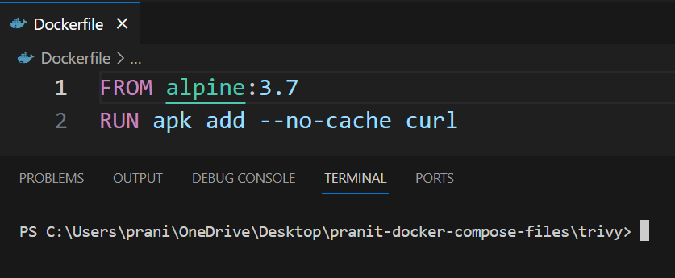

**Step 2:** Now build the docker image by using docker build command.

docker build -t gfg-demo .

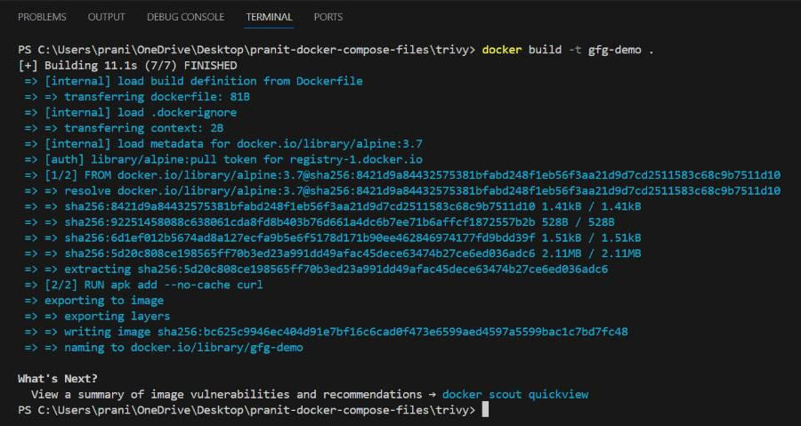

**Step 3:**Tag the docker image and push it to the dockerhub account.

docker tag gfg-demo <***your-username***>/gfg-demo  
docker push <***your-username***>/gfg-demo

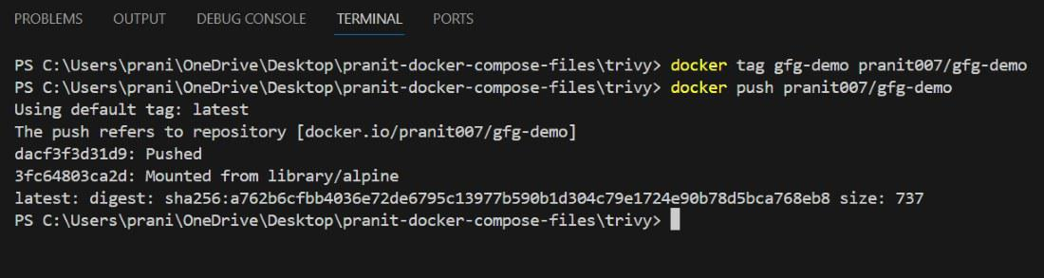

**Step 4:** Now run the trivy scanner to scan the docker image.

docker run --rm -v <***any-local-path***>:/root/.cache/ aquasec/trivy:0.18.3 image <***your-username***>/gfg-demo

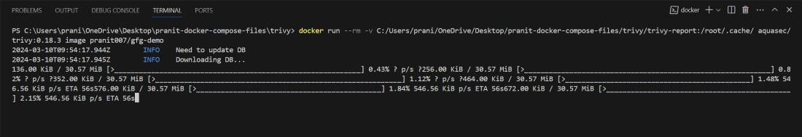

**Step 5:** Now you can observe all the issues . Here you will see two critical issues .

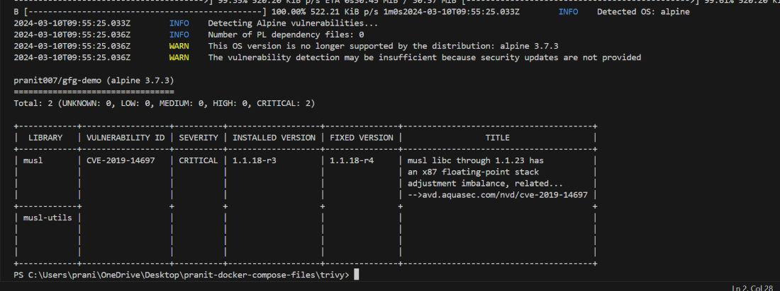

**Step 6:** To fix these critical issues , now update the version of alpine in [dockerfile](https://www.geeksforgeeks.org/cloud-computing/what-is-dockerfile/" \t "_blank) .

FROM alpine:3.19  
RUN apk add --no-cache curl

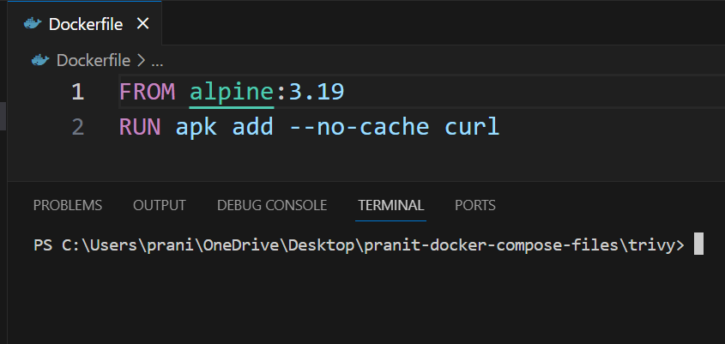

**Step 7:**Again build the image from the updated dockerfile.

docker build -t gfg-demo .

**Step 8:**Again tag the docker image and push it to dockerhub account .

docker tag gfg-demo <***your-username***>/gfg-demo  
docker push <***your-username***>/gfg-demo

**Step 9:** Now run the trivy scan for updated [docker image .](https://www.geeksforgeeks.org/devops/what-is-docker-image/)

docker run --rm -v <***any-local-path***>:/root/.cache/ aquasec/trivy:0.18.3 image <***your-username***>/gfg-demo

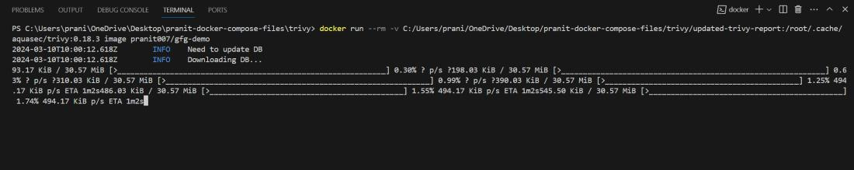

**Step 10:** Now observe , there are no critical issues . With just by updating the docker base image version we have fixed all the critical issues. 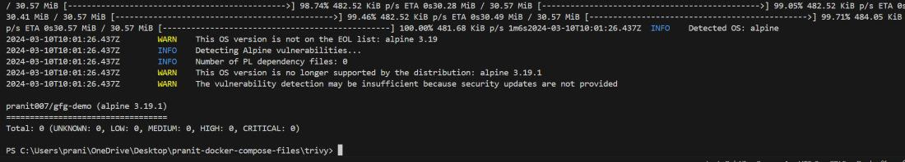

**Docker Scan Commands:**

**1. Scan A Local Image**

The following is the command used for scanning the local docker image:

docker scan <image\_name>

**2. Scan an Image from Docker Hub**

The following is the command for checking the vulnerabilities and scanning the image from Dockerhub.

docker scan docker.io/<image\_name>

**3. View Scan Results**

The following command is used for detailed scanning and displaying the results for a specific image. It helps us to make informed decisions about image security:

docker scan --accept-license <image\_name>

**4. Schedule Scans**

The following is used for performing schedule scanning for a specific image ensuring the continuous monitoring and timely section of new vulnerabilities.

docker scan --schedule <image\_name>

**What are Docker Scout?**

Docker Scout is a software tool that is used in docker for analyze the container images for packages and vulnerabilities. It offers the remediation suggestions. The following are the its implementation guide on its setup and Usuage:

**How to use Docker Scout? A Step-By-Step Guide**

**Step 1: Setup**

It clones the vulnerability of Node.js application repository. For performing this step execute the following command:

**git clone https://github.com/docker/scout-demo-service**

Try on ensure the docker sign in, then build/push the docker image to the Dockerhub

**docker build --push -t ORG\_NAME/scout-demo:v1 .**

**Step 2: Enable Docker Scout**

Enroll to your organization with the docker scout using the following command:

**docker scout enroll ORG\_NAME**

Enable the Scout of your image repository with the following command:

**docker scout repo enable --org ORG\_NAME ORG\_NAME/scout-demo**

**Step 3: Analyze Vulnerability**

Indetify the vulnerabilities in the docker image on using the following command:

**docker scout cves --only-package express**

**Step 4: Fix Vulnerability**

Update the vulnerability packages in the application code, rebuild and push it to the docker image:

**docker build --push -t ORG\_NAME/scout-demo:v2 .**

**Step 5: Evaluate Policy Compiance**

In this step, try on configuring the organization settings with the following command, ensure to replace the ORG\_NAME with your organization name:

**docker scout config organization ORG\_NAME**

Then Evaluate the compliance with the following command:

**docker scout quickview**

**Step 6: Improve Compliance**

Address the policy violations, adjust the Dockerfile and enable the attestations using the following command:

**docker build --provenance=true --sbom=true --push -t ORG\_NAME/scout-demo:v3 .**

**Step 7: View in Dashboard**

Finally try on accessing the Docker Scout Dashboard to view the compliance results and recommendations

\*\*\*\*\*\*\*\*\*\*\*\*\*\*\*\*\*\*\*\*\*\*\*\*\*\*\*\*\*\*\*\*\*\*\*\*\*\*\*\*\*\*\*\*\*\*\*\*\*\*\*\*\*\*\*\*\*\*\*\*\*\*\*\*\*\*\*\*\*\*\*\*\*\*\*\*\*\*\*\*\*\*\*\*\*\*\*\*\*\*\*\*\*\*\*\*\*\*\*\*\*\*\*\*\*\*\*\*\*\*\*\*\*\*\*\*\*\*\*\*\*\*\*\*\*\*\*\*\*\*\*\*\*\*\*\*\*\*\*\*\*\*\*\*\*\*\*\*\*\*\*\*\*\*\*\*\*\*\*\*\*\*\*\*\*\*\*\*\*\*\*\*\*\*\*\*\*\*\*\*\*\*\*\*\*\*\*\*\*\*\*\*\*\*\*\*\*\*\*\*\*\*\*\*\*\*\*\*\*\*\*\*\*\*\*\*\*\*\*\*\*\*\*\*\*\*\*\*\*\*\*\*\*\*\*\*\*\*\*\*\*\*\*\*\*\*\*\*\*\*\*\*\*\*\*\*\*\*\*\*\*\*\*\*\*\*\*\*\*\*\*\*\*\*\*\*\*\*\*\*\*\*\*\*\*\*\*\*\*\*\*\*\*\*\*\*\*\*\*\*\*\*\*\*\*\*\*\*\*\*\*\*\*\*\*\*\*\*\*\*\*\*\*\*\*\*\*\*\*\*\*\*\*\*\*\*\*\*\*\*\*\*\*\*\*\*\*\*\*\*\*\*\*\*\*\*\*\*\*\*\*\*\*\*\*\*\*\*\*\*\*\*\*\*\*\***THE END**